

Annual Report

Northamptonshire Independent Custody Visiting Scheme

April 2024 – March 2025

An Introduction to Police Custody in Northamptonshire

There are two Custody Centres in Northamptonshire; the Criminal Justice Centre (CJC) in Northampton and the Weekley Woods Justice Centre (WWJC) in Kettering.
These two modern centres provide a total of 62 cells, with 40 cells at the CJC and 22 at the WWJC.

Between 1st April 2024 and 31st March 2025, 12,886 detainees were held across the custody centres.

Introduction to the Northamptonshire Independent Custody Visiting Scheme

Northamptonshire Police, Fire and Crime Commissioner, Danielle Stone, has a statutory duty to maintain an effective Independent Custody Visiting (ICV) scheme for Northamptonshire. The scheme allows for volunteers from the local community to observe, comment and report on:
- the welfare of detainees
- that detainees are receiving their rights and entitlements
- that the conditions that detainees are being held in are satisfactory.

The scheme provides independent scrutiny which offers mutual protection to detainees and the police, and reassurance to the community.

This report summaries the independent monitoring of custody in Northamptonshire through the voluntary work of the Independent Custody Visitors (ICVs) who are committed to ensuring custody is a safe and dignified place for all.

There are currently 18 ICV volunteers in Northamptonshire. Six new ICVs were recruited to the scheme this year and are undergoing the vetting process to begin in the new performance year.

There are two Panels of ICVs made up of people with diverse backgrounds, ages and ethnicities.

Governance

Issues and praise are recorded by ICVs via an electronic report form in Custody, which is submitted to the Custody Inspector and the ICV Scheme Manager in the Office of the Police, Fire and Crime Commissioner.

The majority of issues are resolved by staff on duty at the time of visit. Issues that ICVs can not resolve within the visit are escalated to the Custody Inspector to be resolved. This is monitored by the Scheme Manager. Any issues left unresolved are raised with the Police, Fire and Crime Commissioner (PFCC).

The PFCC will raise thematic and serious issues with the Chief Constable or senior staff in Northamptonshire Police at the Accountability Board.

Key findings are sent quarterly to the Independent Custdy Visiting Association (ICVA) who raise national themes with the Home Office and other national bodies.

The Scheme Manager chairs a quarterly meeting for ICVs, which the Custody Inspector attends, to discuss findings and share learning, and to recognise the input of ICVs. Training sessions are also provided regularly for the ICVs.

Custody Visiting Data

During the 12-month period (April 2024 – March 2025), 104 ICV visits to Custody took place and 440 detainees were seen (325 spoken to and 115 observed). Of the detainees asked, 12% refused to talk with ICVs.

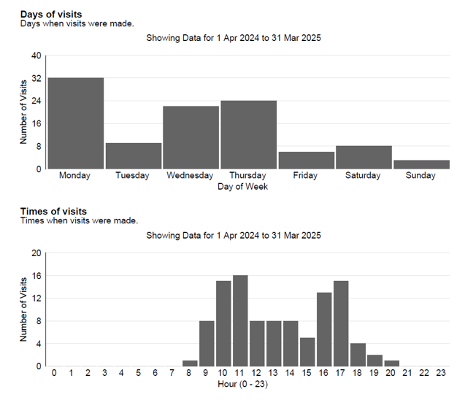

ICV Scheme Findings

Over the past year, there were no serious issues raised that required escalation. The top matters raised by detainees related to not receiving medication and not seeing a healthcare practitioner.

Other areas of note

At the beginning of her appointment, PFCC Danielle Stone introduced herself to the ICVs at their quarterly meeting. The Commissioner also opened a thank you event over the Christmas period to recognise the valuable work and time of the volunteers, as well as delivering a personal thank you card to each ICV during national Volunteers Week.

The PFCC, the Deputy PFCC and the CEO of the Office of the PFCC have each shadowed an ICV visit in the last performance year.

Northamptonshire continues to be recognised nationally for the high quality of its ICV scheme with a Silver Quality Assurance award.

The Northamptonshire scheme has been approached by the National Independent Custody Visiting Association to support the development of a national reporting function for ICVs.

Further information and contact details

Further details about the Northamptonshire ICV scheme can be found here.

Information about the Independent Custody Visiting Association (ICVA) can be found here.

The National Preventative Mechanism website can be found here.

The Northamptonshire ICV Scheme Manager can be contacted by emailing Commissioner@northantspfcc.gov.uk

