Appendix 2


NORTHAMPTONSHIRE POLICE, FIRE AND CRIME COMMISSIONER
RESERVES STRATEGY (REVISED JANUARY 2021)

1. Reserves Strategy

  - Reserves are a key part of medium-term financial planning – other components include revenue spending plans, income forecasts, potential liabilities, capital investment plans, borrowing and council tax levels. Decisions on these are inter-linked. Consequently, some organisations will need to maintain reserves at higher levels than others.
  - All publicly funded organisations should have a reserves strategy to demonstrate transparency and accountability, to comply with best practice financial management and to justify the levels of reserves held.

  - The PFCC maintains reserves to provide a measure of protection against risk. Without this protection, any unforeseen expenditure would have to be met either by increases in Council Tax or immediate savings (potentially through reductions in service levels).

1.4 The term "reserves" has a variety of technical and everyday meanings, depending on the context in which it is used. For the purposes of this Strategy it is taken to mean funds set-aside at the PFCC’s discretion for general or specific future purposes.

1.5 Reserves are required to protect and enhance the financial viability and in particular:

- To maintain a degree of in-year financial flexibility;
- To enable the PFCC to deal with unforeseen circumstances and incidents;
- To set aside monies to fund major developments in future years;
- To enable the PFCC to invest to transform and achieve improved service effectiveness and efficiency;
- To set aside sums for known and potential liabilities;
- To provide an operational contingency at service level.

1.6 Reserves should not be held to fund ongoing revenue expenditure as this is unsustainable in the long term; however, they may be important in smoothing a major financial imbalance (revenue or capital) over a longer timescale. CIPFA guidance LAAP 99 published July 2014 states:

“Balancing the annual budget by drawing on general reserves may be viewed as a legitimate short-term option. However, it is not normally prudent for reserves to be deployed to finance recurrent expenditure. CIPFA has commented that Councils should be particularly wary about using one off reserves to deal with shortfalls in current funding. Where such action is to be taken, this should be made explicit, and an explanation given as to how such expenditure will be funded in the medium to long term”

  - The Reserves Strategy assumes that the Medium Term Financial Plan [MTFP] is broadly balanced on a sustainable basis across the five year planning period. If the financial impact of the COVID pandemic continues to impact on taxbase and council tax levels over the medium term then this could impact on those assumptions.

  - Reserves should reflect the agreed financial strategy and should represent the quantified impact of risks and opportunities over the planning period, weighted for their probability.

- National Guidance and Compliance with Home Office Guidance on Police Reserves

2.1 The 2014, CIPFA guidance included the establishment and maintenance of local authority reserves and balances, setting out the key factors that should be taken into account locally in making an assessment of the appropriate level of reserves and balances to be held.

  - In the written statement that accompanied the Provisional Police Grant report on 19th December 2017, the Minister stated “you may be aware that police reserves currently stand at around £1.6bn, which compares to £1.4bn in 2011. We will be changing guidance to PFCCs to ensure that police officers and the public have access to more detailed information on how PFCCs intend to use this public money.” This strategy complies with the Ministerial requirement.

  - On 31 March 2018, the Minister for Policing and the Fire Service published new guidance on the information that each PFCC must publish in terms of Police Reserves. One of the key requirements is that the information on each reserve should make clear how much of the funding falls into each of the following three categories:

- Funding for planned expenditure on projects and programmes over the period of the current medium term financial plan.

- Funding for specific projects and programmes beyond the current planning period.

- As a general contingency to meet other expenditure needs held in accordance with sound principles of good financial management.

  - The forecast reserves as at 31/3/2021 are summarised as across the Home Office headings as follows:

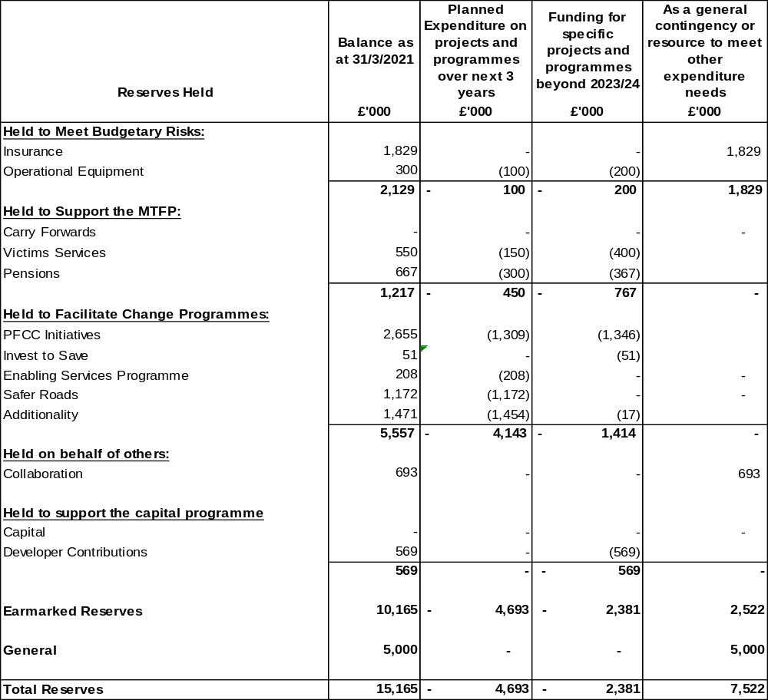

- General Reserve

3.1 In order to assess the adequacy of the unallocated general reserve when setting the budget, the PFCC, on the advice of the two finance officers, should take account of the strategic, operational and financial risks facing the authority. This assessment of risk should include external risks, as well as internal risks, for example the ability to deliver planned efficiency savings.

3.2 Whilst there is no prescribed level of reserves that PFCCs should hold; it is influenced by individual discretion, local circumstances, and advice from external auditors, risk management arrangements and risk appetite. CIPFA guidance in LAAP Bulletin 99 (2014) specifically cautions against prescriptive national guidance for a minimum or maximum level of reserves and states:

“The many factors involved when considering appropriate levels of reserves can only be assessed properly at a local level. A considerable degree of professional judgement is required. The chief finance officer may choose to express advice on the level of balances in cash and/or as a percentage of budget (to aid understanding) so long as that advice is tailored to the circumstances of the authority”

3.3 However, the minimum level of reserves may be set for the authority by the Ministers in England and Wales where an authority doesn’t act prudently, disregards the advice of its chief finance officer or is heading for financial difficulties. LAAP Bulletin 99 (2014) specifies that minimum level of reserves can be imposed on specific circumstances:

“Minimum level of reserves will only be imposed where an authority is not following best financial practice”

3.4 CIPFA indicate a general reserve level is typically between 2% and 3% of net budget requirement and this is consistent with the results of a survey by the PACCTS Technical Support Team where the majority of PFCC’s across the country reporting a Strategy of holding minimum general reserves at 3% net revenue expenditure.

3.5 In determining the PFCC’s position, Appendix A outlines how Northamptonshire currently comply with the 7 key CIPFA principles which can be used to assess the adequacy of reserves.

3.6 Given that the PFCC is required to meet the first 1% of any special grant requirement, and the level and range of earmarked reserves available to the PFCC, it seems prudent that the current policy is to maintain general reserves at a guideline level of 3% of annual net revenue expenditure, with a minimum of 2.5%.

3.7 The 2013/20 outturn increased the General Reserve and at present, there are no plans to use the General Reserve during the period of the MTFP. However, with forecast budget increases, there is a need to ensure the level of general reserves keeps pace to ensure minimum and guideline levels are achieved as follows:

3.8 These levels change each year and forecast general reserve plans are above the minimum level in all years and above or on the guideline level until 2024/25.

Year | Budget (£m) | £m
Year | Budget (£m) | 2.50% | 3%
2020/21 | 146.77 | 3.7 | 4.4
2021/22 | 153.53 | 3.8 | 4.6
2022/23 | 159.72 | 4.0 | 4.8
2023/24 | 162.96 | 4.1 | 4.9
2024/25 | 166.61 | 4.2 | 5.0
2025/26 | 170.09 | 4.3 | 5.1

3.9 Where appropriate, if the budget levels are higher than those forecast in the MTFP, the PFCC will endeavor to increase general reserves from 2024/25.

4. Earmarked Reserves

4.1 In addition to the General reserve, the PFCC holds a number of reserves which are earmarked for specific purposes.

4.2 The predicted position for each earmarked reserve as at 31/3/2021, together with an outline of its specific purpose is attached at Appendix B.

4.3 At the 31/3/2021, it is estimated that the PFCC will hold £10.165m in Earmarked Reserves which are as follows:

Pensions – This reserve is used to smooth the impact of ill-health retirements and to meet the costs of any ill—health or injury retirements in excess of budget provision across years.

Insurance – This reserve holds funds set aside where considered prudent for Civil Claims (Public and Employer liability) in line with professional advice.

Invest to save – this reserve was set aside to fund specific agreed schemes that will deliver long term efficiency savings for the Force and OPFCC.

Collaboration – this reserve relates to previous years underspends on regional collaboration and funds held for regional asset replacements. Each PCC holds their share of the regional reserves and is set aside to meet future regional costs.

Carry Forwards – this reserve relates to previous years Force underspends which are ring fenced and carried forward for use in future years. None are currently anticipated.

Safer Roads – this reserve relates to funds in excess of expenditure for use in line with specific criteria for equipment or road safety initiatives. Following the 2018/19 budget initiatives, a Road Safety Alliance has been set up with partners which will produce priorities and the PFCC’s reserve is used to fund specific road safety grants and is used to fund the policing priorities from this.

Additionality Reserve – this reserve is mainly used to smooth the timing impact of recruitment and staffing levels on the revenue budget.

PFCC Initiatives/Early Intervention – this is to deliver funding towards the specific initiatives of the Commissioner arising from the Police and Crime Plan.

Victims Services – this is to support investment and projects for victims services in future years. This reserve also holds any balances transferred in from Victims Voice at year end.

Operational Equipment – this is a reserve to smooth the impact on the revenue budget in respect of the cost of replacing operational equipment, rather than impacting disproportionately on the budget in any one year.

Developer Contributions – this is a reserve to collect the drawn down developer contributions awarded to the PFCC in line with S106 planning arrangements. These funds will be released in accordance with the terms of the agreements. The reserve only accounts for the estimates once they have been drawn down.

Enabling Services Programme – this reserve was created during 2018/19 to meet the programme costs of shared services, rather than impacting directly on the annual policing revenue budget. The reserve is assumed to be utilised and it is anticipated that the Enabling Services programme will bring efficiencies to the annual revenue budgets of OPFCC and the Force, in conjunction with efficiencies in Fire.

Once the programme has identified and costed efficiencies, they will be built in to the MTFP.

4.4 The forecast balance on the reserves, taking into account a prudent estimate of timings for proposals which are currently being developed is detailed within Appendix C.

- Provisions

5.1 The CIPFA Statement of Recommended Practice is prescriptive about when provisions are required (and when they are not permitted). Basically, a provision must be established for any material liabilities of uncertain timings or amount, to be settled by the transfer of economic benefits. In accordance with this statutory guidance, Northamptonshire established an ‘Insurance Provision’ which is reviewed as part of the closedown process for each year.

Procedures for management and control

  - Any drawdown from Reserves is subject to the approval of the PFCC, on advice from the PFCC’s Chief Finance Officer (CFO); or under the delegated authority of the OPFCC CFO.

6.2 The Local Government Act 2003 requires the s151 officer to report annually on the adequacy of the reserves and this is included within the statement on the robustness of the estimates used for the budget and the adequacy of the proposed financial reserves.

6.3 The Strategy will be reviewed annually by the OPFCC CFO as part of the Budget and Precept process.

Appendix A

Northamptonshire Compliance with the 7 Key CIPFA Principles to assess the adequacy of reserves

Budget Assumptions (CIPFA Principles) | 2021/22 Situation in Northamptonshire
The treatment of inflation and interest rates | Northamptonshire makes full and appropriate provision for pay and price increases, informed by benchmarking with peers. An informed assessment is made in the Treasury Management Strategy of interest rate movements. All income and expenditure in the budget is prepared and published at outturn prices.
Estimates of the level and timing of capital receipts | Northamptonshire has recently reviewed its estates strategy as a fundamental part of the capital programme and has made a prudent assumption of future capital receipts across the programme which are being used to fund capital expenditure and minimise the impact of borrowing on the budget.
The treatment of demand led pressures | The Force is required to operate and manage within its annual budget allocation. Overtime budgets are devolved within the Force to enable operational leaders to make decisions and the Chief Constable retains an operational contingency to support additional major incidents.  On an exceptional basis, agreement is sought from the PFCC to utilise carry forwards to meet one off demand led pressures and demand led pressures are scrutinised and built into the budget set by the PFCC.  Northamptonshire have identified savings in previous years which mean that opportunities for efficiencies are less than in previous years. However, the PFCC will support investment in areas that reduce demand or which increase efficiency/capacity to deal with demand. General reserves are used as a last resort to manage and fund demand led pressures.
The treatment of Planned Efficiency Savings/Productivity Gains | The force has set the Chief Constable an expectation to identify 1% (circa £1.5m) in efficiency savings each year. These are not assumed within the reserves strategy.  The Force operates a Change Steering Group which monitors investments, savings and efficiencies and is attended by OPFCC representatives.

The financial risks inherent in any significant new funding partnerships, collaboration, major outsourcing arrangements or major capital developments. | The financial consequences of partnership collaboration working, outsourcing arrangements or capital investment are reported to the PFCC as part of the medium term planning process. Where relevant, any additional costs are incorporated into the annual revenue budget and/or capital programme.  There is a risk that partners will withdraw funding as their own budgets are squeezed, or that the continued viability of private sector commercial partners will be exposed to risk in the face of an economic recession.
The availability of reserves, government grants and other funds to deal with major contingencies and the adequacy of provisions. | Northamptonshire have created a number of earmarked reserves and provisions to meet specific expenditure items and have added to these further in this strategy. Their use and balances as at 31/3/2021 are detailed in the attached appendix.  Northamptonshire maintains an insurance provision, the adequacy of which is monitored in detail by the legal services insurance advisors, together with our insurance advisors. The access criteria for special grants state that PFCCS may be required to fund up to 1% of their net budget requirement themselves before the Government considers GrantAid. This applies on an annual basis.  Northamptonshire’s General Reserve provides sufficient scope to cover this eventuality.
The general financial climate to which the Authority is subject | The COVID-19 pandemic has hit the Police funding for 2021/22 and future years and reasonable assumptions have been built into the MTFP.  Since March 2017, the PFCC has endeavoured to increase police officers by 330 to 1500 by March 2023. This will be met by the revenue budget and not by the use of reserves.  There are shortfalls in the MTFP and the PFCC has set the Chief Constable efficiency savings to help meet and mitigate these, in addition to providing resources for further investment  It is anticipated that after CSR2021, these funding streams will be more certain and the MTFP will be regularly updated to support operational decision  making.

Appendix B

RESERVES OF THE POLICE AND CRIME COMMISSIONER
2021/22 to 2025/26

 | Rationale | How and when used | Level | Management and control | Risk | Review
GENERAL RESERVE | To maintain a degree of in-year financial flexibility;  To enable the Commission to deal with unforeseen circumstances and incidents;  To set aside sums for known and potential liabilities;  To provide an operational contingency at service level. | To meet exceptional spending needs or overspends which are unable to be otherwise financed at the year end.  To smooth the profile of funding revenue over a medium term financial period  To allow higher spending without raising council tax on a one-off basis | General principle of 3% of net budget requirement, with a minimum level of 2.5% | PFCC, on advice from PFCC CFO | May be inadequate for major catastrophe, which could jeopardise financial status and reputation of the Commission.  The Commissioner would have recourse to Home Office discretionary special grant if costs exceed 1% of budget or CLG Bellwin scheme for natural disasters | Annual
PENSIONS | To meet the costs of any ill—health or injury retirements which are unbudgeted and fall directly on the Commission.  Also, to cover any significant overspend on the employer contributions to the Pension Account | Annually as required.  Transfers out depend on the amount resulted from successful claims during the year.  Historically there has been budget provided within the Force revenue budget for approximately 6 claims in a year. Any unused budget within a year would represent transfers in.  The consideration of utilising this reserve towards the reduction on actuarial is currently in progress | Will vary according to annual risk assessment | PFCC, on advice from PFCC CFO | Significant ill health or injury awards beyond normal profile create pressure on reserve or leave excess funds unused.  Significant change in officer numbers or grades lead to unbudgeted employer pension contributions in-year. | Annual
INSURANCE | To cover the potential and contingent liabilities of uninsured risks as assessed annually by our insurers based on claims outstanding. | Balance will increase or reduce annually dependent on the Commission’s outstanding claims record.  Currently excess limit is £150k per claim. Higher excess levels are being reviewed which may require higher reserve levels.  Increased in 2017/18 following advice from external audit | Will vary according to annual risk assessment | PFCC, on advice from PFCC CFO | If no reserve is held the Commission is potentially open to significant excess and claims payments in year beyond available revenue budgets.  Assessment by insurers needs to be realistic not unduly pessimistic. | Annual
INVEST TO SAVE | To fund specific agreed schemes that will deliver long term efficiency savings for the Force and OPFCC. | To access the funds business case has to be demonstrated and with specific future savings to the organisation identified | Will vary according to usage and annual risk assessment. |  | If funds were not maintained there would be no availability for Invest to save projects and such initiatives would have to be funded from the revenue budget or not implemented.  The need of such reserve arose due to increased amount of savings that Force and the PFCC would have to find due to present economic environment and availability and funding | Annual
COLLABORATION | Transfers in relate to underspend on regional collaboration. Transfers out represent contribution towards regional decisions | Upon requirement on decision made to contribute towards projects in relation to regional collaborations.  Decisions made on East Midlands PFCC and CC Boards | Will vary according to usage and annual risk assessment. | PFCC, on advice from PFCC CFO | If funds were not maintained, there would be a risk of regional projects not being supported. | Annual

CARRY FORWARDS | To fund specific expenditure requested by the force from previous year underspends in 2019/20. | Business cases provided as part of the outturn report. | Will vary according to financial outturn. Currently at NIL. | PFCC, on advice from PFCC CFO | If funds were not provided, the risk is that projects or planned expenditure would need to be found from current year’s budget. | Annual
SAFER ROADS | For surpluses of fines and speed awareness course income over expenditure that is reinvested in replacement equipment and road safety initiatives.  The reserve is influenced by the work of the Road Safety Alliance formed in 2018/19 | As required – typically informed by approved business cases for bids on the Fund. | Will vary according to outturn and annual risk assessment. | PFCC, on advice from PFCC CFO | If Fund was not maintained then safety initiatives would have to be funded from the revenue budget or not implemented. | Annual
PFCC INITIATIVES/EARLY INTERVENTION | To deliver funding to for specific initiatives of the Commission arising from the Police and Crime Plan  To provide funding to deliver radical solutions to deliver the Police and Crime Plan | As required – typically informed by approved business cases for bids on the Fund. | Will vary according to outturn and annual risk assessment. | PFCC, on advice from PFCC CFO | Initiatives not adequately defined or delivered hence poor VFM | Annual
VICTIMS SERVICES | To fund specific programmes or schemes to support victims services | To access the funds business cases, have to be provided. | Will vary according to outturn and annual risk assessment. | PFCC, on advice from PFCC CFO | If funds were not provided, the risk is that projects or planned expenditure would need to be found from current year’s budget. | Annual
OPERATIONAL EQUIPMENT | To smooth the impact of operational equipment purchases on the revenue budget | To access the funds a costed request has to be provided. | Will vary according to usage and annual risk assessment. | PFCC, on advice from PFCC CFO | If funds were not provided, the risk is that equipment would have to be replaced from the current year’s budget. | Annual
DEVELOPER CONTRIBUTIONS | To meet the additional cost of operational requirements | To access the funds a costed request has to be provided which is consistent with the conditions of the developer contribution. | Will vary according to usage and annual risk assessment. | PFCC, on advice from PFCC CFO | If funds were not provided, the risk is that the additional costs would have to be replaced from the current year’s capital programme. | Annual

ENABLING SERVICES PROGRAMME | To meet the additional cost of the programme in the short term which will support the delivery of joint shared services across Fire and Policing. | To access the funds a costed request has to be provided. | Will vary according to outturn and annual risk assessment. | PFCC, on advice from PFCC CFO | If funds were not provided, the risk is that equipment would have to be replaced from the current year’s budget. | Annual

Appendix C
Summary of Revenue and Capital Reserves 2020/21 to 2025/26



