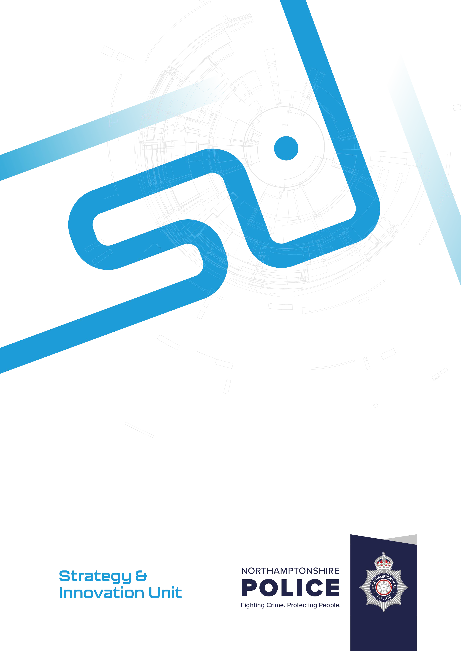144

**Agenda Item 8**

HMICFRS update

Author: Colleen Rattigan, Head of Strategy & Innovation

Decision required: For Information, Joint Independent Audit Committee Date: 2 October 2024

Version: 1

Security Classification: Official

1. **Introduction**

Following the publication of the HMICFRS 2023-25 Report, the force has commenced a revised workstream to address the new Areas for Improvement (AFIs) identified by HMICFRS.

Overall, the force has been content with the direction of travel. It has reduced the number of AFIs and has improved across several areas, most notably the areas it was deemed inadequate in 2019 (Protecting Vulnerable People and Management and Leadership, formerly understanding demand).

The force has fared well in comparison to peers and nationally, where overall the trajectory of gradings was declining in many areas, with many forces being engaged with HMICFRS.

In August 2024, HMI Roy Wilsher wrote to the Chief Constable to highlight a discrepancy with a data return in the original inspection in 2023. This related to data provided by the force and used by the inspectorate to come to a judgment in relation to the 101-abandonment rate within Q4, which was incorrect. Data provided at the time of inspection fieldwork gave the 101-abandonment rate as being at 8.8 percent. The actual figure was 25.6 percent which falls within the bounds of attracting an AFI. It was accepted that the error in data was because of human error.

This has led to the force report to be re-issued with the amended judgement and an additional AFI. The overall picture looks as follows:

|  |  |  |  |  |
| --- | --- | --- | --- | --- |
| Outstanding | Good | Adequate | Requires improvement | Inadequate |
| Recording Data | Police Powers & | Preventing and deterring | Responding to |  |
| about Crime | Treating the | crime and anti-social | the Public |
|  | public fairly and | behaviour, and reducing |  |
|  | respectfully | vulnerability |  |
|  | | Protecting Vulnerable | Investigating |
| People | Crime |
| Managing Offenders and |  | |
| Suspects |
| Building, Supporting and |
| Protecting the workforce |
| Leadership and Force |
| Management |

1. **Continuous Improvement Plan 2024 – 2025**

The force has developed an Improvement Plan in readiness for its future HMICFRS PEEL assessment. (appendix 1)

HMICFRS Inspectors will start to be visible in force meetings in the coming months after a break from engagement, the force liaison officer (FLO) will continue to monitor engagement & work with HMICFRS Inspectors to update the portal with evidence against AFIs.

HMICFRS have been working closely with the force around its positive practice.

A dedicated Chief Superintendent is now working with a small team on the Improving Investigations workstream. This has been branded as “Operation Sherlock” and will take a root and branch approach to determining where improvements can be made to improve the quality of investigations and outcomes for the public of Northamptonshire.

A sequence of key work has already been delivered, a Domestic Abuse end to end review, a Local Policing workload review, & two deep dive reviews which explored Outcome 15 (a Home Office classification used

by the police to describe the finalisation of an investigation where the suspect was identified and the victim supported police action, but evidential difficulties prevented further action) & Outcome 16 (where there are evidential difficulties victim based – named suspect identified – the victim does not support or has withdrawn support for police action).

Under the leadership of the former Head of Crime and Justice, this dedicated work will inform future investment cases in December 2024 & has already been identified as a top priority in formulating the force’s new strategic plan for 2025 – 2028.

The force will also deliver a root and branch review of each Peel Assessment Framework (PAF) area as performed ahead of the last inspection, to help leaders get ahead of any internally identified areas for improvement.

The Deputy Chief Constable has created a new governance to have strategic oversight and grip of all inspection activity. This will be called the Continuous Improvement Board and commence in October 2024, meeting monthly until the Chair is content with direction of travel.

A timetable of work has been tasked (as outlined in the Improvement Plan) and well under way. It is anticipated that each workstream will have its own suite of recommendations, aligned to GOOD and Outstanding police forces, to help Northamptonshire Police continue to make improvements into the coming year.

1. **Thematic HMICFRS Inspection activity**

In addition to PEEL there are several thematic inspections & broader HMICFRS engagement work that Northamptonshire Police is preparing for and engaging with.

**Baroness Casey Review & HMICFRS report into Vetting, Misconduct & Misogyny in the Police Service**

**(**[An inspection of vetting, misconduct, and misogyny in the police service - His Majesty’s Inspectorate of](https://hmicfrs.justiceinspectorates.gov.uk/publications/an-inspection-of-vetting-misconduct-and-misogyny-in-the-police-service/) [Constabulary and Fire & Rescue Services (justiceinspectorates.gov.uk)](https://hmicfrs.justiceinspectorates.gov.uk/publications/an-inspection-of-vetting-misconduct-and-misogyny-in-the-police-service/))

Recognising the grave levels of public concern following the kidnap, rape, and murder of Sarah Everard by a serving Met officer and other deeply troubling incidents, the Metropolitan Police Service (the Met) appointed Baroness Louise Casey to lead an independent review of its culture and standards of behaviour.

The review began in February 2022 and completed in March 2023, when the final report and recommendations were published.

The review discusses whether the Met’s leadership, recruitment, vetting, training, culture and communications support the standards the public should expect and recommends how high standards can be routinely met, and how high levels of public trust in the Met can be restored and maintained.

Northamptonshire Police acted in the wake of this report and developed Operation Admiral.

This saw a review and uplift in resources across counter corruption, vetting and professional standards.

This comprises of a stand-alone unit, commissioned to ensure that concerns raised are clearly addressed by Northamptonshire Police and that as an organisation the force have the highest standards and vigorous procedures in place to ensure the safety of its workforce and the public.

The unit delivered the following workstreams to address national recommendations pro-actively and to provide the public with trust and confidence that concerns being raised nationally are being dealt with robustly across the county.

* A thorough review of all allegations of criminal, improper and prejudicial behaviour by serving police officers and staff over the past three years in line with recommendation 28 of the HMICFRS report.
* Assessed how Northamptonshire Police identify, investigate, and manage misconduct, corruption and criminal behaviour and allegations of such relating to its workforce from referral/report to outcome.
* Sought to understand the prevalence of misogyny and improper conduct towards female officers and members of staff across the organisation in line with the HMICFRS AFI (Areas for Improvement), assess how the force manage this and make changes in line with best practice.
* Sought to understand the prevalence of discriminatory behaviour across the workforce and assess how effectively this is dealt with.
* A bespoke review was done for allegations of prejudicial behaviours.
* Assessed effectiveness of reporting mechanisms available to those within the organisation and members of the public/those in personal relationships with serving Northamptonshire staff and officers.
* A full review of in force systems to check the efficacy of police systems.
* Examined the effectiveness of vetting arrangements in relation to recruits, transferees and serving Northamptonshire staff and officers.
* Assessed recruitment processes to ensure that the force is attracting appropriate applicants from the outset.
* Assessed the use of Regulation 13 within the organisation to ensure it is used appropriately to exit staff not meeting the required standards at the earliest stage possible.

**Angiolini Inquiry**

In addition to the above HMICFRS report, the Angiolini Inquiry was established to investigate how an off- duty police officer was able to abduct, rape and murder a member of the public. The findings and recommendations of this investigation are contained in the Part 1 report. ([Reports – The Angiolini Inquiry](https://www.angiolini.independent-inquiry.uk/reports/))

Part 2 is to establish if there is a risk of recurrence across policing, to investigate police culture, and to address the broader concerns surrounding women’s safety in public spaces. ([Terms of Reference for Part 2](https://www.angiolini.independent-inquiry.uk/angiolini-inquiry-terms-of-reference-for-part-2/) [– The Angiolini Inquiry](https://www.angiolini.independent-inquiry.uk/angiolini-inquiry-terms-of-reference-for-part-2/))

Following the sentencing of former police officer David Carrick in February 2023, Part 3 of the Inquiry was established to examine Carrick’s career and conduct. ([Terms of Reference for Part 3: the Carrick case –](https://www.angiolini.independent-inquiry.uk/the-carrick-case-terms-of-reference/) [The Angiolini Inquiry](https://www.angiolini.independent-inquiry.uk/the-carrick-case-terms-of-reference/)).

In support of the Inquiry, Northamptonshire Police has volunteered to take part in field work activity, where several cases are currently under review, and a series of focus groups and 121 interviews will take place week commencing 30th September 2024.

The force is participating specifically in Part 2 of the Inquiry which focuses on whether systems, policies and processes for the recruitment, vetting and transfer of police officers are fit for purpose and help to identify those who display misogynistic and/or predatory attitudes and behaviours; the extent to which aspects of police culture observed across police forces enable misogynistic and/or predatory attitudes and behaviours and the role of standards; and the extent to which existing measures prevent sexually motivated crimes against women in public spaces.

In addition to the HMICFRS thematic workstreams, the force also is delivering against several recommendations in wider NPCC and Govt reports that may be of interest to JIAC members.

**Operation Soteria**

**(**[Progress to introduce a national operating model for rape and other serious sexual offences investigations](https://hmicfrs.justiceinspectorates.gov.uk/publications/progress-to-introduce-a-national-operating-model-for-rape-and-other-serious-sexual-offences-investigations/)

[- His Majesty’s Inspectorate of Constabulary and Fire & Rescue Services (justiceinspectorates.gov.uk)](https://hmicfrs.justiceinspectorates.gov.uk/publications/progress-to-introduce-a-national-operating-model-for-rape-and-other-serious-sexual-offences-investigations/))

Launched in June 2021, as Operation Soteria Bluestone within Avon and Somerset Police, it’s aim was to increase the number of adult rape and serious sexual assault cases reaching charge, and, in addition, deliver sustained improvement in the criminal justice whole system response.

Operation Soteria was developed in response to national concern around the investigation of rape and serious sexual assault offences (RASSO) and the increasing epidemic that is violence against women and

girls.

The programme combines practitioner knowledge with that of academic experts, along with research insight and transformational change support to forces.

This has led to the development of the first National Operating Model (NOM) for the investigation of rape and serious sexual offences.

A full programme structure is in place locally with senior officer oversight in line with the national model. Both the Chief Constable and the PFCC have been briefed on progress & this remains in place through the Force Executive Meeting & Accountability Board structures.

Since 2021, 19 early adopter forces have been putting Soteria in place via the National Operating Model.

In May 2023, the then Home Secretary commissioned HMICFRS to carry out this inspection using the powers under section 54(2B) of the Police Act 1996. They inspected 9 early adopter forces to evaluate progress so far and a report published in August 2024 set out HMICFRS’ findings.

**Police Productivity Review**

**(**[Policing Productivity Review - GOV.UK (www.gov.uk)](https://www.gov.uk/government/publications/policing-productivity-review))

In October 2023 the Home Office commissioned the National Police Chiefs’ Council to review police productivity and provide recommendations to improve efficiency and effectiveness in policing.

Review was commissioned in summer 2022 against a backdrop of the police officer uplift but also significant challenges to trust and confidence in policing and public expectations.

Productivity is important because it means getting the best services from the resources that are available.

The review highlights improvements that have already been introduced e.g. in mental health response and crime recording. It also makes recommendations on good practice; the use of science and technology and how targeted incentives could help forces to unlock productivity improvements.

The review is broken down into 7 sections: productivity in Policing, Barriers to productivity, Workforce, Technology, The Model Process, Endowment Fund and Investment in Policing.

There are 26 recommendations in the report, some for the Government to consider as part of the Spending Review, and some for the College of Policing, CPS and other partners as well as forces to consider.

In February 2024 the Force Risk Manager presented an overview of the report with considerations for Northamptonshire Police.

These recommendations will form part of the force’s Continuous Improvement Plan, linked to a new force strategy being implemented later this year.

**Annual State of Policing**

**(**[State of Policing: The Annual Assessment of Policing in England and Wales 2023 - His Majesty’s](https://hmicfrs.justiceinspectorates.gov.uk/publications/state-of-policing-the-annual-assessment-of-policing-in-england-and-wales-2023/) [Inspectorate of Constabulary and Fire & Rescue Services (justiceinspectorates.gov.uk)](https://hmicfrs.justiceinspectorates.gov.uk/publications/state-of-policing-the-annual-assessment-of-policing-in-england-and-wales-2023/))

Published in July 2024, His Majesty’s Chief Inspector of Constabulary, Andy Cooke reports to the Secretary of State, under section 54(4A) of the Police Act 1996. It contains his independent assessment of the efficiency and effectiveness of policing in England and Wales. It is based on inspections carried out between 1 April 2023 and 31 March 2024. The report draws on findings from inspections of police forces in England and Wales, to provide an overall view of the state of policing.

The report does not set specific recommendations for forces as seen with other thematics and PEEL, however its context is used as an important document to inform our strategic direction.

Later this year the force will launch its new Policing Plan, this will focus on many areas outlined in the State of Policing Report, such as re-building trust and confidence which is an area of priority and focus in the

coming years.

**Inspection into activism & Impartiality in Policing**

([An inspection into activism and impartiality in policing - His Majesty’s Inspectorate of Constabulary and](https://hmicfrs.justiceinspectorates.gov.uk/publications/activism-and-impartiality-in-policing/) [Fire & Rescue Services (justiceinspectorates.gov.uk)](https://hmicfrs.justiceinspectorates.gov.uk/publications/activism-and-impartiality-in-policing/))

Published in recent weeks, In September 2023, the then Home Secretary commissioned HMICFRS to inspect the extent to which police involvement in politically contested matters may be having an impact on operational policing, by influencing policing policy, priorities and practice.

HMICFRS explored how the police deal with politicised and contested matters, and examined whether police forces allow politics or activism to unduly influence them.

The report makes a series of recommendation at both force and national levels, to improve policing’s ability to both understand and to respond to politicised or contested matters in an impartial way. Many of the recommendations made throughout the report are for National bodies such as the College of Policing however 11 are directly relevant to Northamptonshire Police.

A review of the recommendations has been delivered & assigned to local owners. An overview will go to Force Executive Meeting for information and then the deferred to the Continuous Improvement Board for oversight and monitoring of progress against each.

1. **Inspection Preparedness National Child Protection Inspection**

The force is anticipating notification for the National Child Protection Inspection (NCPI).

The NCPI is a thematic inspection that seeks to understand how well the force is at protecting vulnerable children. The force was last inspected (revisit inspection) in March 2021, this was following an inspection March 2019.

The inspection found that although the force had made a number of changes, HMICFRS found that overall progress since our initial inspection was slow, and the force was not yet effectively managing risk.

Since then, the force has delivered a wealth of change, and in its 2023 PEEL Assessment, clear progress has been made in protecting vulnerable people, which saw a marked improvement in its overall grading.

In readiness for a forthcoming NCPI revisit, aligned to the methods used for the PEEL Inspection, leaders across key departments have developed an inspection readiness framework and are prepared.

The force will get 6 weeks’ notice from HMICFRS before the inspection commences.

1. **Conclusion**

Overall, there are several workstreams and activity ongoing to address improvement across Northamptonshire Police.

The force is confident it has the appropriate oversight in place to address its areas for improvement, and that Strategy and Innovation have the right structure and governance in place for the Deputy Chief Constable to address concerns through the Continuous Improvement Plan and Board.

1. **Appendix**

Appendix 1: Force Improvement Plan



Continuous Improvement Plan Ju



**Strategy Et**

**Innovation Unit**

Su Strategy & Innovation Unit

NORTHAMPTONSHIRE

##### POLICE

Fighting Crime. Protecting People.

6 NORTHAMPTONSH