

Agenda Item 4

Office of the Police, Fire & Crime Commissioner for Northamptonshire, Northamptonshire Commissioner Fire & Rescue Authority and Northamptonshire Police

**Joint Independent Audit Committee – 02 October 2024**

Internal Audit Progress Report

Date Prepared: September 2024



Contents

1. Snapshot of Internal Audit Activity
2. Latest Reports Issued – Summary of Findings
3. Overview of Internal Audit Plan 2024/25 **04** Overview of Collaboration Plan 2024/25 **05** Key Performance Indicators 2024/25

**06** Definitions of Assurance Levels and Recommendation Priority Levels

**A1** Latest Reports Issued – Detailed Findings

**Disclaimer**

This report (“Report”) was prepared by Forvis Mazars LLP at the request of the Office of the Police , Fire & Crime Commissioner (“OPFCC”) for Northamptonshire, Northamptonshire Commissioner Fire & Rescue Authority (“NCFRA”) and Northamptonshire Police (“Force”) and terms for the preparation and scope of the Report have been agreed with them. The matters raised in this Report are only those which came to our attention during our internal audit work. Whilst every care has been taken to ensure that the information provided in this Report is as accurate as possible, Internal Audit have only been able to base findings on the information and documentation provided and consequently no complete guarantee can be given that this Report is necessarily a comprehensive statement of all the weaknesses that exist, or of all the improvements that may be required.

The Report was prepared solely for the use and benefit of OPFCC, NCFRA and Force and to the fullest extent permitted by law Forvis Mazars LLP accepts no responsibility and disclaims all liability to any third party who purports to use or rely for any reason whatsoever on the Report, its contents, conclusions, any extract, reinterpretation, amendment and/or modification. Accordingly, any reliance placed on the Report, its contents, conclusions, any extract, reinterpretation, amendment and/or modification by any third party is entirely at their own risk. Please refer to the Statement of Responsibility in this report for further information about responsibilities, limitations and confidentiality.

1. Snapshot of Internal Audit Activity

Below is a snapshot of the current position of the delivery of the 2024/25 Internal Audit Plan.



**53%**

**13%**

**7%**

**7%**

**20%**

 In Planning  ToR Agreed  Fieldwork  Review  Draft Issued  Final Issued

* + Note the progress being reported and consider final reports included separately in the **Appendix 1**.

**RAG status of delivery of plan to timetable**

**On Track**



**Key updates**

Since the last update provided to the committee, we have issued final reports for the Medium-Term Financial Planning and NCFRA Safeguarding audits. Draft reports have been issued for the Joint Asset Management audit, fieldwork is ongoing for the Joint Core Financials audit and Terms of Reference have been issued for the Joint Estates Management and NCFRA Payroll audits as part of the 2024/25 audit plan. We are continuing to plan and scope the remaining audits of the 2024/25 audit plan.

We have also issued the final report for the EMSOU Workforce Planning audit carried out in 2023/24. We are planning and scoping the audits for the 2024/25 audit plan.

An overview of the Internal Audit Plan can be found in Section 3.

**JIAC decisions needed**

Assurance opinions to date (2024/25) Audit recommendations to date (2024/25)

Substantial

**1**

**1**

**6**

**2**

**1**

Moderate

Limited

Unsatisfactory

Advisory

Low Medium High

2. Latest Reports Issued – Summary of Findings

**EMSOU Workforce Planning 2023/24**

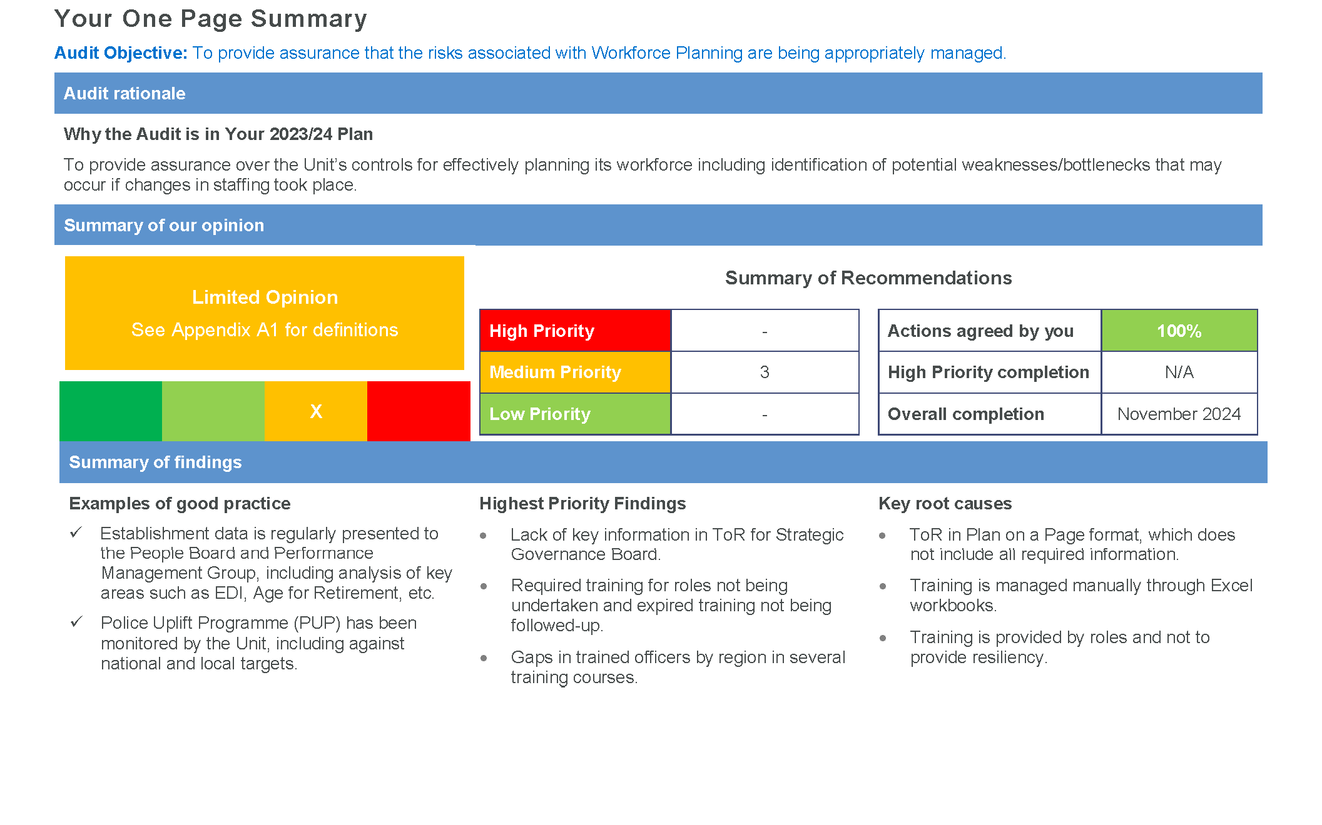

2. Latest Reports Issued – Summary of Findings

**Medium Term Financial Planning 24/25**

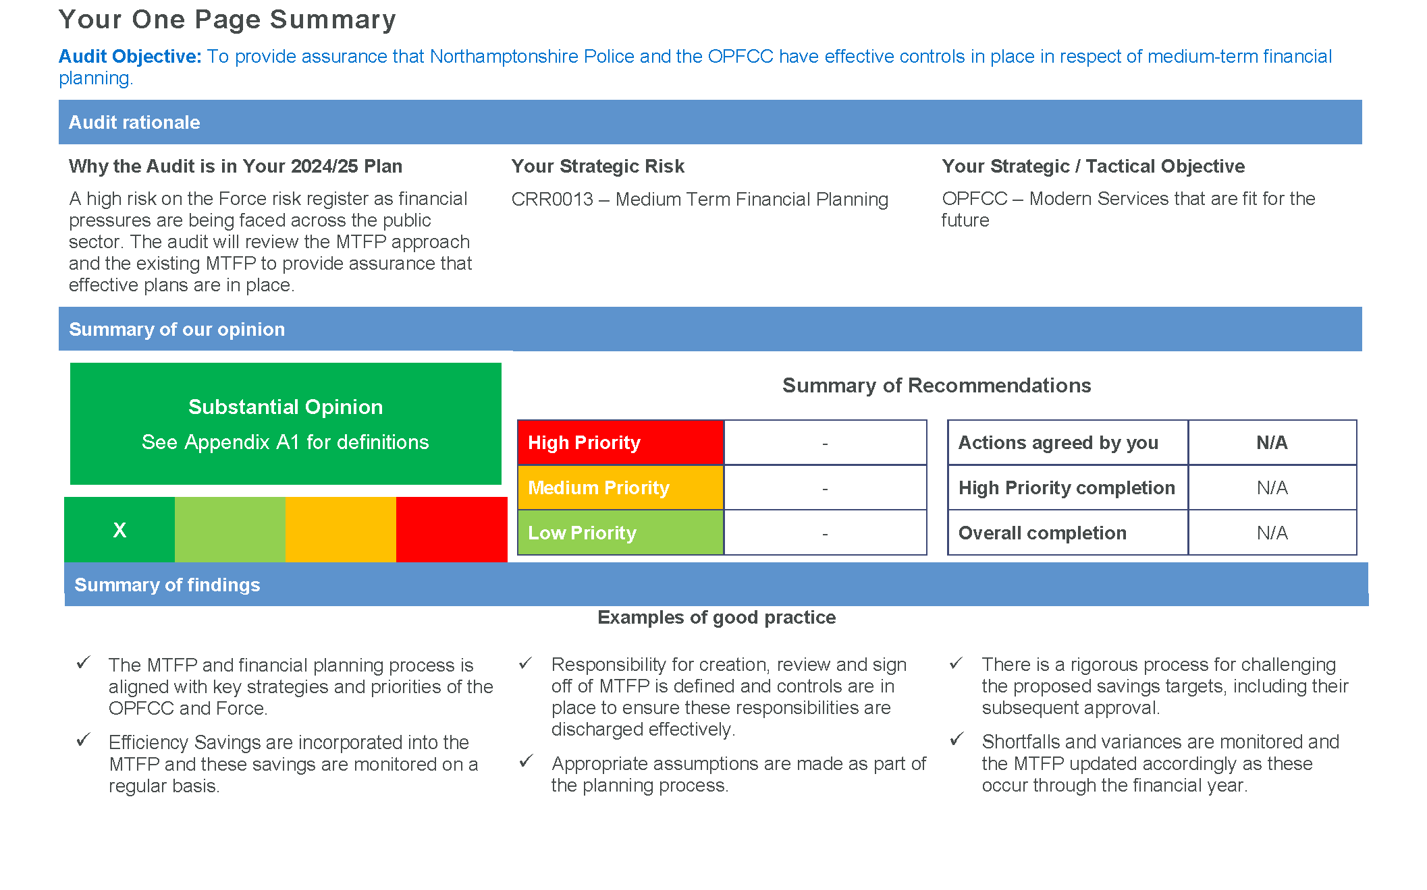

2. Latest Reports Issued – Summary of Findings

**NCFRA Safeguarding 24/25**

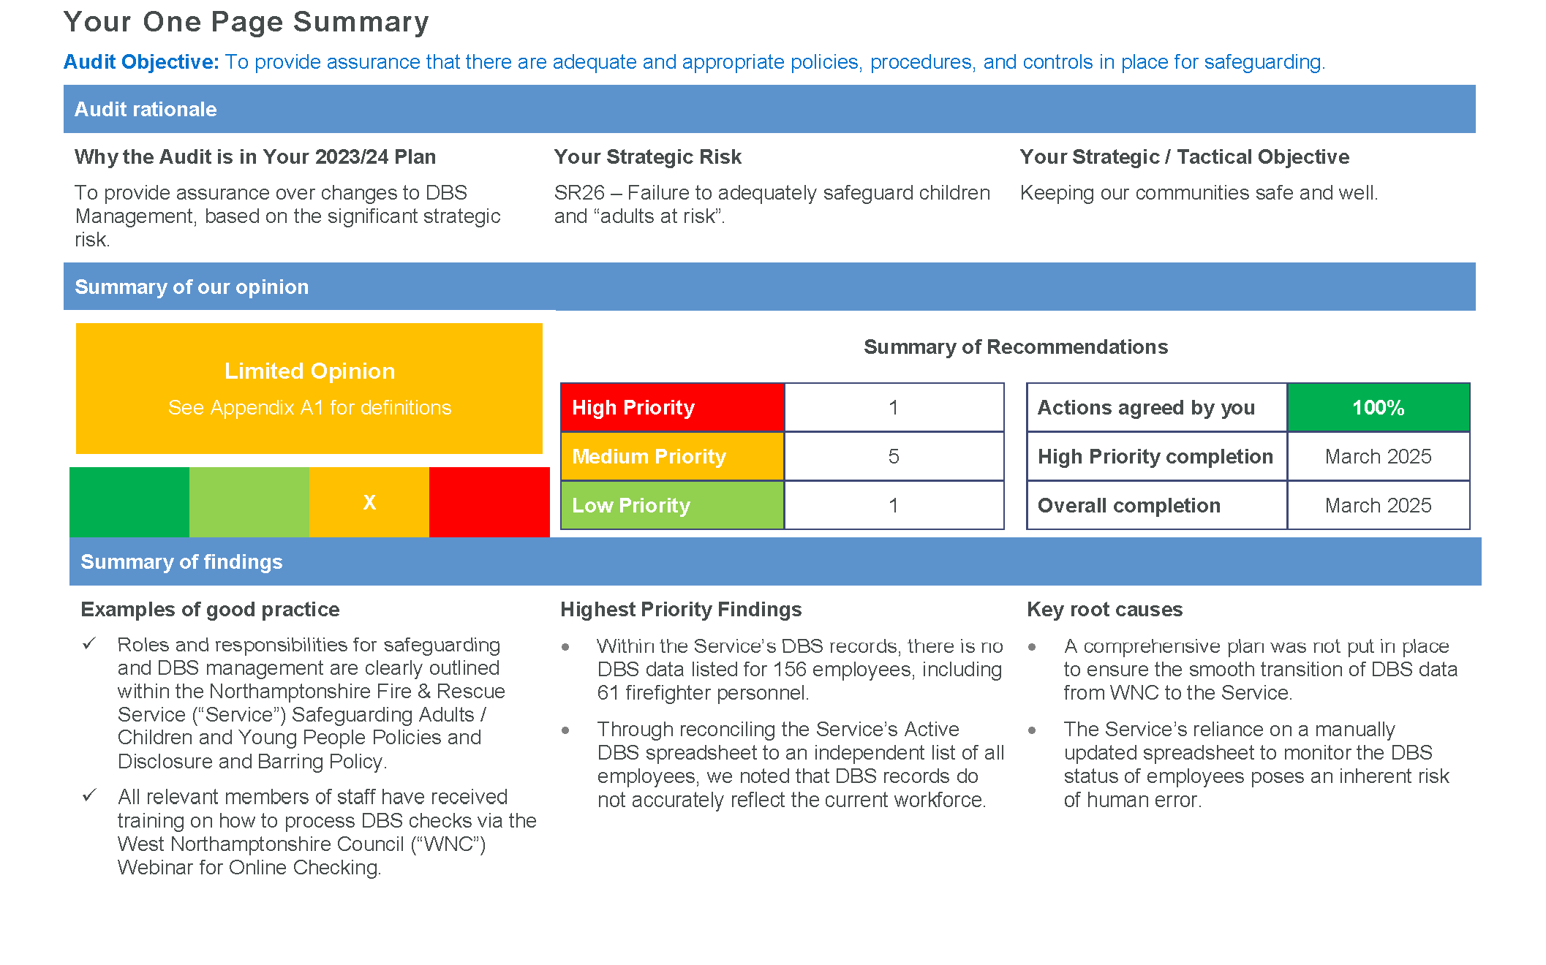

05. Overview of Internal Audit Plan 2024/25

The table below lists the status of all reviews within the 2024/25 Plan.

|  |  |  |  |  |  |  |  |  |  |  |
| --- | --- | --- | --- | --- | --- | --- | --- | --- | --- | --- |
| **Review** | **Original Days** | **Revised Days** | **Status** | **Start Date** | **AC** | **Assurance Level** | **Total** | **High** | **Medium** | **Low** |
| Office of the Police, Fire and Crime Commissioner for Northamptonshire and Northamptonshire Police | | | | | | | | | | |
| OPFCC Grants | 10 | 10 | Final Issued | 13-May-24 | Jul-24 | Substantial | 1 | - | 1 | - |
| Medium Term Financial Planning | 10 | 10 | Final Issued | 28-May-24 | Oct-24 | Substantial | - | - | - | - |
| Workforce Planning | 10 | 10 | In Planning | 09-Dec-24 |  |  | - | - | - | - |
| Business Continuity Follow Up | 5 | 5 | In Planning | 29-Jan-25 |  |  | - | - | - | - |
| Wellbeing | 10 | 10 | In Planning | 04-Feb-25 |  |  | - | - | - | - |
| Procurement & Supply Chain | 10 | 10 | In Planning | 06-Mar-25 |  |  | - | - | - | - |
| IT Audit | 15 | 15 | In Planning | TBC |  |  | - | - | - | - |
| Joint Audits | | | | | | | | | | |
| Asset Management | 10 | 10 | Draft Issued | 23-Jul-24 |  |  | - | - | - | - |
| Core Financials | 30 | 30 | Fieldwork | 16-Sep-24 |  |  | - | - | - | - |
| Estates Management | 20 | 20 | ToR Agreed | 06-Jan-25 |  |  | - | - | - | - |
| Governance | 10 | 10 | In Planning | 03-Feb-25 |  |  | - | - | - | - |
| **Totals** | **140** | **140** |  |  |  |  | **1** | **-** | **1** | **-** |

1. Overview of Internal Audit Plan 2024/25 (Cont.)

The table below lists the status of all reviews within the 2024/25 Plan.

|  |  |  |  |  |  |  |  |  |  |  |
| --- | --- | --- | --- | --- | --- | --- | --- | --- | --- | --- |
| **Review** | **Original Days** | **Revised Days** | **Status** | **Start Date** | **AC** | **Assurance Level** | **Total** | **High** | **Medium** | **Low** |
| Northamptonshire Commissioner Fire & Rescue Authority | | | | | | | | | | |
| Safeguarding | 10 | 10 | Final Issued | 18-Jul-24 | Oct-24 | Limited | 7 | 1 | 5 | 1 |
| Payroll | 15 | 15 | ToR Agreed | 11-Nov-24 |  |  | - | - | - | - |
| Data Quality | 10 | 10 | In Planning | 12-Dec-24 |  |  | - | - | - | - |
| Cyber Security | 15 | 15 | In Planning | TBC |  |  | - | - | - | - |
| **Totals** | **50** | **50** |  |  |  |  | **7** | **1** | **5** | **1** |

1. Overview of Collaboration Plan 2024/25

The table below lists the status of all reviews within the 2024/25 Collaboration Plan.

|  |  |  |  |  |  |  |  |  |  |  |
| --- | --- | --- | --- | --- | --- | --- | --- | --- | --- | --- |
| **Review** | **Original Days** | **Revised Days** | **Status** | **Start Date** | **AC** | **Assurance Level** | **Total** | **High** | **Medium** | **Low** |
| EMSOU Data Governance and Security | 10 | 10 | In Planning | 06-Jan-25 |  |  | - | - | - | - |
| EMSOU Wellbeing and EDI | 10 | 10 | In Planning | 20-Jan-25 |  |  | - | - | - | - |
| **Totals** | **20** | **20** |  |  |  |  | **-** | **-** | **-** | **-** |

1. Key Performance Indicators 2024/25

|  |  |  |  |
| --- | --- | --- | --- |
| **Number** | **Indicator** | **Criteria** | **Performance** |
| 1 | Annual report provided to the JIAC | As agreed with the Client Officer | July 2024 |
| 2 | Annual Operational and Strategic Plans to the JIAC | As agreed with the Client Officer | March 2024 |
| 3 | Progress report to the JIAC | 7 working days prior to meeting | Achieved |
| 4 | Issue of draft report | Within 10 working days of completion of exit meeting | 75% (3 / 4) |
| 5 | Issue of final report | Within 5 working days of agreement of responses | 100% (2 / 2) |
| 6 | Audit Brief to auditee | At least 10 working days prior to commencement of fieldwork | 50% (2 / 4) |
| 7 | Customer satisfaction (measured by survey)  “Overall evaluation of the delivery, quality and usefulness of the audit” Very Good, Good, Satisfactory, Poor or Very Poor | 85% average with Satisfactory response or above | 100% (1 / 1) |

07. Key Performance Indicators 2024/25 (Cont.)

|  |  |  |  |  |  |  |  |  |  |  |
| --- | --- | --- | --- | --- | --- | --- | --- | --- | --- | --- |
| **Review** | **Date of ToR** | **Start of Fieldwork** | **Days Notice (10)** | **Exit Meeting** | **Draft Report** | **Time from Close to Draft Report**  **(10)** | **Management Comments Received** | **Time to Received Comment s**  **(15)** | **Final Report Issued** | **Time Taken to Issue Final Report**  **(5)** |
| Office of the Police, Fire and Crime Commissioner for Northamptonshire and Northamptonshire Police | | | | | | | | | | |
| OPFCC Grants | 09-May-24 | 13-May-24 | 2 | 04-Jun-24 | 13-Jun-24 | 5 | 19-Jun-24 | 4 | 27-Jun-24 | 4 |
| Medium Term Financial Planning | 21-May-24 | 28-May-24 | 4 | 08-Jul-24 | 24-Jul-24 | 8 | 24-Jul-24 | 0 | N/A | |
| Workforce Planning |  | 09-Dec-24 |  |  |  |  |  |  |  |  |
| Business Continuity Follow Up |  | 29-Jan-25 |  |  |  |  |  |  |  |  |
| Wellbeing |  | 04-Feb-25 |  |  |  |  |  |  |  |  |
| Procurement & Supply Chain |  | 06-Mar-25 |  |  |  |  |  |  |  |  |
| IT Audit |  | TBC |  |  |  |  |  |  |  |  |
| Joint Audits | | | | | | | | | | |
| Asset Management | 27-Jun-24 | 23-Jul-24 | 18 | 19-Aug-24 | 30-Aug-24 | 6 |  |  |  |  |
| Estates Management | 21-Aug-24 | 02-Sep-24 |  |  |  |  |  |  |  |  |

07. Key Performance Indicators 2024/25 (Cont.)

|  |  |  |  |  |  |  |  |  |  |  |
| --- | --- | --- | --- | --- | --- | --- | --- | --- | --- | --- |
| **Review** | **Date of ToR** | **Start of Fieldwork** | **Days Notice (10)** | **Exit Meeting** | **Draft Report** | **Time from Close to Draft Report**  **(10)** | **Management Comments Received** | **Time to Received Comment s**  **(15)** | **Final Report Issued** | **Time Taken to Issue Final Report**  **(5)** |
| Joint Audits | | | | | | | | | | |
| Core Financials | 09-Aug-24 | 16-Sep-24 |  |  |  |  |  |  |  |  |
| Governance |  | 03-Feb-25 |  |  |  |  |  |  |  |  |
| Northamptonshire Commissioner Fire and Rescue Authority | | | | | | | | | | |
| Safeguarding | 27-Jun-24 | 18-Jul-24 | 15 | 05-Aug-24 | 30-Aug-24 | 12 | 17-Sep-24 | 12 | 19-Sep-24 | 2 |
| Payroll |  | 11-Nov-24 |  |  |  |  |  |  |  |  |
| Data Quality |  | 12-Dec-24 |  |  |  |  |  |  |  |  |
| Cyber Security |  | TBC |  |  |  |  |  |  |  |  |

08. Definitions of Assurance Levels and Recommendation Priority Levels

|  |  |
| --- | --- |
| **Definitions of Assurance Levels** | |
| Substantial Assurance | The framework of governance, risk management and control is adequate and effective. |
| Moderate Assurance | Some improvements are required to enhance the adequacy and effectiveness of the framework of governance, risk management and control. |
| Limited Assurance | There are significant weaknesses in the framework of governance, risk management and control such that it could be or could become inadequate and ineffective. |
| Unsatisfactory Assurance | There are fundamental weaknesses in the framework of governance, risk management and control such that it is inadequate and ineffective or is likely to fail. |

|  |  |  |
| --- | --- | --- |
| **Definitions of Recommendations** | | |
| High (Priority 1) | Significant weakness in governance, risk management and control that if unresolved exposes the organisation to an unacceptable level of residual risk. | Remedial action must be taken urgently and within an agreed timescale. |
| Medium (Priority 2) | Recommendations represent significant control weaknesses which expose the organisation to a moderate degree of unnecessary risk. | Remedial action should be taken at the earliest opportunity and within an agreed timescale. |
| Low (Priority 3) | Recommendations show areas where we have highlighted opportunities to implement a good or better practice, to improve efficiency or further reduce exposure to risk. | Remedial action should be prioritised and undertaken within an agreed timescale. |

Latest Reports Issued – Detailed Findings **A1**

EMSOU Workforce Planning 23-24

|  |  |  |  |  |
| --- | --- | --- | --- | --- |
| **Ref** | **Recommendation** | **Priority** | **Management Comments** | **Due Date** |
| 1 | ToR are used to define the aims, methods and reporting for key governance forums. These are essential documents that, alongside the wider governance framework, ensure an effective regime of oversight and review.  Audit has reviewed the ToR for the Strategic Governance Board and found several items of key information not included, such as:   * attendees and roles. * frequency of meetings. * standing agenda items. * reporting and escalation.   **The Unit should update the ToR for the Strategic Governance Board and Performance Management Group to include all key information, including:**   * **frequency of meetings.** * **attendees.** * **who chairs the meeting and relevant deputies.** * **standing agenda items.** * **where the board reports to and where they receive reports from.** | Medium | A review has been completed and relevant documents produced, however, these are going to be reviewed further. All meetings within EMSOU are currently being reviewed now that we have had a change in Command and ACC Coulson has become the Regional ACC over EMSOU.  *ACC Diane Coulson – Head of EMSOU* | 30 September  2024 |
| 2 | Training courses and certifications undertaken by police staff and officers often are for a certain timeframe or related to specific legislation that is regularly reviewed and updated. Therefore, these can expire and should be tracked to ensure that they do not elapse or that training is renewed at the earliest opportunity.  For training monitored using the EMSOU, Intelligence and/or OST trackers, audit has noted:   * several instances where required training has not been booked (i.e. for taser training). * several instances where training has expired and there is no evidence that a refresher/follow-up course has been booked. * expiration dates for certifications tracked for Intelligence are added as notes and therefore are not easily monitored for compliance. | Medium | A large piece of work is currently being undertaken to ensure that thew right IT access is role specific. As part of this work, a training matrix will also be completed to ensure that we have the right people with the right skills in the right roles – this will include ensuring that individuals training is kept up to date.  *Katy Harrington – HR Business Partner; T/DSU Kerry Webb – Head of ROCU Intelligence; and, Lauren Cunliffe – Digital, Data and Technology Lead* | 30 November  2024 |

EMSOU Workforce Planning 23-24

|  |  |  |  |  |
| --- | --- | --- | --- | --- |
| **Ref** | **Recommendation** | **Priority** | **Management Comments** | **Due Date** |
| 2 | **The Unit should ensure that expiration dates are clearly recorded for training courses and that these are monitored to ensure training courses are booked in before this date or to minimise the elapsed period.**  **To assist in this, the Unit should investigate the implementation of an L&D system to aid in tracking and booking courses, including sending reminders to officers/staff where certifications are nearing expiration and requiring action of booking a course to be taken.**  **Where training is required for a role, the Unit should ensure that this is either be booked on before the role is taken up or as soon as feasibly possible.** | Medium |  | 30 November  2024 |
| 3 | Organisations with a strong training culture will review training, needs and staff views to determine training requirements. While the Unit undertakes staff surveys covering training and holds information regarding the training undertaken by staff and officers in different regions, audit has noted several gaps in training provision:   * there are no National Intelligence Telecoms (NIT) trainer officers. * the North region has the only two officers trained for Drone operations. * there are no officers with Tier Three Advanced Suspect, Tier Three Advanced Witness, Tier Three Interview or Tier Five Interview training in the South region. * the only Tier Five Interview trained officer is in the North region. * only the North region has officers who are E1 Covert Method of Entry, E2 Vehicle Course or Q7 Covert Vehicle trained.   While there may be operational reasons for these differences in regions, there are also issues with the number of trained officers for resiliency purposes.  **The Unit should review these and any other gaps in training and determine whether additional training should be undertaken to provide sufficient coverage across the Unit, to provide resilience for key skills, or if there is an operational reason.** | Medium | This has been spotted in the PEEL & Thematic review, more stringent checks to be put in place in line with Forces.  *Katy Harrington – HR Business Partner* | 30 November  2024 |

Medium Term Financial Planning 24-25

No recommendations were raised as part of this audit.

NCFRA Safeguarding 24-25

|  |  |  |  |  |
| --- | --- | --- | --- | --- |
| **Ref** | **Recommendation** | **Priority** | **Management Comments** | **Due Date** |
| 1 | Section 2 of the Rehabilitation of Offenders Act 1974 allows fire and rescue services to perform a minimum of a standard DBS check for all representatives.  The Service’s Disclosure and Barring Policy outlines that a minimum of a standard DBS check is required for all staff and volunteers. Operational employees, who through the course of incident responses or targeted prevention / protection activities, carry out work with vulnerable individuals require an Enhanced DBS check. Re-checks are required every three years. The HR Projects Advisor maintains the Active Master DBS spreadsheet to record DBS data for employees, including certificate issue date, expected re-check date and any disclosures or bars on an individual.  We conducted data analysis on the Active Master DBS spreadsheet in order to confirm whether all employees possessed an in date DBS. We noted the following:   * For 156 employees no DBS data was listed, including 61 firefighter personnel. * Eight employees were recorded as having up to date DBS checks however, there was no record to indicate whether they had disclosures or bars. * Three employees were recorded as having DBS checks without a re-check being performed.   The HR Projects Advisor informed us that when the HR Data Hub Team inherited the responsibility for managing DBS checks from West Northamptonshire Council (WNC) in April 2024, WNC did not provide the team with DBS information for a number of employees. Due to this, the Service implemented two phases of DBS applications to obtain DBS checks for those employees for whom it did not possess DBS information. The HR Data Hub Team is currently in the process of phase 2 and expects to have received DBS information from WNC for the outstanding 156 employees by the end of July 2024.  The eight employees DBS checks were conducted prior to April 2024 and the HR Data Hub Team is also waiting for information from WNC on whether each possesses disclosures or bars. | High | Final checks with WNC for those outstanding DBS checks to ensure no records held, prior to undertaking new DBS checks, to take place at the beginning of September.  Outstanding DBS checks to commence as soon as possible.  *June Withey – Head of Workforce Planning* | 31 March  2025 |

NCFRA Safeguarding 24-25

|  |  |  |  |  |
| --- | --- | --- | --- | --- |
| **Ref** | **Recommendation** | **Priority** | **Management Comments** | **Due Date** |
| 1 | We have identified control weaknesses around the Service’s management of DBS’s requiring a re-check which we have outlined in **Recommendation 4**.  **The Service should ensure it prioritises the completion of DBS checks for the 61 firefighter personnel at the earliest opportunity. Following this, the Service should obtain DBS checks for the remaining 95 employees.** | High |  | 31 March  2025 |
| 2 | The HR Projects Advisor is responsible for maintaining the Active Master DBS spreadsheet (master spreadsheet), which is used to monitor the DBS status of the Service’s workforce. Upon receiving confirmation of an employee’s DBS, the master spreadsheet is updated to record the date of issue and expected re-check date.  The HR Projects Advisor receives weekly bulletins from the Service Information Team detailing starters and leavers. The bulletins are reconciled to the master spreadsheet to ensure that the master spreadsheet is up to date and includes all of the Service’s employees.  We conducted a reconciliation between a report of all employees extracted from Unit 4 (enterprise resource planning system) and the master spreadsheet using employee brigade numbers to determine whether the master spreadsheet included all of the Service’s employees at the time of audit.  We noted that 20 employees were included on the Unit 4 report but not listed within the master spreadsheet. We queried these discrepancies with the HR Projects Advisor and were informed of the following:   * 14 were due to employee brigade numbers being incorrectly stated within the master spreadsheet. * One employee was initially a non-starter but later joined the Service which caused a delay in the HR Advisor being notified. * Two employees had been removed from the master spreadsheet as leavers however, had in fact only left their dual contract. * Three employees were external members of staff who did not require a DBS. | Medium | Mechanism implemented to ensure monthly checks of active employees against outstanding DBS checks. To commence with August end of month reporting and be embedded in the coming months.  *June Withey – Head of Workforce Planning* | 01 December  2024 |

NCFRA Safeguarding 24-25

|  |  |  |  |  |
| --- | --- | --- | --- | --- |
| **Ref** | **Recommendation** | **Priority** | **Management Comments** | **Due Date** |
| 2 | **The Service should ensure that reconciliations are conducted between the master spreadsheet and an independent report of employees on a frequent basis (i.e. monthly) in order to identify data discrepancies and employees missing from the spreadsheet.** | Medium |  | 01 December  2024 |
| 3 | The Service possesses a NFRS Employee For Checks spreadsheet which is used to monitor in progress DBS applications. Within the spreadsheet, HR Business Support Advisors record the date the DBS application was made and verified, as well as the result. Comments are added to outline any reasons for delays in processing the DBS, such as the employee failing to provide ID.  Once the DBS check is complete, the issue date and certificate number is added to the NFRS Employee For Checks spreadsheet. The HR Projects Advisor then transfers the issue date and certificate number to the Active Master DBS spreadsheet, which is used to monitor DBS compliance across the entire workforce.  We compared the most recent DBS disclosure received from WNC to the Active Master DBS spreadsheet for a sample of twenty employees, in order to determine whether the issue date, expected re-check date and content status had been accurately recorded within the spreadsheet.  We noted the following:   * One employee possessed no content as per the DBS disclosure email from WNC however, the employees content status was not recorded within the master spreadsheet. * One employees DBS was recorded within the master spreadsheet as having been issued 177 days after the actual issue date. This meant that the DBS would not appear to be due for recheck until 177 days later than required by the policy.   The HR Projects Advisor informed us that these discrepancies were due to errors made by staff members when manually updating DBS data. The Service’s current process is to transfer data from the DBS disclosure email to two separate | Medium | Access to GCON4 has been granted and expires at the end of October, so bulk uploads are to be completed before this date. This has been prioritised after the findings of this audit.  *June Withey – Head of Workforce Planning* | 01 November  2024 |

NCFRA Safeguarding 24-25

|  |  |  |  |  |
| --- | --- | --- | --- | --- |
| **Ref** | **Recommendation** | **Priority** | **Management Comments** | **Due Date** |
| 3 | process is to transfer data from the DBS disclosure email to two separate spreadsheets which poses an inherent risk of human error.  The Service procured Unit 4 (Enterprise resource planning system) in April 2024 and plans to conduct a bulk upload of DBS data by August 2024. The Service anticipates that the use of this system will increase productivity by automating manual tasks and also reduce the risk of human error.  **In the interim period before Unit 4 becomes live, the Service should:**   1. **Implement data validation checks to ensure that data has been accurately transferred from the DBS disclosure email to the spreadsheets. This could include conducting data analysis on the spreadsheets to identify missing or erroneous fields. Spot checks could also be conducted on a sample of DBS checks each month to verify the accuracy of data transferred to the spreadsheets.** 2. **Consider whether the current process of transferring data to two separate spreadsheets is the most efficient and effective approach, or if there are alternatives that could reduce the risk of error.**   **Following the implementation of Unit 4, the Service should ensure that the system is set up to automate tasks where possible to reduce manual input and includes robust data validation checks.** | Medium |  | 01 November  2024 |
| 4 | We reviewed the DBS Policy in order to confirm whether it adequately outlined a process for ensuring DBS re-checks are conducted every three years in line with the Service’s policy requirement.  The policy includes high level stages such as that HR must inform the individual’s Line Manager when a re-check is required and escalate concerns to the Line Manager if the individual fails to comply. If an individual continues to refuse, HR’s disciplinary investigation route must then be followed.  Whilst a re-check process is in place, timescales have not been assigned to govern when each stage of the process should be conducted. For instance, the guidance does | Medium | Once Bulk uploads are completed as part of recommendation 3, we will be implementing the notification of expiring DBS Checks to the HR Transactional team.  *June Withey – Head of Workforce Planning* | 31 December  2024 |

NCFRA Safeguarding 24-25

|  |  |  |  |  |
| --- | --- | --- | --- | --- |
| **Ref** | **Recommendation** | **Priority** | **Management Comments** | **Due Date** |
| 4 | not specify the timeframe within which initial contact should be made with the Line Manager. Timeframes for when additional escalation steps should be initiated are also not stated.  By setting clear deadlines, the Service can ensure that those involved in the process are aware of their responsibilities and when tasks should be completed. This can aid in preventing delays and maximising the probability that re-checks are conducted prior to the Service’s three-year deadline.  This observation was supported by our sample testing, where we noted inconsistent practices for three of our five re-check samples, which we have listed below:   * For three samples, initial contact was not made with the Line Manager until between 79 and 122 days after the end of the three-year period. * For two of these samples, an additional chaser email was sent 8 and 43 days after initial contact was made. A chaser email was not sent for the remaining sample.   Although the Service was not provided with the DBS data for these employees by  WNC until after the end of the three-year period, the additional stages of the re-check process were applied inconsistently once notification was received.  **The Service should:**   1. **Establish clear timeframes for each stage of the DBS re-check process, including when initial contact should be made, when reminders should be sent and when escalation steps should be initiated.** 2. **Consider implementing an automated system that sends reminders when a DBS re-check is due following the implementation of Unit 4. This could help in reducing delays and ensuring timely compliance.** 3. **Ensure that all individuals involved in the process are aware of their responsibilities and the importance of timely DBS re-checks.** | Medium |  | 31 December  2024 |

NCFRA Safeguarding 24-25

|  |  |  |  |  |
| --- | --- | --- | --- | --- |
| **Ref** | **Recommendation** | **Priority** | **Management Comments** | **Due Date** |
| 5 | The Service requires its employees to complete National Chief Fire Council (NFCC) safeguarding training. The level of training required is determined by the likelihood that an employee will come into contact with a vulnerable individual, based on their role.  As per the Service’s Safeguarding Adults / Children and Young People Policies, NFCC level one training should be provided to all staff and volunteers who come into contact with vulnerable individuals. Supervisory managers across the Service should complete NFCC level two. Designated leads should complete NFCC level four. Staff are required to recomplete the training at a two year frequency.  We sought to confirm how oversight is maintained of the number of employees who are compliant with the Service’s training requirements.  We observed that completion rates for NFCC level one training are monitored for all employees by the Competency Framework Team through Red Kite (Personal Development System).  Despite this, we were informed by the Prevention Team Leader that Red Kite does not currently possess the functionality to create a central log of all employees who have completed the additional NFCC training modules (levels two and four). Completion of these modules is instead currently recorded in an individual’s personal development record, which is only visible to the Line Manager.  The Prevention Team Leader informed us that the Service intends to build new modules into Red Kite to allow the additional NFCC modules to be recorded within an individual’s safeguarding competency profile. This should then allow the Service to monitor completion rates of the NFCC additional modules across the workforce.  **The Service should:**   1. **Prioritise building new modules into Red Kite which facilitate centralised tracking and monitoring of all NFCC training levels.** 2. **Consider establishing an interim process for centrally recording and monitoring the completion of additional NFCC training modules. For example, through obtaining employee training records from Line Managers** | Medium | The competency framework for NFRS staff has now been agreed and can be mapped into RedKite to improve recording of competency and the alignment of specific training modules to different competency levels.  This will include those training modules provided internally, from NFCC and from the Local Safeguarding Boards for Adults and Children. These will be provided by the Safeguarding Leads within the Prevention team.  This work will be added to action plans for the Training Department and will be undertaken by the Competency Framework Manager and Competency Systems Coordinator.  *AM Niel Sadler – Acting Area Commander (Operational Support)* | 31 December  2024 |

NCFRA Safeguarding 24-25

|  |  |  |  |  |
| --- | --- | --- | --- | --- |
| **Ref** | **Recommendation** | **Priority** | **Management Comments** | **Due Date** |
| 5 | **example, through obtaining employee training records from Line Managers and recording employee completion rates within a spreadsheet.**  **3. Conduct regular audits to ensure that all employees have completed the required level of training.** | Medium |  | 31 December  2024 |
| 6 | The Service requires all staff and volunteers who come into contact with vulnerable people to complete the NFCC level one safeguarding training module which is accessible via the Moodle portal. Staff are required to retake the module at a two year frequency.  Completion rates for the module are monitored by the Competency Framework Team through Red Kite (Personal Development System). A reminder email is generated automatically based on the training renewal date.  We reviewed an extract of the completion rates and noted that 95% of staff had completed the training. Three staff were overdue to retake the training and 24 staff were yet to complete the training.  We selected a sample of two staff members who were overdue to retake the training and three who had not completed the training and requested evidence to support that they had been appropriately reminded by the Competency Framework Team. We noted the following:   * Two staff members were notified that the training was overdue one day after the two-year period ended (24/06/2024). However, after the initial notification no further reminder emails / escalations were conducted. The training was overdue by 41 days at the time of audit. * The three staff members who are yet to complete the training have not received any reminder emails / escalations. Each of them joined the Service between the 24/06/2024 and 15/07/2024. The current process is to set the training renewal date at two years from the employee’s start date. As such, these employees would not receive a reminder email until 2026 despite having never completed the training. | Medium | This work will cut across Training and Workforce Development and so will be allocated to the two teams to work together. This will ensure that processes for induction training, initial and renewed competency sign off are working effectively.  *AM Niel Sadler – Acting Area Commander (Operational Support)* | 31 December  2024 |

NCFRA Safeguarding 24-25

|  |  |  |  |  |
| --- | --- | --- | --- | --- |
| **Ref** | **Recommendation** | **Priority** | **Management Comments** | **Due Date** |
| 6 | We were informed by the Competency Systems Co-ordinator that a robust process is not in place to continually chase individuals because following the initial automated Red Kite notification, any further correspondence has to be initiated manually. Due to the number of training modules staff have to complete across the Service, it is considered unachievable to continually chase individuals manually.  The Competency Systems Co-ordinator was in the process of finalising a proposal paper at the time of audit to manually update the renewal dates for mandatory training so that when new staff are enrolled, the renewal date is set for between one to three months of the employee’s start date. This is to ensure that the employee receives the first chaser notification at a much sooner date.  **The Service should:**   1. **Investigate whether the Red Kite system could be enhanced to automate follow-up reminder emails at regular intervals until the training is completed.** 2. **Adjust the process so that the training renewal date is set within the first few months of employment for new starters. This is to ensure that where training is incomplete, employees receive the reminder email within the first few months of employment instead of the current two year frequency.** 3. **Implement an escalation process where if a staff member does not complete the training after a certain number of reminders, Line Managers are notified and disciplinary procedures are carried out following repeat non- compliance.** | Medium |  | 31 December  2024 |

We have also raised one Low priority recommendation as part of this audit:

* The Service should ensure that there is regular reporting of performance indicators that cover processing times for DBS requests and provide an overview of DBS’s close to / requiring a re-check, such as the average time taken to process a DBS check; the number / % of DBS checks that require a re-check in less than a month; and, the number / % of DBS checks requiring a re-check.

Contact

**Forvis Mazars**

**David Hoose**

Partner

Tel: +44 7552 007 708

[david.hoose@mazars.co.uk](mailto:david.hoose@mazars.co.uk)

**Sarah Knowles** Internal Audit Manager Tel: +44 7917 084 604

[sarah.knowles@mazars.co.uk](mailto:sarah.knowles@mazars.co.uk)

Forvis Mazars is the brand name for the Forvis Mazars Global network (Forvis Mazars Global Limited) and its two independent members: Forvis Mazars, LLP in the United States and Forvis Mazars Group SC, an internationally integrated partnership operating in over 100 countries and territories. Forvis Mazars Global Limited is a UK private company limited by guarantee and does not provide any services to clients. Forvis Mazars LLP is the UK firm of Forvis Mazars Global.

Visit forvismazars.com/global to learn more about the global network.

© Forvis Mazars 2024. All rights reserved.

|  |  |  |
| --- | --- | --- |
|  |  |  |
|  |  | ✓ |
|  |  | ✓ |
|  |  | ✓ |