Corruption and Fraud Controls and Processes

Author: Nick Alexander

Chief Officer Sponsor: Assistant Chief Officer (Enabling Services)

Date: December 2024

Version: 1

1. Purpose
   1. This report provides updated details of the robust processes and procedures Northamptonshire Police currently has in place to identify and mitigate the likelihood of fraud. These complement and support the national measures that exist for scrutiny of the public sector and managing integrity across Police Forces in England & Wales.
2. Recommendation
   1. To note the content of the report.
3. National Standards - College of Policing: Code of Ethics
   1. The *Code of Ethics* was updated and reintroduce by the College of Policing in its role as the professional body for policing in 2024. The ‘Code of Ethics’ is not a statutory Code of Practice, however, it is underpinned by the ‘[Code of Practise for Ethical Policing](https://www.college.police.uk/ethics/code-of-practice)’, which relates specifically to chief officers in the discharge of their functions. In discharging any function to which this Code of Practice relates, chief officers must have regard to this Code of Practice pursuant to section 39A(7). This Code of Practice does not alter the existing legal powers or responsibilities of any Police and Crime Commissioner (PCC or PFCC’s) or equivalent, chief officer of police, or other person.

It does not alter the statutory basis or provisions of the [Police Reform Act 2002](https://www.legislation.gov.uk/ukpga/2002/30/contents) and associated regulations, including – but not limited to the, [Police (Conduct) Regulations 2020](https://www.legislation.gov.uk/uksi/2020/4/made), [&](https://www.legislation.gov.uk/uksi/2020/2/made) [The Policing Protocol Order 2011 (section 23)](https://www.legislation.gov.uk/uksi/2011/2744/schedule/paragraph/23/made) and this came into effect on 6 December 2023.

* 1. The code applies to all Policing members, including Officers, Staff, PCSO’s, Specials and Volunteers.
  2. The purpose of which is to set out the actions that Chief Officers should carry out to ensure that they lead an ethical culture, where staff are supported and directed to use the ethical policing principles in decision making and to demonstrate professional behaviour. It also describes what needs to be done to proactively and positively identify – and respond to – misconduct and corruption when it occurs.
  3. The *Code* of Practise begins by clearly laying out the expectations of Chief Officers in
* **Ensuring ethical and professional behaviour,** Chief officers should lead and take action to ensure ethical and professional behaviour within their force.

Fig 1

* **Challenging unprofessional behaviour,** Chief officers should take action to ensure that staff welfare is understood and managed within their force.
* **Staff Welfare,** Chief officers should take action to ensure that unprofessional behaviour is challenged within their force.
* **Ensuring Openness and Candour,** Chief officers have a duty to ensure openness and candour within their force.
* **Continuing Professional Development,** Chief officers should take action to ensure CPD within their force.
* **Recognising and responding to misconduct,** Chief officers should take action to respond to misconduct within their force.
  1. The [*Code*](https://www.college.police.uk/ethics/code-of-ethics/principles) is split into two sections:

1. Ethical Policing Decisions, which sets out that;

“The ethical policing principles are a series of guiding statements that should be used to help people in policing do the right things, in the right way, for the right reasons.”

**These are**

* **Courage –** making, communicating and being accountable for decisions and standing against anything that could bring our profession into disrepute.
* **Respect and empathy –** Encouraging, listening to and understanding the views of others, and seeking to recognise and respond to physical, mental and emotional challenges that we and other people may face.
* **Public Service –** working in the public interest, fostering public trust and confidence, and taking pride in providing an excellent service to the public.

**And is summarised by the College as**

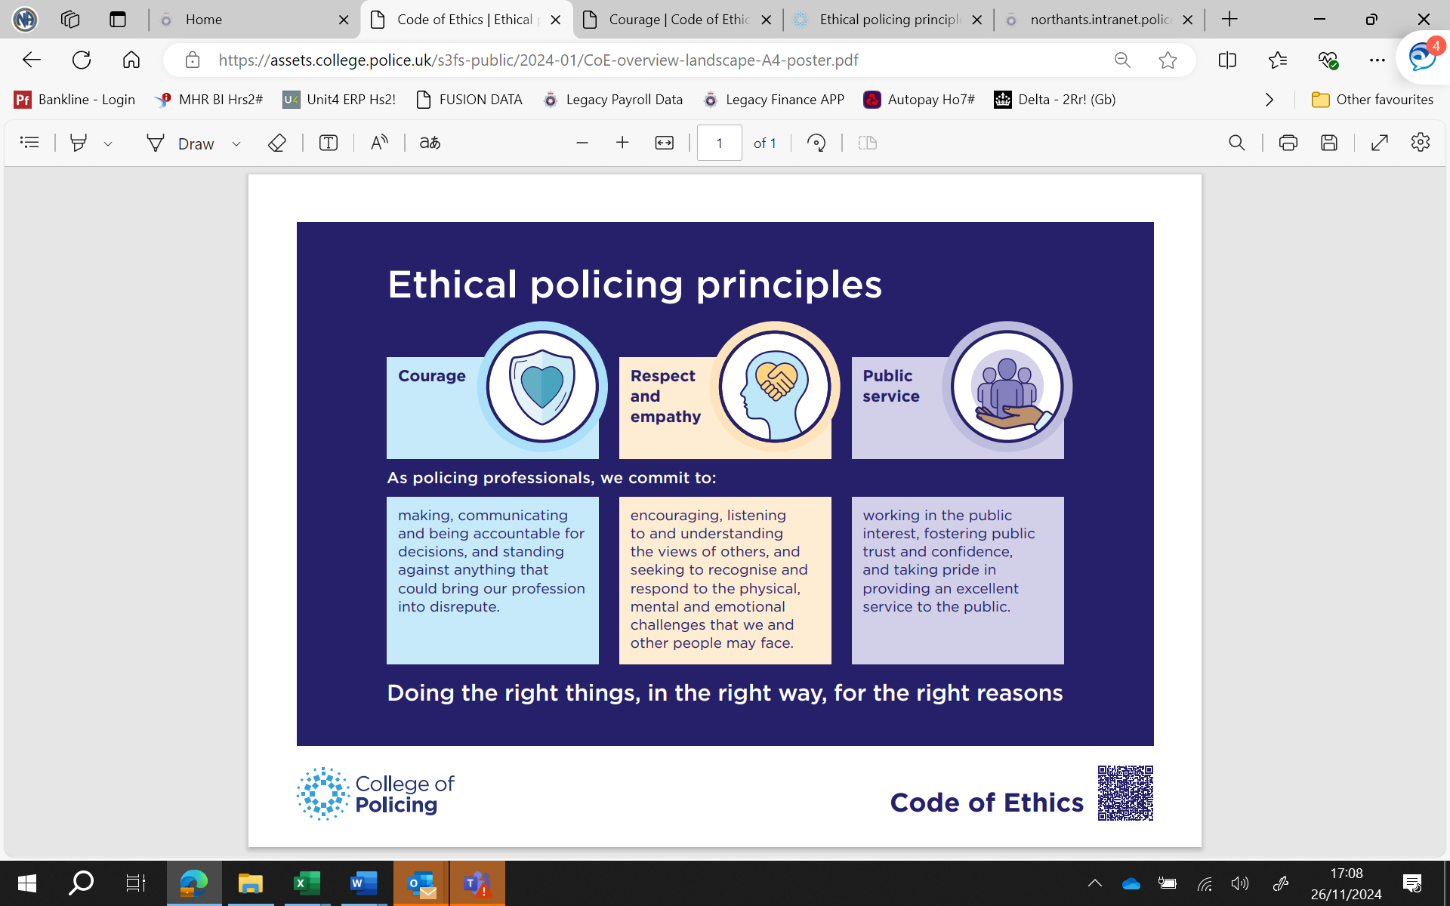

1. The second section is Guidance for ethical and professional behaviour in policing, which sets out that;

“as a result of being part of the policing profession, higher expectations are placed on us compared to the general public. As policing professionals, more attention is likely to be drawn to any misuse of our position or any failure to meet the expectations of our profession.

We uphold and promote the reputation of the police service by acting lawfully and in a way that demonstrates fairness and respect, policing with integrity, trust, confidence and legitimacy (in line with the [College of Policing leadership standards](https://www.college.police.uk/career-learning/leadership/leadership-standards)).“

**The public interest and trust,** thinking about how our actions can be interpreted, acting selflessly, act in truth, do not make false statements, do not use your position for gain and ensuring professional behaviour and language.

**Doing our best,** including acting diligently, promoting a positive professional image, being conscious of the impact of our behaviour, not fearing in conducting our professional duties and taking ownership.

1. National Fraud Initiative
   1. Since 1996 the Audit Commission has run the National Fraud Initiative (NFI), an exercise that matches electronic data within and between public and private sector bodies to prevent and detect fraud. This includes Police Forces and OP(F)CCs, Local Probation Trusts and Community Rehabilitation Companies, Fire and Rescue authorities as well as local councils and a number of private sector bodies.
   2. Fraudsters often target different organisations at the same time, using the same fraudulent details or identities. The NFI can help tackle this by comparing information held by organisations to identify potential fraud and overpayment.
   3. A match does not automatically mean fraud. Often, there may be an explanation for a data match that prompts bodies to update their records and to improve their systems.
   4. Although not mandatory, central government departments, agencies and arm’s length organisations are encouraged to submit datasets on payroll and trade creditors.
   5. The use of data for NFI purposes continues to be controlled to ensure compliance with data protection and human rights legislation.
   6. The main categories of fraud identified by the NFI in England relate to pensions, council tax single person discounts and housing benefit. The latest national report indicated over £416m of detected fraud, broken down by risk area as follows. The full report is available in Appendix 2.

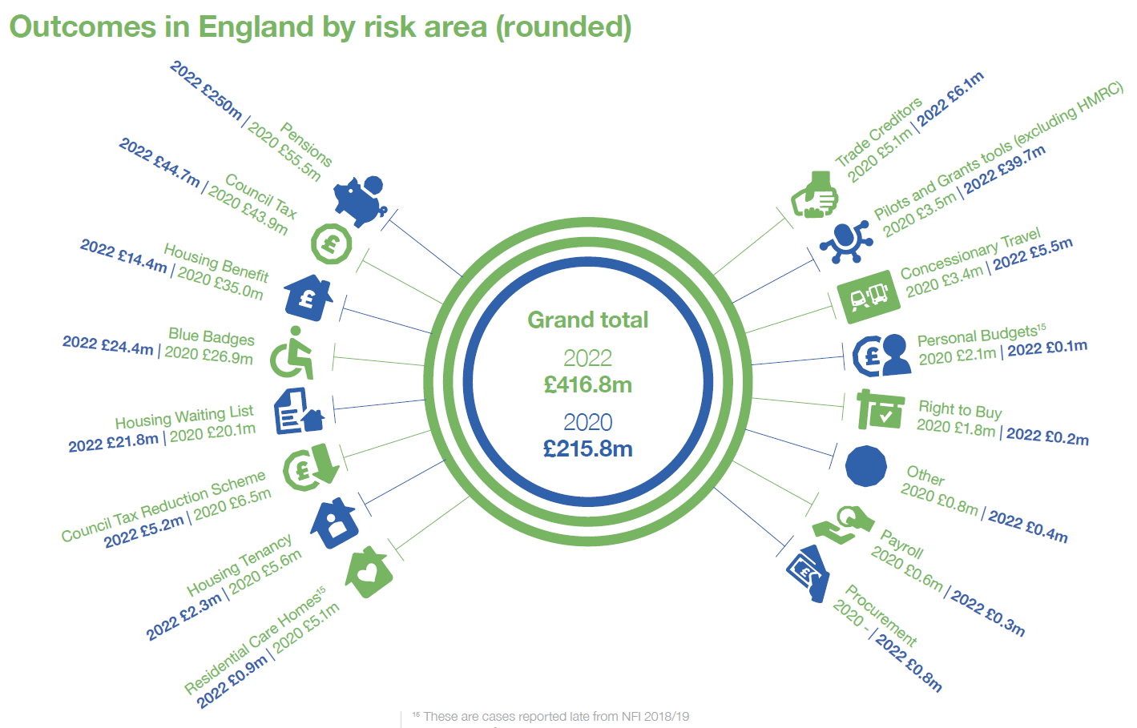

* 1. Data matching showing little or no fraud and error can provide bodies with assurances about the effectiveness of their control arrangements. It also strengthens the evidence for the body’s annual governance statement.
  2. NFI data matching plays an important role in protecting the public purse against fraud. Northamptonshire Police has run the NFI exercise every two years to help detect and prevent fraud for many years.
  3. The 2024/25 review is currently in progress and the following submissions have been completed and are awaiting National review and matching exercises. We expect the outcomes to be available within 2025;
* Payroll, bank details and pay
* Suppliers and payments
* Pension payments
  1. The latest audit to be published remains the previous reported 2023 results, which highlighted 200 items for review (see Appendix 3) but following investigations, none were found to be a result of fraud. Only 2 items ultimately required action. The areas relevant to us and examples of items for review are as follows.
  2. Creditors – it was highlighted if any were set up on more than one reference or if multiple suppliers had the same bank account details. On investigation, all were justified and appropriate.
  3. Duplicated payments – examples of recurring payments were provided. Upon checking, most of these were found to be genuine. eg. Quarterly charges, bacs failures paid by other means. There were 2 genuine duplicate payments that were subsequently corrected/recovered.
  4. Debtors – multiple debtors to the same address. Upon investigation, all were justified and necessary. eg. Government departments, Barristers all based at the court.
  5. VAT discrepancies – all but one had already been addressed as part of the VAT return monthly checks and reconciliation. The remaining error was subsequently corrected.
  6. No issues of concern were identified with pensions or payroll. In the previous NFI exercise, there was an example where it appeared that one of our officers was also being paid by another police force. This was investigated by the finance team and PSD and found to be an administrative error on the part of the Metropolitan Police. It was addressed as required and no further action was necessary.

1. Local Strategies – Policies and Procedures
   1. Northamptonshire Police have re-invigorated it’s policies, procedures and staffing to ensure that following the findings of the Angiolini Report and internal misconduct cases its vetting standards are now at their highest levels. Furthermore, all senior Police Staff and Officers qualifications and vetting have been revisited.
   2. All staff and volunteers must pass a rigorous vetting processes, which may now include additional background and home checks before they are allowed to commence work or use data from within Northamptonshire Police.
   3. Strategies, policies and procedures are in place locally to promote and enforce national standards.

These include ‘Standards of Professional Behaviour’. During the year there have been campaigns to promote awareness and understanding of these, through the communication known as the ‘Standards’, focussed on each standard in turn. This involved pushing email briefings AND national and local training modules to all officers and staff, with a direction to encourage discussion and work through case studies in departmental and team meetings.

The subjects for the year have included;

* Upstander, which aims to equip police officers and staff with the necessary tools to become upstanders, promoting positive change within the organisation and our communities and enabling them to call out behaviours.
* A new code of Ethics ‘Doing the right things, in the right way for the right reasons’;
* Unconscious Bias;
* Managing Challenging Behaviours and Having Courageous Conversations

All of which are designed to equip people to be able to challenge behaviours and report conduct that falls below expected levels.

There have also been a number of direct engagement days across the Service to directly address expected standards chaired by Chief Officers.

* 1. The Professional Standards Dept produces a e-magazine, called “The Standard” which covers a range of topics relating to ethics and professional standards, sharing good practice and promoting reporting channels for inappropriate behaviours. (Latest edition is at Appendix 4)
  2. The Professional Standards Dept (PSD) have been working with our own communications department and an external Communications Agency to identify cultural issues to tackle concerning behaviours. A new Standards Campaign designed to educate staff and officers to prevent behaviours that fall below what we expect and robustly address unacceptable conduct has been issued and a Single Points of Contact from within PSD to each of the stations across the force has continued in order to break down barriers and myths in relation to PSD to promote confidence in reporting and identifying patterns of unacceptable behaviours to ensure early intervention.
  3. A number of local policies and procedures are in place which relate to managing integrity of police officers and staff in Northamptonshire to which all individuals are required to adhere. These include:
* ACPO Guidance on Business Interests
* Business Interest Policy
* Confidential Reporting Policy
* Expenses & Allowances Policy
* Fraud Investigation Policy
* Gifts and Hospitality Policy & Procedure
* Misconduct Outcomes Publications
* Notifiable Associations Procedure
* Overtime (Police Officers) Procedure
* Police Staff Misconduct Policy & Procedure
* Procurement Card Policy
* Service Confidence Procedure
* Social Media Policy
* Substance and Alcohol Misuse Policy
* Vetting Policy and Guidance
* Whistleblowing Policy – supported by the Bad Apple reporting system
* Your Personal Finances Policy
  1. All policies, procedures and guidance are available to staff on the internal website and subject to regular review points.
  2. The Force employs a Corruption Prevention Officer to work with internal stakeholders and external partners to improve preventative measures. This has included implementing Integrity Health Checks for all staff and officers that covers a number of areas including business interests, notifiable associations and financial status. The purpose of this is to reduce organisational vulnerability and enhance personal welfare. The Professional Standards Dept works with HR to ensure this is now included in PDRs to manage and monitor.
  3. Professional Standards and Finance now also discuss matters of concern, including, pay, expenses, overtime and any cases of fraud to ensure that all patterns and concerns are identified and addressed as appropriate. During this review period and up to the issuing of this report, there were no matters of fraud relating to expenditure or income of Northamptonshire Police’s finance that either party were aware of or had begun disciplinary proceedings around.
  4. Furthermore, supporting the Confidential Reporting Policy is a an ‘Integrity’ app to allow concerns, corruption, misconduct and poor behaviours to be reported.

In the last 12 months there has been no report linked to fraud or misuse of public funds, and no corruption identified.

The app has been used to flag varying levels of misconduct and suspected corruption, with cases being managed by both Professional Standards and HR.

* 1. Following the Op Admiral review (see below), the force is seeking to continually improve mechanisms for anonymised reporting and make best use of data that these systems gather.

1. Response to National events
   1. The outcomes of the Baroness Louise Casey independent review into of our culture and standards of behaviour of the Metropolitan police were accepted and continue to be assessed and implemented across the Policing service as a country.

The report has given rise to reviews into

* The ways and speed in which Policing bodies are able to dismiss Staff and Officers for misconduct;
* The speed at which reviews are completed
* Patterns of behaviour
* Inconsistent use of the misconduct procedure
  1. Within Northamptonshire Police Op Admiral was initiated and the first evaluation of the requirements was completed in order to ensure the right safeguarding measures are in place and the very highest professional standards are upheld by all serving officers and staff.

As a result of this review, vetting standards and staff have been raised in order to ensure that more robust challenging and standards are assessed before and following recruitment.

* 1. Op Admiral continues to review all conduct and crime investigations into staff and officers to ensure that patterns of behaviours are robustly and consistently identified and acted upon.

1. Governance and Controls
   1. The Corporate Governance Framework clarifies the following:

## “C4 PREVENTING FRAUD AND CORRUPTION

*Overview and Control*

The PFCC, the CFO and the CC will not tolerate fraud or corruption in the administration of their responsibilities, whether from inside or outside.

There is an expectation of propriety and accountability on officers, staff, volunteers and members at all levels to lead by example in ensuring adherence to legal requirements, rules, procedures and practices.

The PFCC, the CFO, and the CC also expect that individuals and organisations (e.g. suppliers, contractors, and service providers) with whom they come into contact will act towards the PFCC with integrity and without thought or actions involving fraud or corruption.

The key controls regarding the prevention of financial irregularities are that:

|  |
| --- |
| **Key Controls: Preventing Fraud and Corruption** |
| There is an effective system of internal control. |
| The organisation has an effective anti-fraud and corruption policy and maintains a culture that will not tolerate fraud or corruption. |
| All officers, staff, volunteers and members will act with integrity and lead by example |
| Senior managers are required to deal swiftly and firmly with those who defraud or attempt to defraud the organisation or who are corrupt. |
| High standards of conduct are promoted amongst officers, staff, volunteers and members through adherence to codes of conduct. |
| There is an approved Gifts, Gratuities and Hospitality Policy and procedure that must be followed. This includes the maintenance of a register of interests in which any hospitality or gifts accepted must be recorded. |
| Whistle blowing policy and procedures are in place and operate effectively. |
| Legislation including the Public Interest Disclosure Act 1998 and the Bribery Act 2010 is adhered to. |

###### Responsibilities of the Statutory Officers

|  |
| --- |
| **Responsibilities of the Statutory Officers: Preventing Fraud and Corruption** |
| To ensure all staff act with integrity and lead by example. |
| NCFRA CFO/CC are responsible for preparing an effective anti-fraud and anti-corruption policy and maintaining a culture that will not tolerate fraud or corruption and ensuring that internal controls are such that fraud or corruption will be prevented where possible. |
| The organisation shall prepare a joint policy for the registering of interests and the receipt of hospitality and gifts covering officers and staff. The policy is published as appropriate on its website and the Force’s and Service’s website. A register of interests and a register of hospitality and gifts shall be maintained for staff in a manner to be determined by the PFCC. |
| The PFCC and the CC shall prepare a whistle blowing policy to provide a facility that enables staff, the general public and contractors to make allegations of fraud, misuse and corruption in confidence, and without recrimination, to an independent contact. Procedures shall ensure that allegations are investigated robustly as to their validity that they are not malicious and that appropriate action is taken to address any concerns identified. The PFCC shall ensure that all staff are aware of any approved whistle blowing policy. |
| To implement and maintain an adequate and effective internal financial framework clearly setting out the approved financial systems to be followed. |
| The PFCC, the CFO and the CC shall notify the PFCC CFO and the CC CFO immediately if a preliminary investigation gives rise to any suspected fraud, theft, irregularity, improper use or misappropriation of property or resources. This reporting fulfils the requirements of Section 17 of the Crime and Disorder Act 1998. In such instances, the PFCC, the CC, the PFCC/NCFRA CFO and the CC CFO shall agree any further investigative process. Pending investigation and reporting, the PFCC, the CFO, and CC shall take all necessary steps to prevent further loss and to secure records and documentation against removal or alteration. |
| The PFCC and CC may instigate disciplinary procedures where the outcome of an investigation indicates improper behaviour. |

* 1. Specific controls include:
* Reliable tendering procedures including checks to ensure legitimacy and integrity of suppliers. The NFI analysis described above will highlight any relationships between employees and suppliers that may need investigation.
* Internal audits commissioned to scrutinise adherence to controls and to highlight areas of concern/improvement.
* Regular detailed scrutiny of all expenses/overtime claims and purchase card transactions.
* Regular review of purchase card holders and authorisers, with a focus on reducing the number of cards where possible and checking that purchase limits are appropriate.
* Minimal use of cash and rigid cash handling processes in place.
* Vetting of all officers/staff which is refreshed on a periodic basis.
  1. The detailed scrutiny of expenses and purchase card transactions do on occasion identify queries for investigation but none of these have recently been found to be fraudulent. Recent examples include:
* Mileage claims where passenger mileage was claimed as well standard mileage. Claims are robustly reviewed and overpayments are reclaimed where cases are identified
* A typographical error was identified where mileage claim was identified for 200 miles instead 20 miles was picked up post payroll review. This was recovered from the individual.
* A case of personal Amazon expenses were put against a corporate purchase card. This was robustly reviewed, including a review by a s151 officer and it was concluded that this was not an instance of fraud but error and the full costs were recovered.

In all cases, where inappropriate claims are submitted corrections are made, and advice was given about attention to detail and accuracy of submissions. On occasion claims have also been referred to PSD for further review and in case of patterns in behaviours, however, no cases of such behaviours have been identified in the period to this report.

1. Internal and external audits
   1. Internal financial audits which would highlight any potentially fraudulent activity are conducted by Forvis Mazars LLP throughout the year on a cyclical basis, looking at different thematic strands.
   2. External audits which scrutinise the Force’s accounting procedures and which would identify and mitigate the likelihood of fraud are conducted annually.
2. Her Majesty’s Inspectorate of Constabulary and Fire & Rescue Services (HMICFRS) Inspections
   1. The PEEL inspection is the programme in which HMICFRS draws together evidence from its annual all-force inspections. The evidence is used to assess the effectiveness, efficiency and legitimacy of the service. HMICFRS introduced these assessments so that the public will be able to judge the performance of their Force and policing as a whole. The **effectiveness** of a force is assessed in relation to how it carries out its responsibilities including cutting crime, protecting the vulnerable, tackling anti-social behaviour, and dealing with emergencies and other calls for service. Its **efficiency** is assessed in relation to how it provides value for money. Its **legitimacy** is assessed in relation to whether the force operates fairly, ethically and within the law.
   2. The legitimacy inspection focused on the extent to which forces develop and maintain an ethical culture to reduce unacceptable types of behaviour among their workforces.
   3. HMICFRS acknowledged that research tells us that the best way to prevent wrongdoing is to promote an ethical working environment or culture and that police leaders need to promote ethical principles and behaviour and act as role models, in line with the Code of Ethics.
   4. The latest [full](https://s3-eu-west-2.amazonaws.com/assets-hmicfrs.justiceinspectorates.gov.uk/uploads/peel-assessment-2023-25-northamptonshire-2.pdf) Northamptonshire Police HMICFRS inspection took place in September/October 2023. No matters of concern in relation to fraud or corruption were highlighted as part of the review.

The report also reported;

‘Senior officers instil a positive force culture. The workforce reported a strong sense of belonging and were generally proud to be members of Northamptonshire Police. Senior leaders are committed to developing first-line leaders and make support available to officers entering leadership roles for the first time.’

1. Appendix 1 – Code of Ethics

[Code of Ethics | College of Policing](https://www.college.police.uk/ethics/code-of-ethics)

1. Appendix 2 – National Fraud Initiative 2022/23 Report

<https://assets.publishing.service.gov.uk/government/uploads/system/uploads/attachment_data/file/1121678/2022-12-02_NFI_report_2022__12v3__-_JQ.pdf>



1. Appendix 3 – Northamptonshire Police latest NFI Results – 2022/23

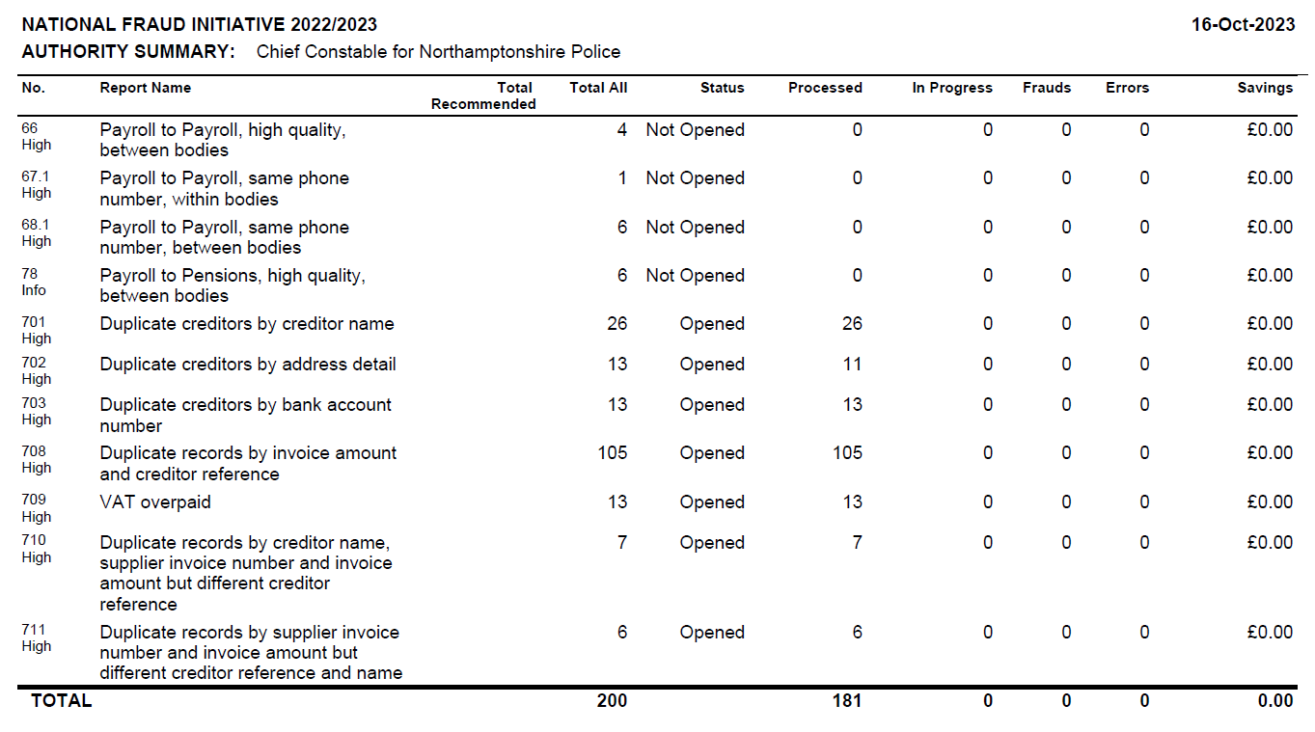

1. Appendix 4 – “The Standard” Professional Standards e-magazine



