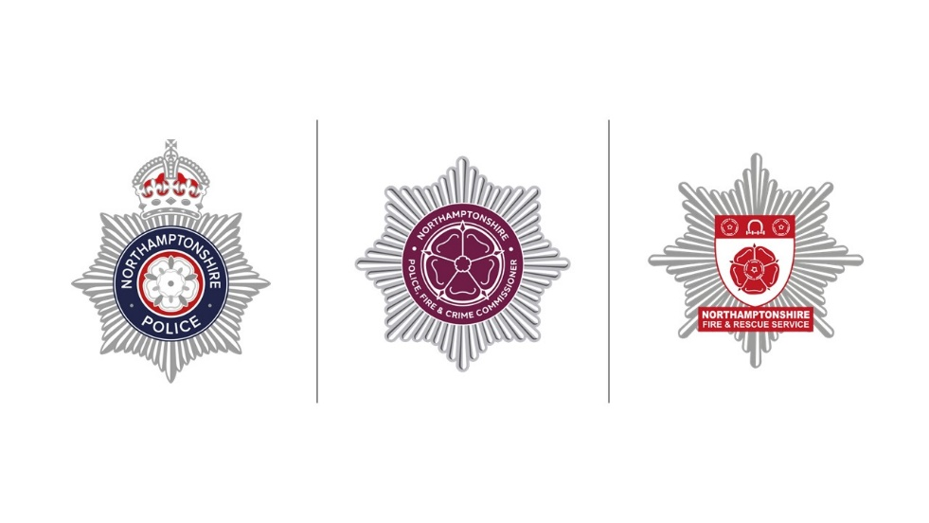

**Procurement Act 2023**

**Video Transcript**

Hi, I’m Lucy Westley, Head of Commercial and Business Development at Northamptonshire Police, Northamptonshire Fire and Rescue Service and Northamptonshire Office of Police, Fire and Crime Commissioner.

Earlier in the summer we sent out a letter to all suppliers we are or have been working with to make sure everyone is aware of the upcoming changes to public procurement. You may know this as Transforming Public Procurement, or the Procurement Act 2023. This video aims to provide a further update.

There has been lots of activity nationally since the letter was sent out, most importantly the commencement date of the Act has been moved to 24th February 2025, to allow time for a new National Procurement Policy Statement to be produced.

The implementation of the Procurement Act means that the rules on how the public sector buy goods, works and services are changing. Therefore, it is really important that you look at the Government guidance and information about the changes. This is really easy to do, if you Go onto [www.gov.uk](http://www.gov.uk) and search Transforming Public Procurement and select the top link to the Transforming Public Procurement Page. From here you will have access to the guidance and information, in addition there are short videos, and you can sign up for regular updates.

A couple of the key changes, under the new Act are:

1. The bidding process will be simplified with 6 different processes being reduced to 3 (Open, Direct Award and Competitive Flexible Procedure).
2. The Act centres on ensuring there is more openness in the purchasing of goods, services and works through an increased number of public notices. These are staged through a cradle to grave approached for all procurements covered by the Act.
3. The Find a Tender Service will become the Central Digital Platform. You will need to register for this and record your core business details for multiple bidding purposes. The programme is being led by the Cabinet Office, and they are starting to release more details about the platform and how and when you can register. For clarity, you shall need to register for the Central Digital Platform even if you are on the Find a Tender Service already.

As we know that each supplier is likely to have its own supply chain, we are asking that you share this information, and specifically the links to the guidance and videos via the Gov.uk pages within your own supply chain. We also ask each of our suppliers to consider the impact the Act will have on your business when tendering for public contracts.

The new Procurement Act 2023 covers procurements which commence on or after 24th February 2025. Therefore, any contracts or tendering opportunities which are commenced prior to that date shall remain under the governance of the existing Public Contract Regulations 2015.

Finally, I just want to finish off with a reminder to visit the Gov.uk website and search for Transforming Public Procurement where you can find lots of information on the upcoming changes.

Thank you for listening.