Cllr. David Smith

Chair, Police, Fire and Crime Panel

C/O James Edmunds

Assistant Manager - Democratic Services

West Northamptonshire Council

One Angel Square, NorthamptonNN1 1ED

28th January 2025

Dear David

In accordance with the Police Reform & Social Responsibility Act 2011 Schedule 8 Paragraph 7(3), I formally confirm that I accept the recommendation of the Police and Crime Panel, who unanimously supported my proposed appointment of Mr Ivan Balhatchet as the Chief Constable of Northamptonshire Police.

I am glad that the panel recognised the robust nature of the recruitment process and I am confident that in Ivan, I have appointed a Chief Constable who is determined to restore trust within policing and with communities across our county.

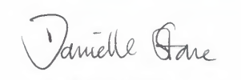

Danielle Stone

Police, Fire and Crime Commissioner for Northamptonshire