**DECISION RECORD**

**Decision Record Number 510**

This document records a decision taken by the Police, Fire and Crime Commissioner, together with details of the advice they received prior to taking the decision.

**Decision taken**

The Police, Fire and Crime Commissioner (PFCC) for Northamptonshire is the Pension Service Authority (PSA) for Northamptonshire Police and is therefore responsible for the submission of applications for pension forfeiture to the Home Secretary. Following a Pension Forfeiture Panel Meeting held on 23rd January 2025, the Police, Fire and Crime Commissioner has taken the decision that in the case relating to former Northamptonshire Police Officer Gareth Cox forfeiture will be at 10% of the whole pension and will be permanent.

Details of the background are published on the OPFCC Website at:

<https://northantspfcc.org.uk/pension-forfeiture-gareth-cox/>

**Details of advice taken**

Legal advice has been sought to ensure the decision meets the requirements of appropriate legislation and that the OPFCC met it all its statutory obligations in relation to the pension forfeiture process.

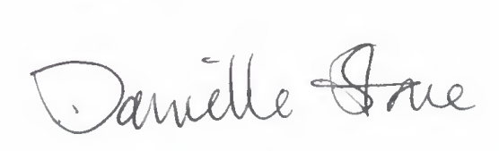

**Danielle Stone**

**Police, Fire and Crime Commissioner**

**23/01/2025**

**END**