Cllr. David Smith

Chairman of the Northamptonshire Police, Fire & Crime Panel

C/O James Edmunds

Assistant Manager - Democratic Services

West Northamptonshire Council

One Angel Square, Northampton

NN1 1ED

17th December 2024

Dear Cllr. Smith,

Following the publication of your response to my draft Public Safety Plan 2025-30 presented on the 5th December 2024, I am pleased to respond to the Panel in accordance with the Police Reform and Social Responsibility Act 2011 sections 5(6)(d) and 28(3).

I was pleased that the Panel recognised the strength of the plans three strategic missions and the renewed relationship it will bring to the public in Northamptonshire on Public Safety.

I accept the two recommendations of the panel from your report and will ensure we present the final plan to you after the public consultation closes in January 2025.

I would like to thank the panel for the positive and constructive response to the draft plan and look forward to working with you all.

Yours sincerely,

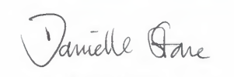

Yours sincerely

Danielle Stone

Police, Fire and Crime Commissioner for Northamptonshire