**NORTHAMPTONSHIRE POLICE, FIRE AND CRIME COMMISSIONER**

**AND NORTHAMPTONSHIRE FIRE AND RESCUE SERVICE**

**Joint Independent Audit Committee Report**

|  |  |
| --- | --- |
| **Report Title** | **Internal Audit Summary Report** |
| **Meeting Date** | **09 July 2025** |
| **Author** | **Don Crook – Assurance Manager** |

1. **Purpose of the Report**

This report provides the Accountability Board with an update on the service improvement associated with the HMICFRS inspection recommendations.

1. **Background**

The Fire sector is subject to independent inspections by His Majesty’s Inspectorate of Constabularies and Fire and Rescue Services.

To support interaction between the inspectorate and fire and rescue services, a Service Liaison Lead (SLL) Clare Hesselwood, is appointed by the HMICFRS who will work with 3 services to provide a point of contact and lead on inspections as they are required.

Each FRS is required to appoint a Service Liaison Officer (SLO) Don Crook, as a SPOC for the SLL. This officer is responsible for liaison with the SLL, lead on service inspections, provide reports to the HMICFRS as required and provide periodic updates on progress against service improvement plans.

In 2024, His Majesty’s inspectorate completed a full inspection of Northamptonshire Fire & Rescue (NFRS). The inspectors use their professional judgement to assess how effective and efficient FRSs are at fire safety, firefighting, and responding to road traffic collisions and other emergencies. They also assess how well the service looks after its people.

Each of the 11 areas are then graded as outstanding, good, adequate, requires improvement or inadequate.

The final report was published by HMICFRS in September 2024 and NFRS was graded to be:

* Good in 3 areas
* Adequate in 5 areas
* Requiring Improvement in 3 areas.

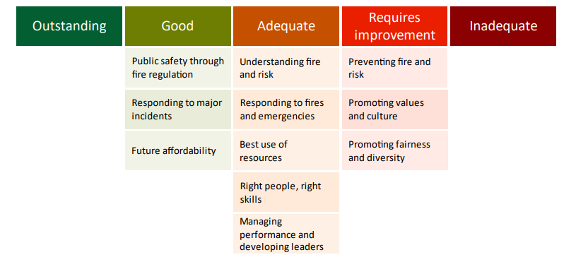

Whilst the overall inspection provides an overall grading against the 11 areas, specific detail is highlighted in the report and several identified areas of good practice and/or areas for improvement may be indicated. Service improvement plans are based around this more specific level of detail.

Inspection areas that require improvement are graded at two levels.

* AFI – Area For Improvement. Services will devise a plan for improvement and progress is reviewed by HMICFRS during their standard 2-3 year inspection regime.
* CoC – Cause of Concern. Services will devise an improvement plan; however, progress is closely scrutinised by HMICFRS by a physical reinspection of the service following a period of 6-8 months.

1. **Inspection outcomes**

The 2024 Inspection identified 16 AFI’s and 1 CoC.

Areas For Improvement

The 16 areas for improvement will be reviewed for progress by HMICFRS as part of the next full inspection regime.

1. Senior leaders should take accountability for community risk management plan priorities. They should lead and influence cross-organisational activity, so staff understand how they contribute to the objectives.
2. The service should make sure that consultation with the public is meaningful in influencing its future plans and informing its risk profile
3. The service should make sure it trains its staff, so that they understand how to target risk effectively and can competently carry out home fire safety visits.
4. The service should make sure it allocates enough resources to meet its prevention strategy to support cross-functional collaborative working and shared intelligence.
5. The service should make sure it quality assures its prevention activity, so staff carry out home fire safety visits to an appropriate standard.
6. The service should make sure its supporting systems provide an accurate picture of community risk, so that staff can prioritise the most vulnerable.
7. The service should make sure its response strategy provides the most appropriate response and wholetime and on-call availability, in line with its community risk management plan.
8. The service should make sure it has an effective system in place to learn from operational incidents and exercises.
9. The service should have effective measures in place to assure itself that its workforce is productive and that their time is used as efficiently and effectively as possible to meet the priorities in its community risk management plan.
10. The service needs to assure itself that it is making the most of opportunities to improve workforce productivity and develop future capacity using innovation, including technology
11. The service should assure itself that senior and middle managers are visible and inclusive and demonstrate the Core Code of Ethics through their behaviours.
12. The service should formally monitor overtime, secondary contracts and secondary employment to make sure working hours aren’t exceeded.
13. The service should assure itself that managers are appropriately trained for their role, including those involved in grievance, discipline and welfare processes
14. The service should make sure it has effective arrangements in place to manage its workforce plan, supported by the appropriate departments and roles. It should take full account of the skills and capabilities it needs to implement its community risk management plan.
15. The service put in place an open and fair process to identify, develop and support all high-potential staff and aspiring leaders.
16. The service should make sure its selection, development and promotion of staff are open and fair, and it should do more to make sure staff have confidence in promotion and selection processes.

The AFI’s are being delivered through our services business plans and overall improvement work. Activity is monitored through the Services relevant boards (People and Culture, Performance Assurance and Productivity, Continuous Improvement).

Learning from previous processes have already been implemented into service BaU. For example, learning from the previous CRMP process was embedded into the recent creation of the new service CRMP, greatly improving the use of consultation and involvement of senior leaders in its development.

Improvement activity is being captured and evidenced where it delivers outcomes against the AFI’s.

Cause of Concern

The service received on cause of concern which was ‘The Service hasn’t made enough progress since our last inspection to improve equality, diversity and inclusion‘. This was broken down by HMICFRS into 5 recommendations. These were

1. Working with staff to develop clear EDI objectives.
2. Effective ways to show how it monitors and evaluates EDI objectives.
3. Robust processes in place to do equality impact assessments.
4. Improvements to the way it collects equality data.
5. Confidently challenge and manage inappropriate behaviour.

The service developed an improvement plan to address the recommendations with relevant persons identified to hold responsibility for delivery.

Progress on the action plan is reviewed at the service People and Culture Board (PACB)

HMICFRS are currently reinspecting the service. This consists of an initial document and data collection, followed by virtual and onsite interviews with a range of staff.

This process will allow the inspection team to evaluate service improvement and make a professional judgement on whether the service have undertaken sufficient activity to remove recommendations detailed under the Cause of Concern.

The inspection officially began in Service with a formal notification meeting between the Chief Fire Officer and the SLL on 16th June 2025.

A draft debrief is expected to be received by the service during the week commencing 14th July 2025.

1. **Conclusion**

The Accountability Board are asked to note the contents of this report and the Governance arrangements discharged by the Service People and Culture Board in ensuring there is sufficient scrutiny and quality assurance of actions relating to inspection recommendations.