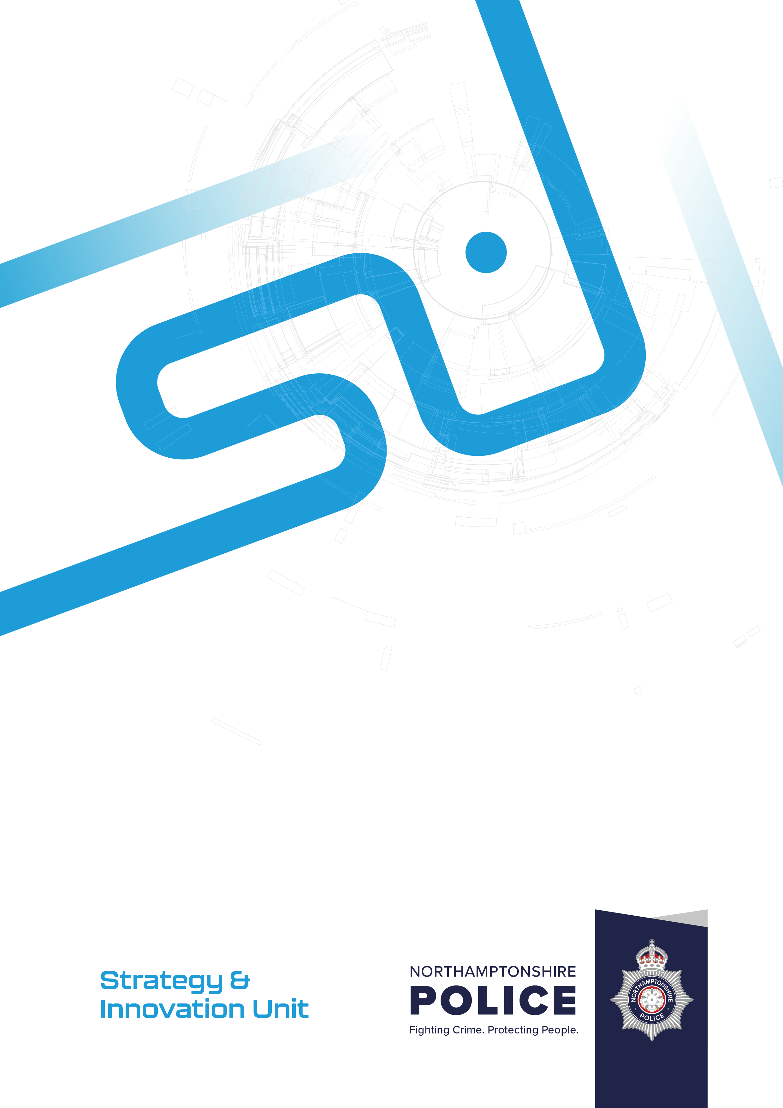
Author: Sarah Peart, Strategy & Improvement Manager and Force Liaison Officer
Decision required: For Information, Joint Independent Audit Committee
Date: October 2025
Version: 1
Security Classification: Official
HMICFRS update
- Introduction

The Force received its National Child Protection Inspector (NCPI) report in August 2025.
Northamptonshire Police: National child protection inspection - His Majesty’s Inspectorate of Constabulary and Fire & Rescue Services

This national inspection focuses on safeguarding children; the HMICFRS Inspection team were in force for 2 weeks during February 2025, carrying out fieldwork, reality testing, focus groups and crime file reviews.

The overall picture for Northamptonshire Police looks as follows:

Outstanding | Good | Adequate | Requires improvement | Inadequate
 | Working with safeguarding partners | Leadership of child protection arrangements | Responding to the children at risk of harm
 |  | Risk assessment and referrals | Investigating child abuse, neglect and exploitation

During the inspection, the lead inspector flagged issues as they were identified, and the force took immediate remedial action where required. The report provides details on 8 Areas for Improvement (AFI); progress of these is governed through the Child Vulnerability Board, chaired by the Assistant Chief Constable. The inspection also highlighted a number of areas of Promising Practice. These included The Observatory and Op Satin.

The HMICFRS PEEL 2025-27 cycle has now commenced with the Force being in Batch 3; the fieldwork commences on 12th January 2026, for 2 weeks. However, the force has already been subject to a number of interviews, reality testing, focus groups, and provided written material as part of the continuous improvement approach being applied for this cycle. The Continuous Improvement Board (CIB), in force, governs the PEEL Assessment Preparedness process; which has been in place for 12 months. The force has completed a number of self-assessments in preparation for the latest cycle of PEEL.

During September 2025, the Force was notified that it had been selected for a National Thematic Inspection on Firearms Licensing; 6 Forces have been selected. The force is preparing for this inspection, with the fieldwork commencing on 15th December 2025.

- Continuous Improvement Plan 2024 – 2026

The force has delivered a root and branch review of each Peel Assessment Framework (PAF) area, as performed ahead of the last inspection, to help leaders get ahead of any internally identified areas for improvement.

The Deputy Chief Constable has strategic oversight and grip of all inspection activity. This is managed through the Continuous Improvement Board which commenced in October 2024, meeting monthly and attended by senior leaders and subject matter experts. This Board considers the forces direction of travel in relation to all HMICFRS Recommendations and AFIs, following all publications. It also ensures the Force Management Statement (FMS), during the creation stages, progresses in a timely manner.

- Thematic HMICFRS Inspection activity

In addition to PEEL there are several thematic inspections & broader HMICFRS engagement work that Northamptonshire Police is engaging with.

Annual State of Policing
State of Policing: The Annual Assessment of Policing in England and Wales 2024–25 - His Majesty’s Inspectorate of Constabulary and Fire & Rescue Services

Published in August 2025, His Majesty’s Chief Inspector of Constabulary, Andy Cooke reports to the Secretary of State, under section 54(4A) of the Police Act 1996. It contains his independent assessment of the efficiency and effectiveness of policing in England and Wales. It is based on inspections carried out between 1 April 2024 and 31 July 2025. The report draws on findings from inspections of police forces in England and Wales, to provide an overall view of the state of policing.

The report does not set specific recommendations for forces as seen with other thematics and PEEL, however its context is used as an important document to inform our strategic direction.

- Conclusion

Overall, there are several workstreams and activity ongoing to address current HMICFRS inspections and improvement across Northamptonshire Police.

The force is confident it has the appropriate oversight in place to address its areas for improvement, and that Strategy and Improvement have the right structure and governance in place for the Deputy Chief Constable to address concerns through the Continuous Improvement Plan and Board.

