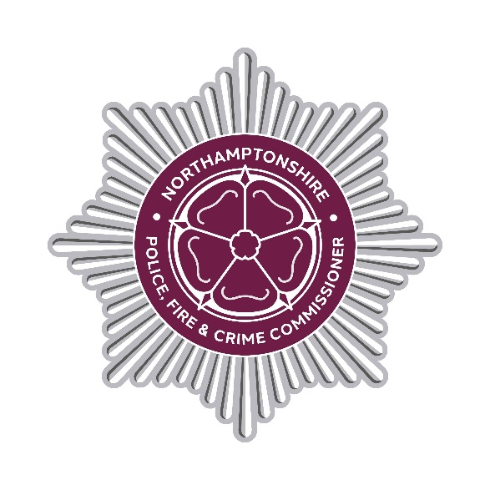

DECISION RECORD

Decision Record Number

This document records a decision taken by the Police, Fire and Crime Commissioner, together with details of the advice they received prior to taking the decision.

Decision taken

The decision has been taken to award two Northamptonshire Fire and Rescue Contracts for the Provision of Fire Workwear Uniform. Contract 1 is awarded to Clad Safety Limited T/A HeroQuip. Contract 2 is awarded to Oxford Safety Supplies Limited. The contracts are for the supply of the following Fire Uniform Workwear items: Short sleeve t shirt, long sleeve t shirt, shirt, rig trousers, cargo trousers and 3 in 1 jacket.

The contract term for both contracts is from 02/02/2026 to 01/02/2029 with an option to extend for 12 months until 31/01/2030. The Contract value for Contract 1 is £205,000 excluding VAT or £246,000 including VAT if all extension options were taken. The Contract value for Contract 2 is £81,000 excluding VAT or £97,200 including VAT if all extension options were taken.

Details of advice taken

Professional operational, financial, commercial and legal advice has been sought to ensure the decision best supports operational needs and represents value for money.

Danielle Stone
Police, Fire and Crime Commissioner
16 February 2026
END

