
Treasury Management Strategy 2026/27

Northamptonshire Commissioner Fire & Rescue Authority (NCFRA)

Author: Joint Finance Team

Version Control: 1

- Introduction

CIPFA Treasury Management in the Public Services: Code of Practice and Cross Sectoral Guidance Notes
  - The Chartered Institute of Public Finance and Accountancy (CIPFA) defines treasury management as “the management of the organisation’s investments and cash flows, its banking, money market and capital market transactions; the effective control of the risks associated with those activities; and the pursuit of optimum performance consistent with those risks.”

CIPFA Prudential Code for Capital Finance in Local Authorities
  - The CIPFA Prudential Code for Capital Finance in Local Authorities (the Prudential Code) is a professional code of practice. Authorities have a statutory requirement to comply with the Prudential Code when making capital investment decisions and carrying out their duties under Part 1 of the Local Government Act 2003 (Capital Finance etc. and Accounts).
  - The CIPFA Prudential Code sets out the manner in which capital spending plans should be considered and approved, and in conjunction with this, the requirement for an integrated treasury management strategy.
  - The Northamptonshire Commissioner Fire & Rescue Authority (NCFRA) is required to set and monitor a range of prudential indicators for capital finance covering affordability, prudence, and a range of treasury indicators.

Treasury Management Policy Statement
  - The NCFRA’s Treasury Management Policy Statement is included in Appendix 1. The policy statement follows the wording recommended by the latest edition of the CIPFA Treasury Code.

Treasury Management Practices
  - The NCFRA’s Treasury Management Practices (TMPs) will set out the manner in which the NCFRA will seek to achieve its treasury management policies and objectives, and how it will manage and control those activities.
  - The NCFRA’s TMPs Schedules will cover the detail of how the NCFRA will apply the TMP Main Principles in carrying out its operational treasury activities. They are reviewed annually, and any amendments approved by the NCFRA’s Chief Finance Officer.
- The Treasury Management Strategy
  - It is a requirement under the Treasury Code to produce an annual strategy report on proposed treasury management activities for the year. The purpose of the Treasury Management Strategy is to establish the framework for the effective and efficient management of the NCFRA’s treasury management activity, including the NCFRA’s investment portfolio, within legislative, regulatory, and best practice regimes, and balancing risk against reward in the best interests of stewardship of the public purse.
  - The NCFRA’s Treasury Management Strategy is prepared in the context of the key principles of the Treasury Code and incorporates:
- The NCFRA’s capital financing and borrowing strategy for the coming year.
- Policy on borrowing in advance of need.
- Policy on the making of Minimum Revenue Provision (MRP) for the repayment of debt.
- The Affordable Borrowing Limit.
- The Annual Investment Strategy for the coming year, including creditworthiness policies.
  - The strategy considers the impact of the NCFRA’s Medium Term Financial Plan (MTFP), its revenue budget and capital programme, the balance sheet position, and the outlook for interest rates.
  - The NCFRA regards the successful identification, monitoring, and control of risk to be the prime criteria by which the effectiveness of its treasury management activities will be measured. The Treasury Management Scheme of Delegation is detailed within the NCFRA’s Corporate Governance Framework.
- Current Treasury Management Position
  - The NCFRA’s projected treasury portfolio position at 1st April 2026, with forward projections into future years, is summarised below. Table 1 shows the actual forecast external borrowing (the treasury management operations), against the Capital Financing Requirement (CFR).
  - The CFR is the total of outstanding capital expenditure which has not yet been paid for from either revenue or capital resources. It is essentially a measure of the NCFRA’s underlying borrowing need.
  - Any capital expenditure which has not immediately been paid for will increase the CFR. The CFR does not increase indefinitely, as the MRP is a statutory annual revenue charge which broadly reduces the borrowing need over each asset’s life.

Table 1: Capital Financing Requirement
Capital Financing Requirement | 2025-26  Forecast  £'000 | 2026-27  Estimated  £'000 | 2027-28  Estimated  £'000 | 2028-29  Estimated  £'000 | 2029-30  Estimated  £'000 | 2030-31  Estimated  £'000
External Borrowing at 1st April b/fwd | 2,970 | 12,736 | 30,878 | 57,245 | 62,691 | 63,381
Net Borrowing Requirement  to fund Capital Programme | 10,299 | 18,747 | 27,192 | 7,131 | 2,982 | 4,508
Debt Repayment | (83) | (83) | (83) | (83) | (83) | (83)
MRP | (451) | (522) | (743) | (1,602) | (2,210) | (2,341)
CFR - Borrowing at 31 March c/fwd | 12,736 | 30,878 | 57,245 | 62,691 | 63,381 | 65,465
Investments at 31 March | 391 | 3,054 | 5,000 | 5,000 | 5,000 | 5,000
Net Borrowing | 12,344 | 27,824 | 52,245 | 57,691 | 58,381 | 60,465

  - There are a number of key indicators to ensure that the NCFRA operates its activities within well-defined limits. Among these the NCFRA needs to ensure that its gross borrowing does not, except in the short term, exceed the total of the CFR in the preceding years. This ensures that borrowing is not undertaken for revenue purposes except to cover short term cash flows.
  - The Chief Finance Officer does not envisage borrowing for investment purposes, nor difficulties complying with these indicators based upon current commitments, existing plans, the proposals in this strategy, the budget report, the Capital Programme and the Medium Term Financial Plan.
- Prospects for Interest Rates
  - The NCFRA’s assessment of the likely path for bank base rate, investment market rates (The London Interbank Bid Rate - LIBID), and PWLB borrowing rates are set out below:
Table 2: Interest Rate Outlook as at 4th February 2026

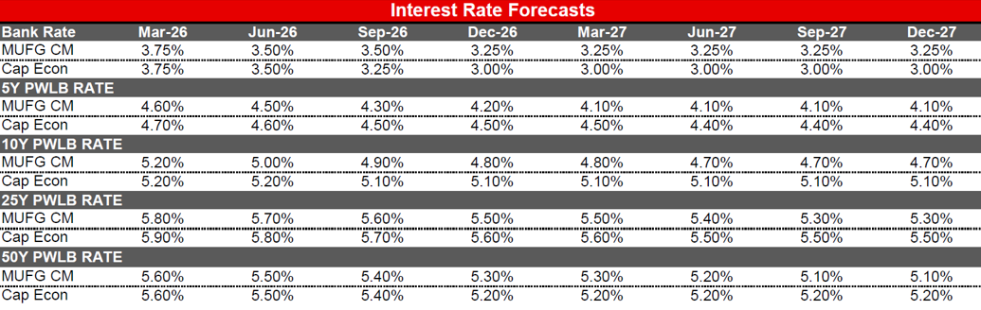

  - The economic situation to the UK resulted in a steep interest increase which impacted early 2024/25. In December 2024 the Bank of England base rate decreased to 4.5% compared to 5.25% in March 2023. The Bank of England forecasters were expecting base rate to begin to dip in the short term future, falling to 4.05% from 4.5% during the final quarter of 2026/27. The table above shows the interest rates reducing quicker than estimated in 2026/27. The table shows a further decline in the interest rates, leveling to 3.25% for Quarter 3 2026/27. The forecast table above shows the current forecast of the PWLB interest rates from our Treasury Advisors.
  - Investment returns are likely to slightly decrease in 2026/27 from the interest earnt in 2025/26 due to the decrease in rates and lower anticipated cash balances, and then continue to decline over the medium term.
  - In March 2020, the Government started a consultation process for reviewing the margins over gilt rates for PWLB borrowing for different types of PFCC capital expenditure. Following the consultation, the Government published their responses in November 2020 which stated these outcomes:
- PWLB will not lend to a PFCC who intends to buy investment assets primarily for yield.
- Reduction to the interest on borrowing on all standard and certainty rates by 100 basis point which took effect from 26th November 2020.
- Managing daily cash balances and investing surpluses
  - In order that the NCFRA can maximise income earned from investments, the target for the un-invested overnight balances in our current accounts is usually always lower than £10k where possible. However, if there is an emergency, we are unable to place an investment or it is not prudent or cost-effective to do so, we will maintain any excess balances in the Natwest account in order to safeguard funds.
  - The average cash available to or forecast to invest throughout 2025/26 including a projection of 2026/27 is as follows, which includes fluctuations due to the timing of borrowing for capital expenditure.
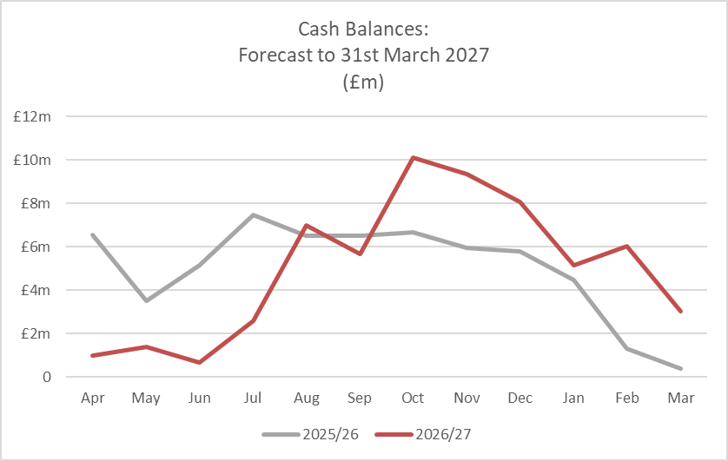
  - At any one time, the NCFRA tries to maintain between £0.5m and £15.0m (depending on the cash flow of both revenue and capital financing) available to invest. Where this is not possible due to the utilisation of Internal Borrowing to support the costs of the capital programme in order to reduce debt costs, the NCFRA will ensure that positive cash flows are maintained using short term borrowing where necessary.
  - As with most local authorities with a high proportion of employee to Supplies and Services expenditure, the NCFRA’s cash flow is fairly consistent month on month and therefore investable cash balances only significantly deviate when single payments (such as internally funded capital purchases) or large annual income receipts are forecast.
  - The increase and decline in cash balances represented above occurs with the:
- Receipt of Annual Managed Expenditure (AME) Grant for firefighter pensions during August.
- The costs associated with the firefighter pensions being expended throughout the financial year.
- Repayment of PWLB loans and planned borrowing.
- Precept income being receivable over the first 10 months of the financial year.
- Borrowing Strategy
  - The overarching objectives for the NCFRA’s borrowing strategy are as follows:
- To manage the NCFRA’s debt maturity profile. This is achieved by monitoring short- and long-term cash flow forecasts in tandem with balance sheet analysis.
- To maintain a view on current and possible future interest rate movements, and to plan borrowing accordingly. This is achieved by monitoring of economic commentary to undertake sensitivity analysis.
- To monitor and review the balance between fixed and variable rate loans against the background of interest rates and the Prudential Indicators; this is achieved by monitoring of economic commentary to undertake sensitivity analysis.
  - The NCFRA is currently maintaining an under-borrowed position. This means that the capital borrowing need (the Capital Financing Requirement) will not been fully funded with loan debt as cash supporting the NCFRA’s reserves, balances and cash flow has been used as a temporary measure.
  - The sources of borrowing;
- PWLB – the NCFRA will receive a ‘Certainty Rate’ which is reduced by 20 basis points (0.20%) against the PWLB standard rate.
- Local Authorities, particularly for short-term borrowing.
- OPFCC (Police funds) – this Strategy enables that if there is an instance that either NCFRA or OPFCC (Police) has similar term excess of funds when the other entity has a borrowing need, that borrowing can take place from either party. This must be mutually beneficial and hold minimal risk and to provide additional assurance, approval will be provided by both s151 officers or their deputies, so that both parties interests are demonstrably represented. It ensures that interest rates are competitive to the market and no broker fee is payable (historically 10 basis points of the amount borrowed).
  - Caution will be adopted with the 2026/27 treasury operations against this background and the risks within the economic forecast. The Joint Finance Team will monitor interest rates in financial markets and regularly brief the Chief Finance Officer so the NCFRA may adopt a pragmatic approach to changing circumstances. For example:
- If it was felt that there was a significant risk of a sharp FALL of 25% or more in long- and short-term rates (eg. due to a marked increase of risks around a relapse into recession or of risks of deflation), then long term borrowings may be postponed and potential rescheduling from fixed rate funding into short term borrowing considered (where appropriate).
- If it was felt that there was a significant risk of a much sharper RISE of 25% or more in long and short-term rates than that currently forecast (eg. arising from an acceleration in the start date and rate of increase in central rates in the USA and UK) then the portfolio position will be re-appraised. This may include drawing fixed rate funding whilst interest rates are lower than they are projected to be in the next few years.
- Prudential & Treasury Indicators
  - There is a requirement under the Local Government Act 2003 for Authorities to have regard to CIPFA’s Prudential Code for Capital Finance in Local Authorities (the “CIPFA Prudential Code”) when setting and reviewing their Prudential Indicators. The Prudential Code was most recently updated in 2021.
  - A full set of Prudential Indicators and Borrowing Limits are shown in Appendix 2.
- Policy on Borrowing in Advance of Need
  - The NCFRA’s policy is to keep cash balances as low as possible and not to borrow in advance of need for capital purposes, whilst ensuring that cash is available to make payments when they become due. However, this policy may be reviewed should it be prudent to do so, subject to support by the Chief Finance Officer.
- Debt Rescheduling
  - The NCFRA may reschedule debt if it is prudent to do so. The reasons for any rescheduling to take place may include:
- the generation of cash savings and/or discounted cash flow savings.
- helping to fulfil the treasury strategy regarding the capitalised asset purchases.
- Enhance the balance of the portfolio (amend the maturity profile and/or the balance of volatility).
  - Any rescheduling activity decision must be recommended by the Chief Finance Officer, and reported in the next Treasury Management report following its action.
- Minimum Revenue Provision
  - The NCFRA is required to repay annually an element of its outstanding capital expenditure which has not yet been paid for from either revenue or capital resources (the CFR). This is achieved through a revenue charge known as the Minimum Revenue Provision (MRP). It is also allowed to undertake additional voluntary payments (Voluntary Revenue Provision - VRP) if it is prudent to do so.
  - MHCLG regulations have been issued which requires the NCFRA to approve an MRP Statement in advance of each year. A variety of options are provided so long as there is a prudent provision. The NCFRA is recommended to approve the MRP Policy in Appendix 3 which sets out how MRP will be charged against particular asset types or other forms of capital expenditure.
- Investment Strategy
  - Government guidance on Local Government Investments in England requires that an Annual Investment Strategy (AIS) be set. The Guidance permits the Treasury Management Strategy Statement (TMSS) and the AIS to be combined into one document.
  - The NCFRA’s general policy objective is to invest its surplus funds prudently. As such the NCFRA’s investment priorities, in priority order, are:
- Security of the invested capital.
- Liquidity of the invested capital.
- Yield received from the investment.
  - The following graph demonstrates interest earned (cumulative) against the profiled budget, projected to the end of the financial year for 2025/2026:
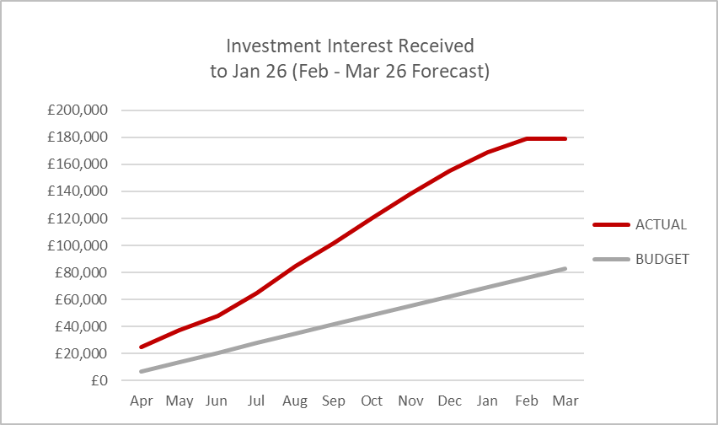
  - The NCFRA expects to invest all surplus funding and is forecast over the medium term that interest rate returns are expected to decrease. The average cash balances from those is expected to remain consistent with peaks in August following the receipt of grant income with reductions in available levels through to the end of each financial year. An estimate of possible income is as follows:
  - The following graph shows the profiled interest income budget for 2026/27:
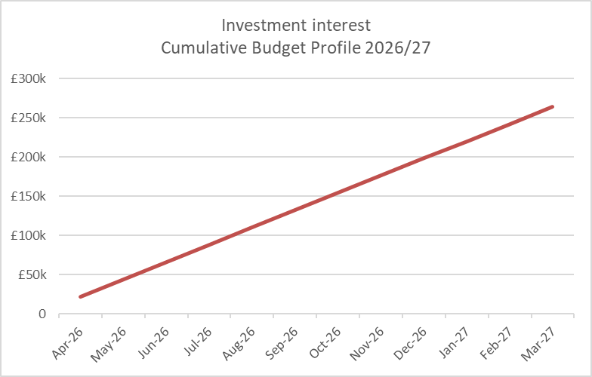
  - The NCFRA’s Investment Strategy is shown in Appendix 4.
- Risk Analysis and Forecast Sensitivity

Risk Management
  - The NCFRA regards the successful identification, monitoring and control of risk to be the prime criteria by which the effectiveness of its treasury management activities will be measured. Treasury management risks are identified in the NCFRA’s approved Treasury Management Practices.
  - The Schedule of Treasury Management Practices set out the ways in which the NCFRA seeks to mitigate these risks. Examples are the segregation of duties (to counter fraud, error and corruption), and the use of creditworthiness criteria and counterparty limits (to minimise credit and counterparty risk). Officers will monitor these risks closely.

Sensitivity of the Forecast
  - The sensitivity of the forecast is linked primarily to movements in interest rates and in cash balances, both of which can be volatile. Interest rates in particular are subject to global external influences over which the NCFRA has no control.
Both interest rates and cash balances will be monitored closely throughout the year and potential impacts on the NCFRA’s debt financing budget will be assessed. Action will be taken as appropriate, within the limits of the TMP Schedules and the treasury strategy, and in line with the NCFRA’s risk appetite, to keep negative variations to a minimum. Any significant variations will be reported in the next available Treasury Management report.
- Capital Strategy
  - CIPFA’s revised 2021 Prudential and Treasury Management Codes requires all local authorities, to have in place a Capital Strategy, which will provide the following:
- a high-level long-term overview of how capital expenditure, capital financing and treasury management activity contribute to the provision of services.
- an overview of how the associated risk is managed.
- the implications for future financial sustainability.

  - The aim of this Capital Strategy is to ensure a full understanding of the overall long-term policy objectives and resulting capital strategy requirements, governance procedures and risk appetite.
  - NCFRA publishes a Capital Strategy which is aligned to the Police, Fire and Crime Plan. The Capital Strategy will be reviewed and updated in line with the new Police, Fire and Crime Plan for 2026/27.
- Treasury Management Reporting
  - The PFCC receives two treasury reports as a minimum each year, with a mid-year update as and when appropriate, which incorporate a variety of policies, estimates and actuals:
- Treasury Management Strategy and Prudential and Treasury Indicators (this report – essential report)

This report is forward-looking and covers:
- the capital plans (including prudential indicators)
- a Minimum Revenue Provision (MRP) policy (how residual capital expenditure is charged to revenue over time)
- the Treasury Management Strategy, (how the investments and borrowings are to be organised), including treasury indicators.
- an Investment Strategy, (the parameters on how investments are to be managed)

- A mid-year treasury management report (as required)

This is primarily a progress report and updates on the capital position, amending prudential indicators as necessary, and whether any policies require revision.

- An annual treasury outturn report (essential)

This is a backward-looking review document and provides details of a selection of actual prudential and treasury indicators and actual treasury operations compared to the estimates within the strategy.
- Treasury Management Budget
  - The table below provides a breakdown of the treasury management budget. Minimum Revenue Provision (MRP) charges have been calculated in line with the Policy at Appendix 3:
Treasury Management Budget | 2025-26  Forecast  £'000 | 2026-27  Estimated  £'000 | 2027-28  Estimated  £'000 | 2028-29  Estimated  £'000 | 2029-30  Estimated  £'000 | 2030-31  Estimated  £'000
Interest payable on borrowing | 141 | 251 | 1,097 | 1,984 | 2,228 | 2,363
Minimum Revenue Provision | 451 | 522 | 743 | 1,602 | 2,210 | 936
Revenue Contribution to Capital | 300 | 300 | 300 | 300 | 300 | 300
Total | 892 | 1,073 | 2,140 | 3,886 | 4,738 | 3,599
  - Budget estimates will be revised during the year to reflect the further development of capital programme plans and other relevant strategies.

- Policy on the use of External Service Providers
  - The NCFRA recognises that responsibility for treasury management decisions always remains with the organisation. The NCFRA also recognises there is value in employing an external provider of treasury management services in order to acquire access to specialist skills and advice to support the treasury management function.
  - Treasury Management services are undertaken by the Enabling Services Joint Finance Team and the Treasury Advisor is currently MUFG (previously known as Link Group).
- Future Developments
  - Public bodies are having to consider innovative strategies towards improving service provision to their communities. This approach to innovation also applies to treasury management activities. The Government has already introduced new statutory powers, and regulatory agencies such as CIPFA are introducing policy changes, which will have an impact on treasury management approaches in the future. Examples of such changes are:
  - Localism Act
A key element of the Act is the “General Power of Competence”: “A PFCC has power to do anything that individuals generally may do.” The Act opens up the possibility that a PFCC can use derivatives as part of their treasury management operations.
The NCFRA has no plans to use financial derivatives under the powers contained within this Act.
  - Loans to Third Parties
The NCFRA may borrow to make grants or loans to third parties for the purpose of capital expenditure. This will usually be to support local economic development, and may be funded by external borrowing.
The NCFRA has not lent any funds to third parties and has no plans to do so in the immediate future.
  - Proposals to amend the CIPFA Treasury Management and Prudential Codes
CIPFA conducted a review of the Treasury Management Code of Practice and the Prudential Code. This review particularly focused on non-treasury investments and especially on the purchase of property with a view to generating income. Such purchases could involve undertaking external borrowing to raise the cash to finance these purchases, or the use of existing cash balances. Both actions would affect treasury management.
The Capital Strategy will cover non-treasury investments to deal with such purchases, their objectives, how they have been appraised, how they have been financed, and what powers were used to undertake these purchases.
  - Impact of International Financial Reporting Standard 9 (IFRS 9)
All public bodies were required to adopt the principles of accounting standard IFRS 9 from 1st April 2018, this was amended 1st January 2026 for guidance with ESG (Enviromental, Socail and Governance) linked investments. A key element of this standard is a requirement to set aside financial provision within revenue budgets for losses on financial assets based on potential expected losses (i.e. the likelihood of loss across the asset lifetime). This does not have a material impact upon the traditional treasury management investments the NCFRA will undertake.
- Training
  - The NCFRA needs to ensure appropriate training and knowledge in relation to treasury management activities, for officers engaged in treasury activity and those with oversight responsibilities charged with governance of the treasury management function. Treasury management training will be considered and delivered as required to facilitate best practices, informed decision making and challenge processes.
List of Appendices

Appendix 1: Treasury Management Policy Statement
Appendix 2: Prudential & Treasury Indicators
Appendix 3: Minimum Revenue Provision (MRP) Policy Statement
Appendix 4: Annual Investment Strategy
APPENDIX 1
Treasury Management Policy Statement

Northamptonshire Commissioner Fire and Rescue Authority (NCFRA) defines its treasury management activities as:

The management of the NCFRA’s investments and cash flows, its banking, money market and capital market transactions; the effective control of the risks associated with those activities; and the pursuit of optimum performance consistent with those risks.

The NCFRA regards the successful identification, monitoring, and control of risk to be the prime criteria by which the effectiveness of its treasury management activities will be measured. Accordingly, the analysis and reporting of treasury management activities will focus on their risk implications for the organisation, and any financial instruments entered into to manage these risks.

The NCFRA acknowledges that effective treasury management will provide support towards the achievement of its business and service objectives. It is therefore committed to the principles of achieving value for money in treasury management, and to employing suitable comprehensive performance measurement techniques, within the context of effective risk management.

APPENDIX 2

Prudential and Treasury Indicators

- The Capital Prudential Indicators

  - The NCFRA’s capital expenditure plans are the key driver of treasury management activity. The output of the capital expenditure plans is reflected in prudential indicators, which are designed to assist overview and confirm capital expenditure plans.

Capital Expenditure and Borrowing Need

  - This prudential indicator shows the NCFRA’s capital expenditure plans and capital financing requirement as described in the body of the Strategy and summarised in Table 1 (Para 3.3 above).

The Operational Boundary

  - This is the limit beyond which external borrowing is not normally expected to exceed. All things being equal, this could be a similar figure to the Capital Financing Requirement (CFR), but may be lower or higher depending on the levels of actual borrowing undertaken as impacted by the level of current and future cash resources and the shape of the interest rate yield curve.

Operational Boundary | 2025-26  Forecast  £'000 | 2026-27  Estimated  £'000 | 2027-28  Estimated  £'000 | 2028-29  Estimated  £'000 | 2029-30  Estimated  £'000 | 2030-31  Estimated  £'000
Total Borrowing | 13,000 | 31,000 | 58,000 | 63,000 | 64,000 | 66,000

  - The Operational Boundary is calculated here by rounding the CFR for each year up to the nearest £1m. This allows nominal flexibility to account for price variations on capital investment.

The Authorised Limit for external borrowing

  - A further key prudential indicator represents a control on the maximum level of borrowing. This represents a limit beyond which external borrowing is prohibited, and this limit needs to be set or revised in line with the NCFRA’s Corporate Governance Framework. It reflects the level of external borrowing which, while not desired, could be afforded in the short term, but is not sustainable in the longer term.

- This is the statutory limit determined under section 3 (1) of the Local Government Act 2003.
- The NCFRA is asked to approve the following Authorised Limit:
Authorised Limit | 2025-26  Forecast  £'000 | 2026-27  Estimated  £'000 | 2027-28  Estimated  £'000 | 2028-29  Estimated  £'000 | 2029-30  Estimated  £'000 | 2030-31  Estimated  £'000
Total Borrowing | 14,300 | 34,100 | 63,800 | 69,300 | 70,400 | 72,600

  - The rising trend of the Authorised Limit reflects that of the CFR and subsequently the Operational Boundary. The level set is at a 10% margin above the Operational Boundary, providing additional headroom for further short-term borrowing should it be required for cashflow purposes and changes to short term estimates, before the legal limit is reached.

- Treasury Management Limits on Activity

  - There are four debt and investment related treasury activity limits. The purpose of these is to contain the activity of the treasury function within certain limits, thereby managing risk and reducing the impact of any adverse movement in interest rates. However, if these are set to be too restrictive, they will impair the opportunities to reduce costs or improve performance. The indicators for debt are:

- Upper limits on variable interest rate exposure; this identifies a maximum limit for variable interest rates based upon the debt position net of investments.
- Upper limits on fixed interest rate exposure; this is similar to the previous indicator and covers a maximum limit on fixed interest rates.
- Maturity structure of borrowing; these gross limits are set to reduce the NCFRA’s exposure to large, fixed rate sums falling due for refinancing, and are required for upper and lower limits.

  - The interest rate exposure is calculated as a percentage of net debt. Due to the mathematical calculation, exposures could be greater than 100% or below zero (ie. negative) depending on the component parts of the formula. The formula is shown below:

Fixed rate calculation:
(Fixed rate borrowing – Fixed rate investments)
Total borrowing – Total investments

Variable rate calculation:
(Variable rate borrowing – Variable rate investments)
Total borrowing – Total investments

Interest rate Exposures | 2025-26  Forecast  £'000 | 2026-27  Estimated  £'000 | 2027-28  Estimated  £'000 | 2028-29  Estimated  £'000 | 2029-30  Estimated  £'000 | 2030-31  Estimated  £'000
 | Upper | Upper | Upper | Upper | Upper | Upper
Limits on fixed interest rates based on net debt | 100% | 100% | 100% | 100% | 100% | 100%
Limits on variable interest rates based on net debt | 50% | 50% | 50% | 50% | 50% | 50%

  - The indicators above therefore allow for a maximum 100% of borrowing to be undertaken on a fixed interest rate basis, but a maximum of 50% on a variable interest rate basis. This allows flexibility to utilise variable rate instruments for up to half the NCFRA’s borrowing requirement where prudent to do so, whilst limiting the variable interest rate risk against the NCFRA’s revenue budget.

  - The maturity structure of borrowing indicator represents the borrowing falling due in each period expressed as a percentage of total borrowing. These gross limits are set to manage the NCFRA’s exposure to sums falling due for refinancing or repayment.

Maturity Structure of Borrowing
 | Lower | Upper
Under 12 months | 0% | 75%
12 months to 2 years | 0% | 75%
2 years to 5 years | 0% | 80%
5 years to 10 years | 0% | 80%
10 years and above | 0% | 100%

  - The only current loan is from PWLB, taken in 2021 over 40 years on a EIP (Equal Instalments of Principal) basis, meaning that the principal is paid throughout the loan rather than at the end of the loan term. £3.300m was taken and the principal balance as at 31st March 2026 will be £2.888m. The loan matures in 2061.

  - The NCFRA does not expect to hold any investments that exceed 365 days but may do so in the future if it holds sufficient cash balances and such investments assist in the prudent management of the NCFRA’s financial affairs.

Liability Benchmark

  - The PFCC is required to provide a comparison of the existing loan portfolio against the committed borrowing needs. This is to provide evidence that it has a strong grasp of both its existing debt maturity profile and how MRP / LFR (Loan Fund Repayment) and other cash flows affect the future debt requirement.

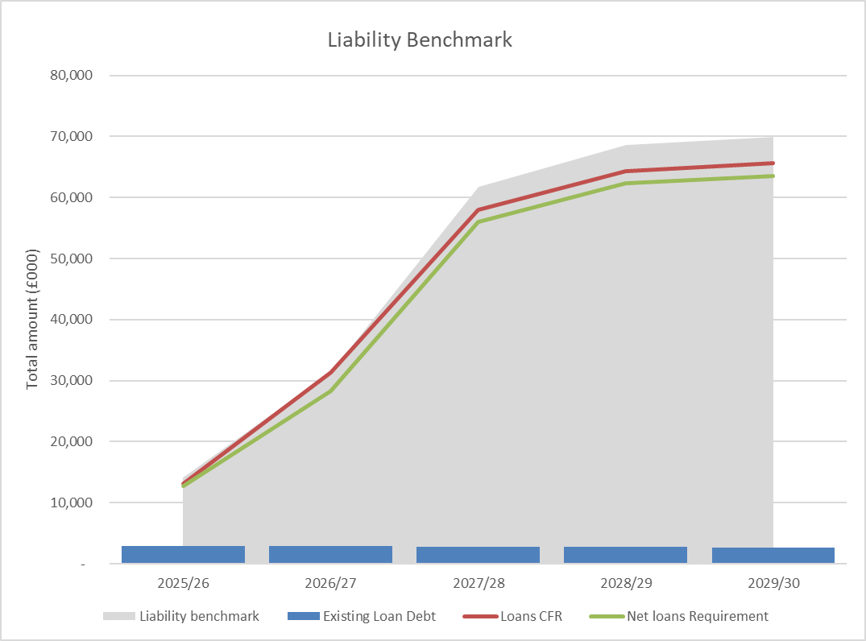

  - Currently, the only NCFRA loan is held with PWLB. The graph shows the current outstanding loan and the forecasted CFR loan requirement to deliver the Capital Programme.

Affordability Prudential Indicator

  - The previous sections cover the overall capital and control of borrowing prudential indicators, but within this framework is an indicator required to assess the affordability of the capital investment plans. This provides an indication of the impact of the capital investment plans on the NCFRA’s overall finances.
 | 2025-26  Forecast  £'000 | 2026-27  Estimated  £'000 | 2027-28  Estimated  £'000 | 2028-29  Estimated  £'000 | 2029-30  Estimated  £'000 | 2030-31  Estimated  £'000
Financing costs to net revenue stream | 3% | 3% | 5% | 9% | 11% | 8%

  - The NCFRA is asked to approve the actual and estimates of financing costs to net revenue stream. This indicator identifies the trend in the cost of capital (borrowing and other long term obligation costs net of investment income) against net revenue stream. The estimates of financing costs include current commitments.

  - This is calculated as the estimated net financing costs for the year divided by the amounts to be met from government grants and local taxpayers.

APPENDIX 3
Minimum Revenue Provision Policy Statement

  - The Northamptonshire Commissioner, Fire and Rescue Authority (NCFRA) is required to repay an element of the accumulated General Fund capital spend each year (Capital Financing Requirement - CFR) through a revenue charge (Minimum Revenue Provision - MRP), although it is also allowed to undertake additional voluntary payments if required.

  - The Ministry of Housing, Communities and Local Government (MHCLG) have issued regulations that requires the NCFRA to approve an MRP Statement in advance of each year. A variety of options are provided in the guidance with the underlying principle that a prudent provision is made.

Accumulated Debt Liability

  - For unsupported capital expenditure, MRP will be charged from the year after the assets funded have become operational and spread over the estimated useful life of the assets using an equal annual instalment method.

  - Estimated useful life periods will be determined under delegated powers. To the extent that expenditure is not on the creation of an asset, it will be spread across the estimated life of each group of assets, with overall asset group principles being applied. However, the PFCC reserves the right to determine useful life periods and prudent MRP in exceptional circumstances where the recommendations of the guidance would not be appropriate.

  - As some types of capital expenditure incurred are not capable of being related to an individual asset, asset lives will be assessed on a basis which most reasonably reflects the anticipated period of benefit that arises from the expenditure. Whatever type of expenditure is involved, it will be grouped together in a manner which reflects the nature of the main component of expenditure with substantially different useful economic lives.

Non-operational assets

  - The NCFRA will not charge MRP on non-operational assets. MRP will only be charged in the financial year following the asset becoming operational. This policy will be reviewed annually.

Use of Capital Receipts

  - The NCFRA may use capital receipts in the year in which they are received to reduce the CFR and to offset the MRP charge for that year. Any unapplied capital receipts will be available in future years and will be applied in a prudent manner.
APPENDIX 4

Annual Investment Strategy

- Investment Policy

  - MHCLG and CIPFA have extended the meaning of ‘investments’ to include both financial and non-financial investments. This report deals solely with financial investments managed by the treasury management team. Non-financial investments, essentially the purchase of income yielding assets, are covered in the Capital Strategy.

  - The NCFRA’s appetite for risk must be clearly identified in its strategy report. The NCFRA affirms that its investment policies are underpinned by a strategy of prudent investment of funds held on behalf of the local community. The objectives of the investment policy are firstly the security of funds (protecting the capital sum from loss) and then liquidity (keeping money readily available for expenditure when needed). Once approved levels of security and liquidity are met, the NCFRA will seek to maximise yield from its investments, consistent with the applying of the agreed parameters. These principles are carried out by strict adherence to the risk management and control strategies set out in the TMP Schedules and the Treasury Management Strategy.

  - Responsibility for risk management and control lies within the NCFRA and cannot be delegated to an outside organisation.

- Creditworthiness Policy

  - The NCFRA’s counterparty and credit risk management policies are set out below. These, taken together, form the fundamental parameters of the NCFRA’s Investment Strategy.

  - The NCFRA defines high credit quality in terms of investment counterparties as those organisations that are:
- Minimum strong grade long term credit rating (equivalent to A- / A3 / A from Fitch, Moody’s and Standard and Poor’s)
- UK banking or other financial institutions, or are;
- UK national or local government bodies, including bonds, or are;
- Triple-A rated Money Market funds.

  - The NCFRA will assess the credit ratings from the three main credit rating agencies, Fitch, Moody’s and Standard & Poor’s. The credit ratings of counterparties will be supplemented with the following overlays:

- Credit watches and credit outlooks from credit rating agencies.
- Credit Default Swaps (CDS – a traded insurance policy market against default risk) spreads to give early warning of likely changes in credit ratings.

  - This approach of combining credit ratings, credit Watches and credit Outlooks along with an overlay of CDS spreads will be used to determine duration for investment. The NCFRA will apply these duration limits to its investments at all times, unless otherwise approved by the Chief Finance Officer.

  - Credit ratings will be monitored on a regular basis. If a rating downgrade results in the counterparty or investment scheme no longer meeting the NCFRA’s minimum criteria, its further use as a new investment will be withdrawn immediately. In addition, extreme market movements (which may be an early indicator of financial distress) may result in the removal of a counterparty from new investment.

  - The NCFRA will also use market data, financial press, and information on any external support for banks to help support its decision-making process.

  - The NCFRA recognises that responsibility for treasury management decisions always remains with the organisation and so to enable the effective management of risk in relation to its investments, the Chief Finance Officer shall have the discretion during the year to:

- Strengthen or relax restrictions on counterparty selection.
- Adjust exposure and duration limits.

  - Where this discretionary NCFRA decision-making is exercised, records will be maintained, and details reported in the next available Treasury Management update report.

- Banking Services

  - The NCFRA currently uses NatWest to provide day-to-day banking services. The NCFRA may continue to use its own bankers for short term liquidity requirements if the credit rating of the institution falls below the minimum credit criteria set out in this report, monitored daily. A pragmatic approach will be adopted, and rating changes monitored closely.

- Investment Position and Use of NCFRA’s Resources

  - The application of resources (capital receipts, reserves etc.) to either finance capital expenditure or other budget decisions to support the revenue budget will have an ongoing impact on investments unless resources are supplemented each year from new sources (asset sales etc.).

  - Investments will be made with reference to the core balances and cash flow requirements and the outlook for interest rates.

  - The NCFRA will primarily utilise business reserve accounts, notice accounts, low-volatility money market funds (known as LVNAV class) and short-dated deposits. This strategy will be reviewed and developed in future years.

  - The PFCC has the scope to support local communities with funding of social projects.

- Specified Investments

  - The NCFRA assesses that an investment is a specified investment if all of the following criteria apply:

- The investment is denominated in sterling and any payments or repayments in respect of the investment are payable only in sterling.
- The investment is not a long-term investment (ie. up to 1 year).
- The making of the investment is not defined as capital expenditure by virtue of regulation 25(1)(d) of the Local Authorities (Capital Finance and Accounting) (England) Regulations 2003 [SI 3146 as amended].
- The investment is made with a body or in an investment scheme of high credit quality (see below) or with one of the following public-sector bodies:
  - The United Kingdom Government.
  - An Authority in England or Wales (as defined under section 23 of the 2003 Act) or a similar body in Scotland or Northern Ireland.
  - High credit quality is defined as a minimum credit rating as outlined in this strategy.

Instrument | Minimum ‘High’ Credit Criteria | Maximum Amount
Debt Management Agency Deposit Facility (DMADF) | - | No maximum
Call Accounts with the NCFRA’s bankers | - | No maximum
Certificate of Deposits | A / A3 / A | £8m per UK banking group.
Term Deposits - Banks and Building Societies | A / A3 / A | £8m per UK banking group.
Term Deposits - Local Authorities and Housing Associations | Considered on an individual basis | £8m per UK banking group.
Collective Investment Schemes structured as Open-Ended Investment Companies (OEICs):
Money Market Funds (CNAV, LVNAV or VNAV) | AAA MMF rating | £2m per individual/ group in total

  - The NCFRA may enter into forward agreements up to 1 months in advance of the investment commencing. If forward agreements are made, the forward period plus the deal period should not exceed the 1 year to be classified as a specified investment.

  - Maximum counterparty limits may be temporarily exceeded by small amounts and for very short periods where interest is compounded by the counterparty to the principal investment amount. In such instances the interest amounts will be withdrawn as soon as reasonably practicable.

- Non-specified investments

  - Non-specified investments are defined as those not meeting the specified investment criteria above (including investments exceeding 1 year).

  - At this point in time, the NCFRA has no plans to invest in any non-specified investments.

- Investments Defined as Capital Expenditure

  - The acquisition of share capital or loan capital in any corporate body is defined as capital expenditure under Regulation 25(1)(d) of the Local Authorities (Capital Finance and Accounting) (England) Regulations 2003. Such investments will have to be funded from capital or revenue resources and will be classified as ‘non-specified investments’.

  - Investments in “money market funds” which are collective investment schemes and bonds issued by “multilateral development banks” – both defined in SI 2004 No 534 – will not be treated as capital expenditure.

  - A loan, grant or financial assistance provided by this NCFRA to another body will be treated as capital expenditure if the NCFRA would define the other bodies use of those funds as capital had it undertaken the expenditure itself.

- Provisions for Credit Related Losses

  - If any of the NCFRA’s investments appear at risk of loss due to default (ie. this is a credit-related loss and not one resulting from a fall in price due to movements in interest rates) the NCFRA will make revenue provision of an appropriate amount.

- End of Year Investment Report

  - At the end of the financial year, the NCFRA will report on its investment activity as part of its Annual Treasury Outturn Report.

- Governance Arrangements

  - By approving this strategy, the NCFRA is setting the framework from which treasury activity will be conducted and reported.

  - The Chief Finance Officer has delegated powers through approval of this strategy to take the most appropriate form of borrowing from approved sources, and to make the most appropriate form of investments in approved instruments. Paragraph 2.7 above delegates powers to the Chief Finance Officer giving discretion during the year to lift or increase the restrictions on the counterparty lending list and/or to adjust the associated lending limits on values and durations should it become necessary, to enable the effective management of risk in relation to its investments.

  - The Chief Finance Officer may delegate powers to borrow and invest within the confines of this strategy to members of the Joint Finance Team, who will provide regular updates on treasury activity. In the absence of the Chief Finance Officer his deputy can approve the investments, who will report any investments placed.

  - Any other amendments to this strategy must be approved in line with the NCFRA’s Corporate Governance Framework.

