

Annual Report

Northamptonshire Independent Custody Visiting Scheme

April 2025 – March 2026

An Introduction to Police Custody in Northamptonshire

There are two Custody Centres in Northamptonshire: The Criminal Justice Centre (CJC) in Northampton and the Weekley Woods Justice Centre (WWJC) in Kettering.
These two modern centres provide a total of 62 cells, with 40 cells at the CJC and 22 at the WWJC.

Between 1st April 2025 and 31st March 2026, 12,753 detainees were held at the custody centres.

Introduction to the Northamptonshire Independent Custody Visiting Scheme

Northamptonshire Police, Fire and Crime Commissioner, Danielle Stone, has a statutory duty to maintain an effective Independent Custody Visiting (ICV) scheme for Northamptonshire. The scheme allows for volunteers from the local community to observe, comment and report on:
- the welfare of detainees
- that detainees are receiving their rights and entitlements
- that the conditions that detainees are being held in are satisfactory.

The scheme provides independent scrutiny which offers mutual protection to detainees and the police, and reassurance to the community.

This report summarizes the independent monitoring of custody in Northamptonshire through the voluntary work of the Independent Custody Visitors (ICVs) who are committed to ensuring custody is a safe and dignified place for all.

There are currently 23 ICV volunteers in Northamptonshire. There are 12 ICVs on the CJC Panel and 11 ICVs on the WWJC Panel. Eight new ICVs were recruited to the scheme in the previous 12 months.

Below shows the diversity of the group of ICVs.

Age Group | Count | %
18-34 | 5 | 22%
35-49 | 5 | 22%
50-64 | 7 | 31%
65-74 | 4 | 17%
75-84 | 1 | 4%
85 and over | 1 | 4%
Ethnicity | Count | %
White British | 14 | 61%
White other | 4 | 17%
Black (or Black British) | 4 | 17%
Asian (or Asian British) | 1 | 4%
Mixed | 0
Other | 0
Gender | Count | %
Female | 13 | 57%
Male | 10 | 43%
Other
Disability | Count | %
Yes | 2 | 9%
No | 21 | 91%

Governance

Issues and praise are recorded by ICVs via an electronic report form in Custody, which is submitted to the Custody Inspector and the ICV Scheme Manager in the Office of the Police, Fire and Crime Commissioner.

The majority of issues are resolved by staff on duty at the time of the visit. Issues that ICVs cannot resolve with staff within the visit are escalated to the Custody Inspector to be resolved. This is monitored by the Scheme Manager. Any issues left unresolved are raised with the Police, Fire and Crime Commissioner (PFCC).

The PFCC will raise thematic and serious issues with the Chief Constable or senior staff in Northamptonshire Police at the Accountability Board meeting.

Key findings are sent quarterly to the Independent Custody Visiting Association (ICVA) who raise national themes with the Home Office and other national bodies such as the National Preventative Mechanism.

The Scheme Manager chairs a quarterly meeting for ICVs to discuss findings, share learning and to recognise the input of ICVs. A Custody Inspector attends to provide any relevant police updates as well as guest speaker who highlights their area of work. Training sessions are also provided regularly for the ICVs.

Custody Visiting Data

During the 12-month period (April 2025 – March 2026), 95 ICV visits to Custody took place and 345 detainees were seen (244 spoken to and 101 observed). Of the detainees asked, 14% did not wish to talk with ICVs.

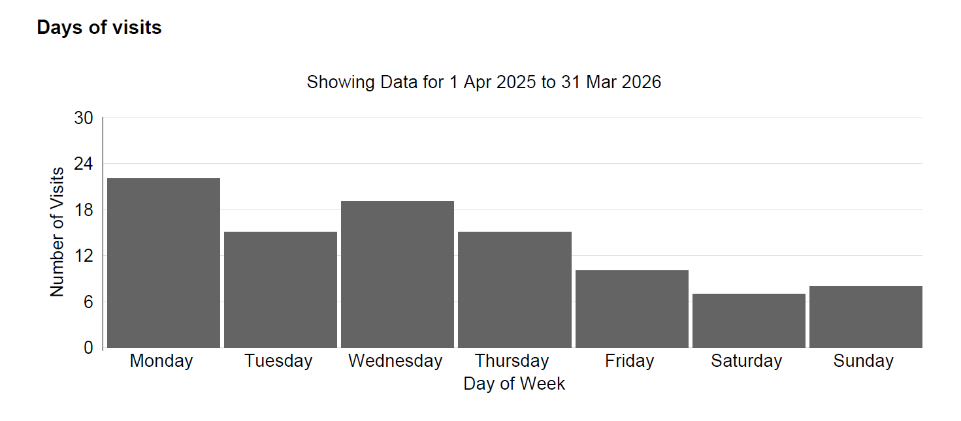

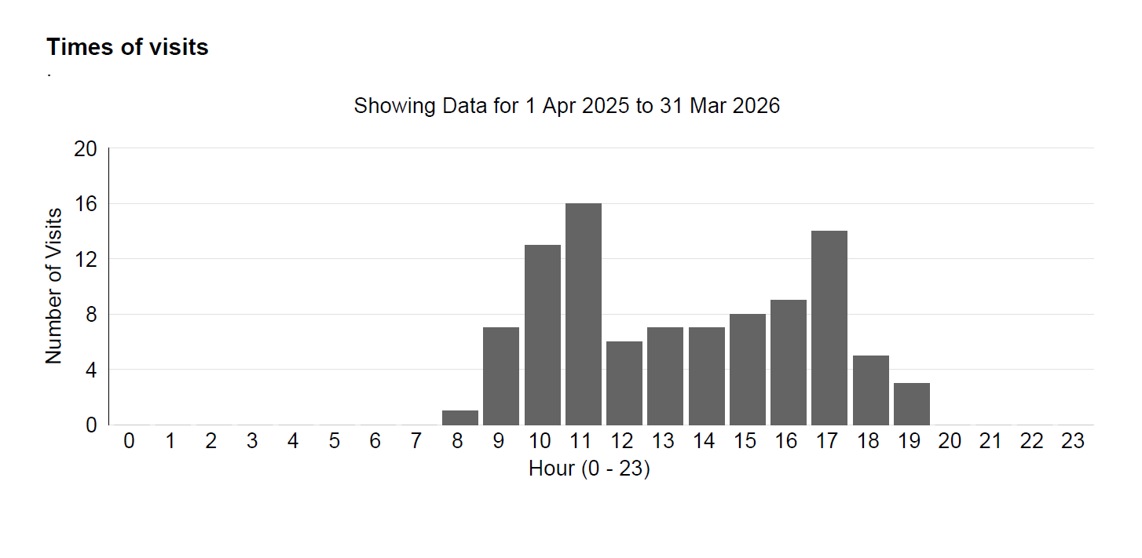

ICV Scheme Findings

Over the past year, there were no serious issues raised that required escalation. The top matters raised by detainees related to not receiving medication (3 instances), not seeing a Solicitor (3 instances) and an Appropriate Adult not being identified (3 instances). Each of these matters were resolved.

Other areas of note

Northamptonshire continues to be recognised nationally for the high quality of its ICV scheme with a Silver Quality Assurance award.

Further information and contact details

Further details about the Northamptonshire ICV scheme can be found here.

Information about the Independent Custody Visiting Association (ICVA) can be found here.

The National Preventative Mechanism website can be found here.

The Northamptonshire ICV Scheme Manager can be contacted by emailing Commissioner@northantspfcc.gov.uk

