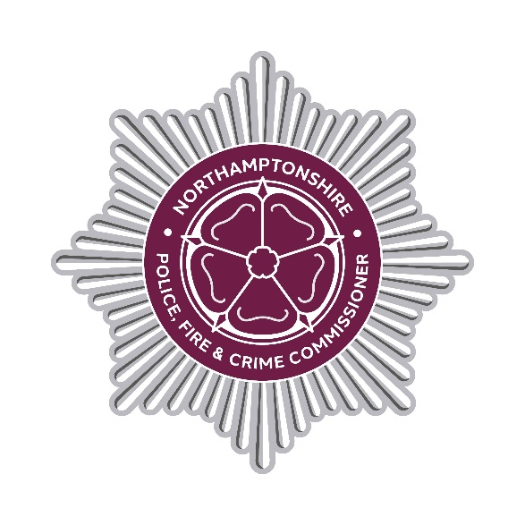

DECISION RECORD

Decision Record Number

This document records a decision taken by the Police, Fire and Crime Commissioner, together with details of the advice they received prior to taking the decision.

Decision taken

The decision has been taken to award a Northamptonshire Fire and Rescue Contract for The Provision of Servicing, Repair and Maintenance of Holmatro Rescue Equipment to Terberg DTS UK Limited. This provision is for the servicing of various pieces of battery powered cutting equipment used to cut car doors to free trapped crash victims and force open doors.

The contract term is from 26th January 2026 to 25th March 2028 with 3 x 12-month optional extensions available. The contract value is up to £110,960 excluding VAT for the initial 2 year and 2-month contract. The Authority has no commitment to spend the full amount.

Details of advice taken

Professional operational, financial, commercial and legal advice has been sought to ensure the decision best supports operational needs and represents value for money.

Danielle Stone
Police, Fire and Crime Commissioner 30th March 2026
END

