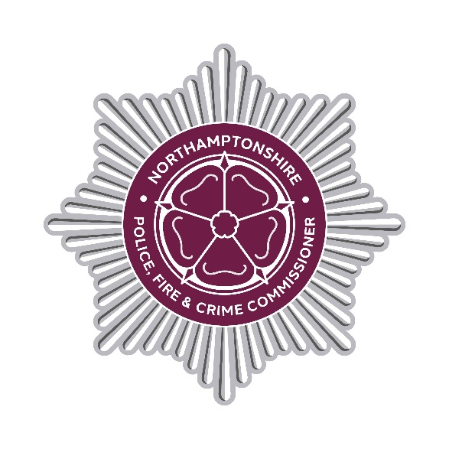

DECISION RECORD

Decision Record Number

This document records a decision taken by the Police, Fire and Crime Commissioner, together with details of the advice they received prior to taking the decision.

Decision taken

A Northamptonshire Fire and Rescue Contract for the Provision of Servicing, Repair and Maintenance of Vehicles and Equipment that was awarded to UK Truck and Plant Group Ltd has been novated to Wheels in Motion Group Ltd.

The Contract term is from 28/10/2024 until 27/10/2027 with the extension options available of four (4) periods of three (3) years. The Contract value is up to £1,380,000 excluding VAT for the initial three (3) year term. There is no commitment for the Authority to spend the full amount.

Details of advice taken

Professional operational, financial, commercial and legal advice has been sought to ensure the decision best supports operational needs and represents
value for money.

Danielle Stone
Police, Fire and Crime Commissioner
18 May 2026

END

