NORTHAMPTONSHIRE POLICE, FIRE AND CRIME COMMISSIONER
AND NORTHAMPTONSHIRE FIRE AND RESCUE SERVICE
Joint Independent Audit Committee Report

Report Title | NFRS HMICFRS update
Meeting Date | 01 July 2026
Author | Lisa Jackson

- Purpose of the Report
This report provides the Joint Independent Audit Committee with an update on the service improvement associated with the HMICFRS inspection recommendations.

- Cause of concern
Following the 2024 ‘round 3’ inspection The service received a cause of concern which was ‘The Service hasn’t made enough progress since our last inspection to improve equality, diversity and inclusion‘. This was broken down by HMICFRS into 5 recommendations. These were
- Working with staff to develop clear EDI objectives and training to increase awareness of EDI and its importance across the organisation;
- Developing effective ways to show how it monitors and evaluates EDI objectives, including understanding and addressing the effect positive action has on staff;
- Making sure it has robust processes in place to do equality impact assessments and reviewing any actions agreed as a result;
- Making improvements to the way it collects equality data to better understand its workforce demographics and needs; and
- Supporting staff and managers to confidently challenge and manage inappropriate behaviour.

HMICFRS re-inspected NFRS in July 2025 in respect of progress in against these areas and formally closed the cause of concern in their letter of 4 September 2025.
The letter notes that “the service has made significant improvements in response to four of the five recommendations.”
However, the inspectorate found positive action processes need to be more robust and issued an additional Area for Improvement:
- The service should improve equality, diversity and inclusion (EDI) by developing effective ways to show how it monitors and evaluates EDI objectives, including understanding and addressing the effect positive action has on staff.
Work to address this has been built into service planning and good progress is being made.

- Areas for Improvement
The service has made good progress across all the Areas for Improvement from round 3 (AFI’s, see appendix A for list). Progress is reported through the HMICFRS monitoring portal and is scrutinised internally at the Change and Improvement Board.
The service has developed a self-assessment process whereby AFI’s can be ‘closed’ on the portal, indicating to HMICFRS that the service believes it has completed the necessary work. This aligns to HMICFRS guidance and expectations. Obviously, only HMICFRS can formally close AFI’s following a full inspection (see section 4).
The service uses the Plan, Do, Check, Act model to assess when it has completed the necessary work for any particular AFI and at the point the AFI owner believes that have reached the monitor and evaluation stage (check/act), they submit a report to SLT for agreement and the outcome is recorded on the monitoring portal.
Based on this process figure 1 provides an update on current progress.
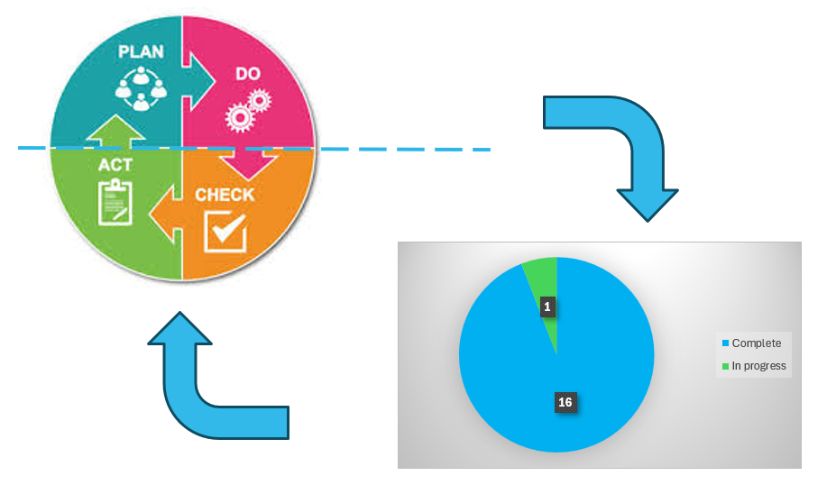
Figure 1

- Round 4 inspection
HMICFRS commenced their current inspection on 1 June 2026 and will take 10 weeks to complete, formally finishing on 7 August 2026. Current timelines suggest that the report will publicly available in October, however, Principal Officers will receive a verbal debrief and presentation on 4 August that will provide an indication of service performance.

Appendix A – Round 3 Areas for Improvement
The 2024 Inspection identified 16 AFI’s
Areas For Improvement
The 16 areas for improvement will be reviewed for progress by HMICFRS as part of the next full inspection regime.
- Senior leaders should take accountability for community risk management plan priorities. They should lead and influence cross-organisational activity, so staff understand how they contribute to the objectives.
- The service should make sure that consultation with the public is meaningful in influencing its future plans and informing its risk profile
- The service should make sure it trains its staff, so that they understand how to target risk effectively and can competently carry out home fire safety visits.
- The service should make sure it allocates enough resources to meet its prevention strategy to support cross-functional collaborative working and shared intelligence.
- The service should make sure it quality assures its prevention activity, so staff carry out home fire safety visits to an appropriate standard.
- The service should make sure its supporting systems provide an accurate picture of community risk, so that staff can prioritise the most vulnerable.
- The service should make sure its response strategy provides the most appropriate response and wholetime and on-call availability, in line with its community risk management plan.
- The service should make sure it has an effective system in place to learn from operational incidents and exercises.
- The service should have effective measures in place to assure itself that its workforce is productive and that their time is used as efficiently and effectively as possible to meet the priorities in its community risk management plan.
- The service needs to assure itself that it is making the most of opportunities to improve workforce productivity and develop future capacity using innovation, including technology
- The service should assure itself that senior and middle managers are visible and inclusive and demonstrate the Core Code of Ethics through their behaviours.
- The service should formally monitor overtime, secondary contracts and secondary employment to make sure working hours aren’t exceeded.
- The service should assure itself that managers are appropriately trained for their role, including those involved in grievance, discipline and welfare processes
- The service should make sure it has effective arrangements in place to manage its workforce plan, supported by the appropriate departments and roles. It should take full account of the skills and capabilities it needs to implement its community risk management plan.
- The service put in place an open and fair process to identify, develop and support all high-potential staff and aspiring leaders.
- The service should make sure its selection, development and promotion of staff are open and fair, and it should do more to make sure staff have confidence in promotion and selection processes.

