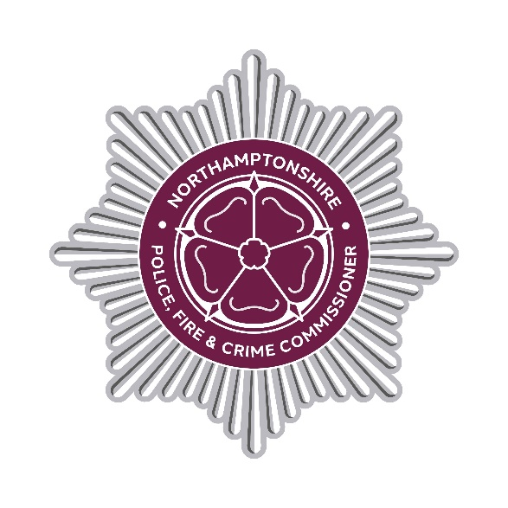

DECISION RECORD

Decision Record Number

This document records a decision taken by the Police, Fire and Crime Commissioner, together with details of the advice they received prior to taking the decision.

Decision taken

The decision has been taken to vary the Northamptonshire Police contract for the Provision of GSA Communications Data Acquisition Solution in AWS Cloud (CycComms) with support and maintenance with Geoff Smith Associates (GSA). This system is used for all communication applications under the Investigatory Powers Act 2016.

This contract is being varied to change the contract start date to 29 October 2024. The term remains 3 years with 1 x 12 month extension option and the contract value remains at £208,503.88 ex VAT if the extension option is enacted.

Details of advice taken

Professional, operational, financial, commercial and legal advice has been sought to ensure the decision best supports operational needs and represents value for money.

Danielle Stone
Police, Fire and Crime Commissioner
22 June 2026

END

