

2027/28 Budget
Joint Strategy & Detailed Guidance

CC Chief Finance Officer
July 2026

Contents
Contents 1
Executive Summary 2
1. Introduction 2
2. Budgeting principles 2
3. Key Areas of Focus 4
4. Timelines 5
Strategic Overview 6
5. Context – The Financial Challenge 6
6. Organisational Priorities 6
7. Considerations 6
8. Capital Programme 7
9. Medium Term Financial Plan 8
10. Key Risk Areas 8
Detailed Guidance 10
11. Timescales - Revenue 10
12. Timescales – Capital 10
13. The Approach (Devolved Budget Setting) 11
14. The Process 12
15. Staff Pay 14
16. Non-Pay Budgets 15
17. Regional budgets [Police] 15
18. Budgets requiring specific evidence 16
19. Non-Devolved Budgets 16
20. Capital Budgeting 17
21. OPFCC Budgets 18
22. Potential budget changes/risks 18
23. Appendix A – Timetable 20
24. Appendix B – Responsibilities 22

Executive Summary

Introduction
  - The purpose of this paper is to give context to the next budget round to prepare for the 2027/28 budgetary need and to provide guidance for the finance team and to give assurance to those charged with governance. All aspects of this paper relate to both Police (incl. OPFCC) and Fire unless otherwise stated.

Budgeting principles

  - The strategic plans of each organisation will underpin the budget-setting process. All budgetary decisions need to be tested against the relevant strategic plans and should support delivery of its key objectives.
  - Budgets will be built incorporating efficiency savings identified over the previous 12 months and clearly recording any reinvestment and cashable benefits achieved.
  - The proposed budgets will be benchmarked against the indicative MTFP figures included in the 2026/27 Police, Fire and Crime Panel budget reports in each organisation.
  - Variations to the approved MTFP will be documented and shared with the Chief Constable/Chief Fire Officer and CC CFO in the first instance. The CC CFO will discuss any variances with the PFCC CFO for consideration.
  - Statutory and other unavoidable costs will be budgeted as required and variations to previous assumptions presented to the CFOs for consideration.
  - Devolved Budget Holders will be fully consulted and given opportunity to provide operational context throughout the budget build process. As part of this, a process will run alongside the budget build via the Finance and Efficiencies board and Strategic Finance Board, where stakeholders will consider;
- Savings that can be delivered from their areas; and
- Efficiency options
These will be scrutinised and reported to consider alongside organisational discussions on;
- Workforce mix
- Enabling Services reviews covering
  - Supplies & Services procurement; &
  - Staffing
- Operational model reviews
- Vacancy freezes
- Investments and reversing previous investments decisions
- Scrutinising historic Business Benefits realisation
- Process re-engineering and reviews
- Outsourcing and alternative methods of delivery.

In Fire, there is an ongoing Community Risk Management Policy (CRMP), which means that we will consider the full operational delivery of the plan, including;
- Investments and savings from changes, including the control room, wholetime/ retained fire fighter mix, day time or 24/7 crewing and operational stations
- Enabling Services
  - As per usual practice, all others will contribute by way of one-to-one budgeting conversations with finance specialists.
  - Where practicable and as much as possible, budget proposals will be calculated using a zero-based approach.
  - Detailed workings will be recorded for all budgets over £5k for Fire or £10k for Police or of a sensitive nature.
  - The budget proposals will be presented in such a way to clearly show department level and the subjective breakdown of all budgets, in particular to identify the cost of Enabling Services split between each organisation and in comparison to operational budgets.
  - Unavoidable budget variations will be separately identified to those discretionary pressures that are a result of internally agreed/implemented changes in each organisation. In doing so, it will be easier to assess which pressures are within or outside the control of the organisations.

Key Areas of Focus

  - Overtime – Detailed analysis will need to be undertaken to ensure budgets are aligned across departments accurately, based on demand, expected abstractions/resourcing and in line with the operating model.
  - Fire, will continue to look to deliver an understanding between strength and availability of operational resources and Overtime and Bank Cover costs, whilst ensuring it is aligned to workforce plans and operational demand requirements, with focus on the response modelling that is due in July.
  - DDaT Revenue – The volume and complexity of DDaT contracts are notoriously difficult to track accurately, and experience has shown that these need an enhanced level of scrutiny and oversight. The contracts register will be used as a basis to calculate budgets across the DDaT and Comms budget headings, with provision for inflation included as appropriate. A review of the capital programme and ongoing projects will be undertaken to ascertain revenue impacts in 2026/27 and across the MTFP.
  - Premises – The cost of all utilities and building maintenance are to be reviewed with attention on new buildings and savings applied for buildings due for disposal throughout the MTFP. The budget proposals should clearly show which aspects of the proposed Estates Masterplan are included or not and the timings of those assumptions and risks, to enable informed decision-making.
  - Commercial – The Commercial Strategy will be reviewed/updated as part of the budget setting process, incorporating any new income generation activity, realisation of benefits and cost avoidance. Specific areas of commercial development will be budgeted with the most up-to-date picture in mind.
  - Impact of economic uncertainty – There remains impacts on funding and expenditure from the cost-of-Living crisis and preceding pandemic and Ukrainian crisis, which will need assessment and prudent budgeting, to include:
- Rates of inflation – particularly in relation to fuel, vehicles and equipment/materials (current headline UK rate is 2.8%)
- Supply chain issues (particularly laptops, technology & vehicles)
- Tax base assumptions
- Collection Fund Surplus/Deficit assumptions
- Business Rates assumptions (Fire)
- Personal Protective Equipment (PPE) & Cleaning/Hygiene Supplies
- Income Streams (inc. Vehicle Recovery, Firearms Licencing, Events, Special Services charges, canteen provisions)
  - Police Officer/Firefighter recruitment and rank profiling – Police Officer/Firefighter pay make up huge proportions of the overall organisational budgets and is subject to detailed budget workings to include the following key areas:
- Recruitment/Cohort plans
- Leaver projections
- Rank profile and glide-path
- Secondments
- Regional/Partnership posts
- Maternity and abstractions
- Pension uptake and prevailing contribution rates
- Allowances and levies
- Pay Awards and other changes to pay-scales
- Particular attention in relation to the budgeting assumptions and methodology of Retained Firefighters
  - CRMP [Fire] – Updates and amendments as a result of this will be built in, following the completion of the new plan.

Timelines

  - A detailed timetable has been produced to ensure key milestones are met (Appendix A). This allows sufficient time to ensure all key information is produced, and that statutory officers have the ability to challenge and scrutinise prior to the production of papers in good time for key meetings which include:
- 7th October 2026 – JIAC Meeting to consider the budget and MTFP process
- 22nd October 2026– SLT outline budgetary position proposal (expenditure)
- 5th November 2026 – FEM for the outline budgetary proposal (expenditure)
- 12th December 2026– Problem Solving Board (Police and Fire)
- 6th January 2027 – Accountability Board to agree proposed budget
- 5th February 2027 – Police, Fire and Crime Panel to consider proposed precepts

Strategic Overview

Context – The Financial Challenge

  - As planned, the Medium-Term Financial Plans have been reviewed since the 2026/27 Budget Build and an interim update is being presented to the Accountability Boards in July, which includes the estimated impact of capital slippage and pay awards.
  - Any funding gaps will need to be considered as part of the budget build and savings made where realistically possible.
  - The budgets need to be built with longer term impacts in mind.

Organisational Priorities

  - The budget for all organisations needs to be prepared in support of the longer-term strategies identified in the Police, Fire and Crime Plan:

Safe and Sound: The Public Safety Plan for Northamptonshire 2025-2030 - Northamptonshire Police & Fire Commissioner
  - The Police budget needs to be prepared in support of Force Matters of Priority and HMICFRS Areas For Improvement (AFIs)
  - Fore Policing Plan 2025-2028:

Northants Police Policing Plan
  - The budget needs to be prepared in support of the new Fire Priorities, CRMP and Response Modelling, which is currently in draft, but the major estimates are known.

Considerations

  - The budget should be prepared allowing for:
- Statutory Changes
- Business Plans/Investment Bids
- Approved Business Cases
- HR Workforce Strategy and delivery plan
- DDaT Strategy and Plan
- Asset Strategy and Plan
- Outputs from Strategic Planning Efficiencies Subgroup activity [Police]
- The CRMP
- Op Regen (Police)
- Horizon scanning
- The impact of purchase/sale of estate
- Regional/Partnership developments
- Revenue operational equipment replacement programmes

Capital Programme

  - The revenue budget in future years is directly affected by the size of the capital programme. The level of government capital funding, specific grants and borrowing will all have an impact.
  - The Assets Strategy and delivery plan
  - The DDaT strategy and delivery plan
  - The priorities and profile of the capital programme will be managed by the Technical Accountant and delivered with enhanced scrutiny via a number of focussed meetings with budget leads.
  - The programme should be realistic and take into account the availability/priorities of resources needed to deliver each project.
  - The cost of borrowing, the return on investment and the risk factors of the global economy
  - Estimated slippage and re-prioritisation provisions will be reviewed and included as necessary

Medium Term Financial Plan

  - The MTFP is updated through the year and was refreshed formally in July to incorporate changes since setting the 2026/27 budgets. It will be refreshed again following completion of the draft budget proposal, to incorporate the 2026/27 funding settlement, precept proposals and tax base.
  - Police/Firefighter Pay modelling will be updated as part of the budgeting process, which will take into account the projected glide-path relating to recruitment, promotions and rank profile.
  - Specific savings and pressures will be built into the modelling workbooks.
  - General inflation will be based on fixed rate assumptions.
  - Assumptions will be reviewed and updated based on professional estimates and benchmarking by the s151 and ds151 Officers.

Key Risk Areas

  - There are a number of local and regional factors that may impact the budget requirement and currently carry a significant level of uncertainty:
  - Increases and changes in Demand;As part of the Op Regen, demand levels are monitored and could ultimately result in a need for additional investment in people, or increased levels of overtime expenditure.
  - Emergency Services Network (ESN), which continues to be delayed, but is currently being re-planned and is expected to commence in 2028.
  - Certainty surrounding ESN project has improved since last year and both Police and Fire are expecting to have sufficienct budget to meet the needs for both Revenue & Capital, but this remains under review. The latest information will be used to inform both Police and Fire budgets.
  - Staff Pay Award
Grey (3.8%) and Gold book (3.8%) Fire Fighter pay awards have been implemented, so this poses negligible risk.
Police Officers and Staff are not yet known. It is possible that the police staff pay award will be negotiated to the same 3.8% agreed for police officers, which would cause a budgetary pressure of around £0.8m. Consistent assumptions will be used across Police and Fire where practical to do so.
  - Overtime
The effect of abstractions, vacancies, increasing demand and structural changes could all potentially change the overtime requirement. In Fire this is currently monitored under the Overtime Gold Group, as well as by the Area Manager for workforce and in Police, this is jointly monitored by Finance and the operational team
  - Staff Vacancies
It is common for the savings from vacant staff posts to be used to offset other departmental pressures. As in previous years, there will a full review of the vacancy factors applied to staff budgets, to reflect budgetary need as accurately as possible.
A more stringent approach to vacancy management will commence in 2026/27, however, it is expected to be used to offset some required savings/ growth.
  - Other local authorities
Given budget pressures throughout the public sector, there is a growing trend for other authorities to start charging for services and/or stopping services resulting in increased demand for emergency services.
  - Regional Collaboration [Police]
Collaborations are being reviewed to ensure that they are offering the best possible outcomes and value and also to look at the in year pressures in order to provide mitigations.
Wider risks include:
  - Home Office Funding
The government has indicated a need to make savings across both Police and Fire.
In Policing, the HO has also indicated the intention to consult on the third phase of the Neighbourhood Uplift, but it is expected that the full cost of new Officers will not be met, which will need to be mitigated. Whilst there is some reassurance that Uplift funding is due to remain in place, the lack of certainty around levels of funding, brings significant concerns given its material impact.
The Potential for changes in funding for the nationalisation of services/ the recent White Paper
Furthermore, a change of Prime Minister and government reshuffle may bring even more uncertainty about the future of public sector funding.
  - Protection Grant [Fire]
As an assumption of 80% of the grant that was received in 2025/26 is expected to be rolled into base budget and inflated year on year.
  - Precept Funding
As part of the 2026/27 budget round, the final MTFPs were prepared on the basis of a modest tax base increase and:
- Police - Band D precept increases of £15 for 2 years and then £10 thereafter
- Fire - a £10 precept for 1 years and then £5 for 2 years and then £2.50 thereafter
The tax bases may not be available from the local authorities until the end of January and the precept increase is subject to approval by the Police, Fire and Crime Panel in February 2027.
  - Business Rates Funding (Fire)
As part of the 2026/27 budget round, the Business Rates were set on a new set of base assumptions given the forecasts from North & West Northamptonshire Councils. It is not expected that final business rates figures from the national review will be fully understood before the budget is finalised and so will be set on a best estimate basis, which increases both positive and negative.

Detailed Guidance

Timescales - Revenue

  - Initial devolved budgets need to be completed by Finance personnel by 1st October 2026.
  - Initial review and consolidation of bids into the main budget model to be completed by 12th October 2026. This will allow time for budget proposals to be scrutinised and developed during November and built into the overarching budget papers.
  - See Appendix A for the detailed timetable.

Timescales – Capital

  - 15th September 2026– Capital Programme Review – Budget leads
  - To check monitoring against the latest programme and highlight issues/actions. To also brief on next steps and deadlines for budget setting
  - 15th October 2026- Revised Capital Programme and Financing Proposals (s151 Sign-off)
  - 20th October 2026 - Capital Programme (ACO Sign-off) – Budget leads
  - This meeting being after all ES leads have confirmed proposals/updates for budget round. Finance will have had follow up meetings with ES leads, to have final sign off of requirements.
  - This meeting being after ACO and all ES leads have confirmed proposals/updates for budget round. Finance Dept will have calculated Capital Financing implications to feed into revenue and shared with s151 PFCC in good time before the meeting, to allow for revisions.
  - Capital Financing should be updated to reflect revised programme and reflected in the budget and MTFP by 27st October 2026.

The Approach (Devolved Budget Setting)

  - Any agreed programmes of work or savings identified as part of the Finance Efficiencies process [Police] or Fire SLT as set out in the 2026/27 budget process or within year will be factored into devolved budgets as soon as agreed.
  - The budgeting process will be largely the same as that used in 2026/27. There will be detailed scrutiny of all requests for inflationary growth and miscellaneous pressures.
  - Budgets will be zero-based where practical to do so, and not be set on a rolling basis, with savings of 2% being requested from departments outside of areas already identified for savings, which will be reviewed by the Strategic Planning Board in Police and the Chief and s151 Officers in NCFRA.
  - Budget Model templates will be provided along with instructions for completion alongside this guidance. They will allow for budgets to be entered and tracked against 2026/27 budget levels.
  - In consideration of priority based budgeting, only budgets over £10k will require a mandatory review of the planned expenditure requirements for the following year, with budgets below this value able to have lighter touch where time does not allow, by the approval of either the FAB Team Leader, Strategic Account or Head of Finance.
  - Any changes brought resulting in growth/savings should be reflected in budget bids where they have been formally signed off at the appropriate level, with the movements captured transparently.
  - Savings/growth that is identified but awaiting formal approval will be considered for inclusion by the Chief Finance Officer(s). This includes proposals for contingency provisions.

The Process

  - The Finance team will be issued with budget templates for each cost centre.
  - Budgets should be calculated for each subjective line, taking into account information from budget holders, and the resultant movement recorded as either:
- Inflation – Enter here all budget increases relating to inflationary pressures, rather than Growth. This includes contractual inflation and price increases for budgeted products and services already in place. Annotation and evidence must be provided.
- Growth – This should be clearly evidenced by working papers and/or business cases and will be considered by the Joint Head of Finance and CFOs in line with the MTFP.
- Savings – This should be clearly evidenced and captured corporately.
- Virements – These should always balance to zero and will be reviewed by the Joint Head of Finance and CFOs. Any virements between departments should be clearly annotated, and any of a value above thresholds set out in the Corporate Governance Framework(s) will be subject to authorisation as necessary.
  - Completed devolved and non-devolved budget templates will be reviewed by the Strategic Management Accountant, to ensure that:
- Working papers are adequate
- Virements balance to zero
- Savings have been captured appropriately
- Growth is minimised and highlighted for further scrutiny
- Expected changes have been taken into account
  - The CFOs will cross reference the MTFP to ensure all new growth and savings have been factored into the budget.
  - The Strategic Management Accountant will arrange for consolidation of the budget templates, cross-casting as necessary and production of summary reports as required.
  - Budget templates, working papers and summary reports will be reviewed by the Joint Head of Finance and respective CFO’s.
  - The PFCC CFO will work with the Joint Finance team to ensure appropriate links are made between the local authorities and the team to receive details of council tax bases, business rates and collection funds ensuring they can be fed into funding calculations, although it is accepted that these may not arrive until late in the process (see timetable for details).
  - In Police, the CC CFO will brief the Chief Officer Team on draft budgets, inviting further scrutiny, highlighting assumptions, growth/savings and risk areas. This will be through the Strategic Planning Board, with reference to discussions at FEM. In Fire, this will be through FEG meetings and briefings/discussion between the Deputy Chief Finance Officer and the Chief Fire Officer. The PFCC CFO will brief the PFCC and a similar process to previous years will be followed with an OPFCC senior budget workshop to check and challenge the submissions and challenge meetings as appropriate.
  - The CC CFO will then present the completed budget to the PFCC CFO and initiate discussions on issues that may need to be raised with the PFCC regarding growth, savings and risk areas.
  - A final version of the budget will be shared with Chief Officers by the respective CFO and presented with a covering report to the Accountability Board for approval.
  - The PFCC CFO and CC CFO will hold briefing sessions as appropriate throughout the process including: MP’s, Local and parish councillors, local representative groups and the Police, Fire and Crime Panel.
  - The PFCC CFO will share the final budget summary and precept proposals to the Police, Fire & Crime Panel to inform the panel’s deliberations and seek their approval for the PFCC’s precept proposal.
  - The Strategic Management Accountant will share devolved budgets with budget holders as soon as possible after budget approval, but by the end of March 2027 at the very latest.
  - Budgets will be loaded onto the finance system for 2027/28 prior to the start of the financial year.

Staff Pay

  - As pay forms the greatest proportion of the budget in the majority of devolved areas, this should be treated as a priority.
  - Reconciliations between the budget bid, establishment and payroll should be undertaken by the end of September. This includes checks on post details, pay grade, spinal points and whether staff are opted in/out of the pension scheme.
  - Posts on spot salaries shall be checked and updated as required.
  - Posts that need to be added or removed from the budget should be recorded as growth or savings for scrutiny.
  - Grant-funded and temporary-funded posts should be budgeted and annotated as necessary to enable understanding of funding sources and timescales. Assumptions regarding these income streams should be prudent and budget holders fully briefed.
  - Any vacancies must be reviewed and discussed with the budget holder in order to ascertain whether the posts are to be recruited into or can be released as a saving.
  - National Insurance and Superannuation budgets will be calculated using rates determined by the budgeting templates. The Strategic Management Accountant will ensure that the rates are updated as required.
  - In the event that any Pay award negotiations have not concluded in time for initial budget workings, the most up-to-date assumptions will be used.
  - Appropriate turnover saving targets should be proposed based on last 12 months experience with any decreases justified and evidenced. This will be proposed by the Strategic Management Accountant and reviewed by the ds151, s151 for Police and s151 for NCFRA. There is an expectation that these will deliver a material saving.
  - Any approved decisions made in the past 12 months need to be reflected in the staffing budgets.
  - Where department reviews/restructures are still underway, budgets should be based on the current position and any changes can be made during 2026/27. The CC CFO should be informed to determine if part-year contingency growth is required.

Non-Pay Budgets

  - Inflationary pressures for 2027/28 and the MTFP will be considered at a base assumption suitable to the current global economy.
  - Initial non-pay budgets should be based on current experience and knowledge, analysing expenditure over the past 6 months or more as appropriate to ‘zero-base’ budgets. Any further savings that can be achieved in non-pay will assist in protecting officer/staff posts in the future, so it is important to reduce non-pay budgets if savings are achievable. Budget managers should be fully consulted on any changes to ensure they are fully sighted and can assist finance personnel to explain/justify any significant movements.
  - Detailed workings/notes for all budgets in excess of £10k that are not specifically referred to below will be required. Workings are not required for budgets below £10K, but should be included if it is felt this will be helpful as a future reference.
  - All price increases relating to contracts need to be fully evidenced. The commercial team should be asked to provide details of any contractual changes and RPI increases so that these can be reflected in budget proposals.

Regional budgets [Police]

  - It is anticipated that regional budgets will be discussed at the EMPCC Board in Late 2026 and details of contributions will be provided by lead Forces. However, historic practice is usually that regional budgets are agreed after the national police settlements have been received.
  - It is expected that the funding formula will not change.
  - Specific attention will be given to the achievement of planned savings and income budgets.

Budgets requiring specific evidence

  - Detailed workings are required for the following, regardless of the budget value:
- Contractual payments – These should be cross-referenced to details provided by Commercial, with price increases and savings captured as necessary.
- Computer Maintenance – Please provide a detailed list of the IT system, length of the contract and annual value. Consideration should be given to vire any IT systems elsewhere into the devolved to centralised IT budgets where possible.
- Agency Payments/Contributions – list all contributions to/from other agencies/partners with their end dates if known. The OPFCC will confirm a list of agreed funding to assist with this.
- Operational Equipment – Detailed spending plans should be included with your budget submission where possible.
- Mileage – Workings should include details of all Essential Users along with evidence that recipients continue to fulfil the conditions for entitlement to the allowance.
- Overtime – Calculate how much is required for overtime (inc. BH cover) and ensure that discussions are held with budget holders to take account of expected changes in staffing and demand.

Non-Devolved Budgets

  - The following budgets are not devolved across the organisation and will be set within their host departments for the whole organisation:
  - Police
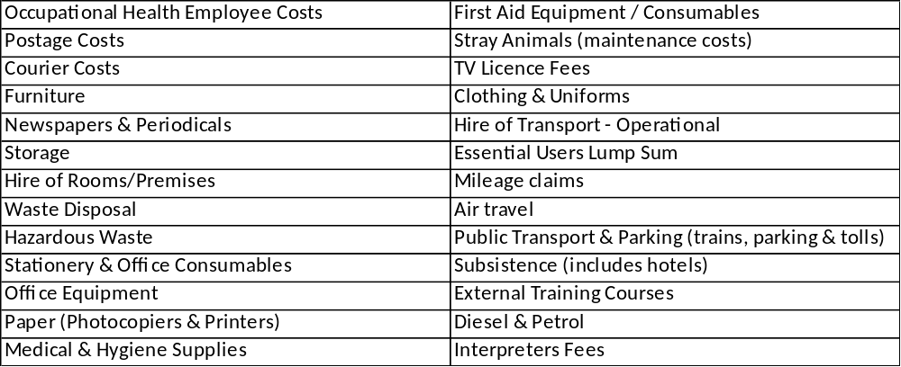
  - Fire
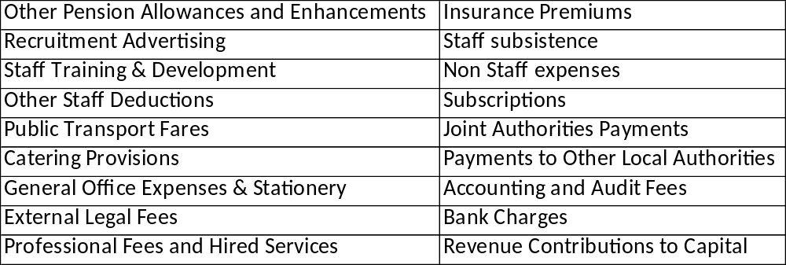
  - The charges between Police, Fire and the OPFCC and will be specifically calculated, aligned and approved.

Capital Budgeting

  - The Technical Accountant will produce the capital programme using information from approved Estates, Transport, Operational Equipment and DDaT Strategies, alongside meetings with the Budget Holders and senior stakeholders.
  - Budget holders will be consulted regarding slippage and underspends to ensure these are reflected accurately. This should be done in reference to the overarching strategies and decisions/directions of travel laid out in these strategies and associated boards. In particular, attention should be paid in relation to Estates and the timing/nature of each agreed project.
  - Asset disposals and timing of these (particularly buildings) need factoring in and explanations given if these deviate from the intended plan/strategy.
  - The final capital programme and proposed funding of the programme will be reviewed by the Joint Head of Finance and presented to the CFOs by 27th October 2026.

OPFCC Budgets

  - The budget build and timetable will be shared with all OPFCC Directors and the PFCC and briefings on the MTFP and the budget process will take place throughout September.
  - OPFCC Directors and budget holders will review all their budgets from a zero base - identifying new priorities and requirements in line with the PFCC direction and the Police and Crime Plan. This will include reviewing and identifying opportunities for savings and efficiencies.
  - Savings and efficiencies will only be built in when finalised and agreed.
  - Inflationary assumptions used will be consistent with force assumptions.
  - Initial Director proposals will be prepared by the 5th October 2026 and reviewed at an OPFCC Directors meeting in mid-October where check and challenge will be undertaken by Directors and the PFCC.
  - Preferred options and budgets will continue to be reviewed and refined and a draft budget prepared by the 31st October (or earlier if possible), for consolidation with the overall budget for the Force and OPFCC.

Potential budget changes/risks

  - Funding levels are uncertain given the election, cost-of-Living Crisis and the Labour announcements around the state of Public Finances.
  - The impact of demand changes, departmental reviews and other structural changes.
  - The timing of savings from planned building disposals.
  - Running cost budgets of buildings due for renovation or sale will not be adjusted until the impact is fully known, but estimated savings may be captured centrally if these are likely.
  - Digital and technology systems changes and inflation are likely to be significant in the next round of budgetary updates.
  - Whilst the Emergency Service Network (ESN) remains a risk area due to delays nationally, however, it is expected that the project will commence within the MTFP timetable.
  - Reviews of various areas of the business may require budget changes, including the risk that intended cashable efficiencies might not be achieved. This will be impacted from the outcome of ongoing demand-analysis work.
  - Silverstone, Firearms licensing and Speed Awareness Course, income is expected to be fundamentally reviewed due to changes in guidance and also the national recharge rates. [Police]
  - There are ongoing reviews of regional units that may result in budget differences, including the uncertainty of the future of regional government grants (eg. ROCU). [Police]
  - The latest information on premises rates reviews will be considered and estimates for 2027/28 will be included where confirmed and prudent to do so. The treatment of any adjustments relating to previous years will be considered by the CFOs separate to the budget process.

Appendix A – Timetable
Joint Finance Team Deadlines | Key Meetings | Capital

Activity | Proposed Date | Lead
Budget Process to be completed/shared (Fire papers for SLT due 15/07) | 07/07/2026 | NA
Budget file roll forward | 03/08/2026 | SC
Budget templates distributed for completion | 03/08/2026 | SC/SAC
Fire Strategic Finance Group | 04/08/2026
Team Briefing on Budget Build | 04/08/2026 | SC
Capital – Templates shared with budget holders for updates | 01/08/2026 | MS
Capital – Budget holder meetings commence | 15/08/2026 | MS
NCFRA Senior Leadership Team Meeting | 19/08/2026 | SC/SA/NA/VA
Fire Strategic Finance Group | 08/09/2026 | SC/SA/NA/VA
Capital – Review meeting. Detailed challenge of proposals | 15/09/2026 | MS/SAC
Set Vacancy Factor | 18/09/2026 | SC/SAC
NCFRA Senior Leadership Team Meeting | 23/09/2026 | SC/SA/NA/VA
Budget bids completed and inputted into the Budget Model by Finance Advisors - NO FURTHER CHANGES WILL BE ACCEPTED | 25/09/2026 | SC/SAC
Police/Fire Staff reconciled and updated on Excel templates | 25/09/2026 | SC/SAC
Capital Budgeting – Reports distributed for ACO sign-off meeting | 29/09/2026 | MS/SAC
Consolidation of devolved budgets into Master Model | 28/09/2026 - 09/10/2026 | SC/SAC
OPFCC Directors budget proposals due | 05/10/2026 | OPFCC/VA
Set Fire recharge assumptions | 05/10/2026 | OPFCC/VA
Fire Strategic Finance Group | 05/10/2026 | SC/SA/NA/VA
Deadline for JIAC Papers – October meeting | 07/10/2026 | ALL
JIAC Consider 2025/26 Budget & MTFP Process | 07/10/2026 | SAC/NA
Capital Programme (s151 sign-off) | 13/10/2026 | MS/NA/VA
Government Budget announcement | TBC
Capital Budgeting – Revised capital programme sign-off by ACO | 20/10/2026 | SAC
NCFRA Senior Leadership Team Meeting | 22/10/2026 | SC/NA
Draft Treasury Management Strategy shared with OPFCC | 23/10/2026 | VA/NA/DC
Agreement of 3-way cross-charging | 23/10/2026 | VA/NA
Finance and Efficiences Board | 21/10/2026
Capital Budgeting – Final programme to be shared with PFCC s151 | 27/10/2026 | MS
Investment Bids finalised | 30/10/2026
Finance department sign off of budget proposal based on need | 30/10/2026 | NA/SA/SC
Budget/MTFP Briefing to Chiefs | 30/10/2026 | VA/NA
First level of scrutiny by Finance supervisors | Two Weeks | SC/SA/NA
Creation of the MTFP |  | SC/SA/NA
Reconciliation of MTFP |  | SC/SA/NA
Production of growth, savings & statutory growth |  | SC/SA/NA
Budget report |  | SC/SA/NA
Force Draft Budget discussed by s151s/ Incl ds151 | 02/11/2026 | NA/VA
Final Draft OPFCC Budgets | 02/11/2026 | OPFCC/VA
Finalise draft budget proposals and reports | 03/11/2026 | NA (Force)  VA( OPFCC)
FEM | 05/11/2026
Fire Strategic Finance Group | 06/11/2026 | SC/SA/NA/VA
Estates Board | 09/11/2026
Updated draft Budget & MTFP to be shared with OPFCC (both Police & Fire) | 11/11/2026 | NA
Deadline for JIAC papers | 17/11/2026 | ALL
Deadline for Police, Fire and Crime Panel papers | 17/11/2026 | ALL
NCFRA Senior Leadership Team Meeting | 18/11/2026 | SC/NA
Regional CFO/FD meeting | 19/11/2026
Regional PCC Business meeting (PFCC only) | 26/11/2026 | VA
JIAC | 02/12/2026
Police, Fire and Crime Panel – PFCC’s precept intentions | 04/12/2026 | VA
FORCE EXEC MEETING | 04/12/2026
Joint CC/PCC Board – submission of the Collaborative budgets and PCC fund requests | 08/12/2026
Joint CC/PCC Board – review of 2026/27 budgets if not previously agreed | 08/12/2026
Provisional Police Settlement announced | Mid-Dec | HOME OFFICE/DLUHC
Accountability Board – January deadline | 06/01/2027
Regional CFO/FD Meeting | TBC
Draw the line on Council Tax Changes/Taxbase to finalise total budget and requirement | 12/01/2027 | NA/VA
Accountability Board – agree:
Force budget 2026/27 |  | NA/VA
Capital Programme | 13/01/2027 | NA/VA
Treasury Management Strategy |  | NA/VA
Reserves Strategy |  | NA/VA
Joint CC/PCC Board – review of 2025/26 budgets if not previously agreed | TBC
Preliminary Budget Briefing to Police, Fire and Crime Panel | TBC | VA/NA
Police, Fire and Crime Panel papers finalised | 27/01/2027 | VA/NA/ ALL
Statutory Date for CT Surplus and Taxbase Confirmations | 31/01/2027 | LAs
Police, Fire and Crime Panel consider proposed budget and precept, Capital Programme and associated strategies | 05/02/2027 | VA
Police, Fire and Crime Panel – backup date if veto | 10/02/2027 | VA
PFCC Issues Precept | 28/02/2027 | VA
Advise of Grant and Council Tax Settlement dates and amounts | 28/02/2027 | VA
Issue Budgets to Budget Holders | 26/03/2027 | SC/SAC

Appendix B – Responsibilities

Police
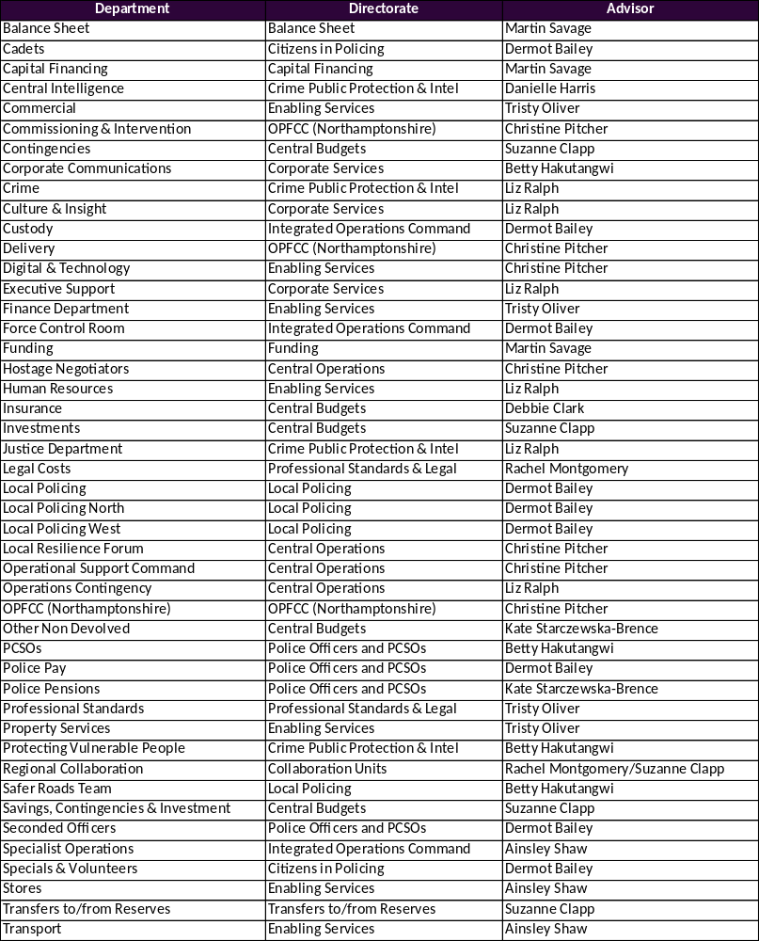

Fire
